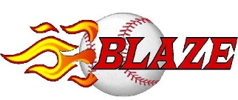
Hello Perspective Player/Family Member,
Welcome to Cleveland Blaze Baseball, a player development organization that has successfully operated since 2004. The college team is entering its 4th season and we are starting our 3rd year with 2 teams competing in the Diamond League, which consists of 10 teams separated into 2 divisions of 22U and Unlimited/Major (18+). Home and cross-over games will primarily be played at Victory Park Ohio (North Ridgeville), Lake Catholic HS and Mentor HS. Our team(s) consists of current and former collegiate baseball players across 20 different colleges ranging from DI/DII/DIII/JUCO/NAIA and the high school classes of 2010-2018. We are proud to be more than a team; we are a cohesive family of coaches and players that strive to support and motivate each other to further your athletic and college/career abilities. We strive to create an enjoyable baseball atmosphere and in-game experience. We want to help you succeed, by keeping you healthy, enhancing your skill sets as a player, providing a competitive atmosphere, and driving behaviors that will benefit your role as a college baseball player. If you are unable to make it to a practice or game (vacations, work schedules, etc.), you need to communicate with your coach well in advance. This will make the coaches aware of their game-day roster and develop a competitive lineup/practice plan accordingly. In-Season team information will be posted under the Blaze Baseball tab on the victory park website at: http://www.victoryparkohio.com/teams as well as our team “GroupMe” (app on phone, see Brendon Borkey 440-477-3876 to be added). The player fee for the 2018 season will remain at $200 a player. We are highly leveraged with sponsorships and community support that affords us the opportunity to keep this reduced rate for player fees.

We look forward to having you join (return to) our organization in 2018. Below is our Player questionnaire and introductory packet for the upcoming season.

Go Blaze!

Joe Borkey
General Manager
Blaze Baseball
(440)-477-3311
jborkey@victoryparkohio.com

Highlights from the last 3 years of the Blaze College Team:
2017
- Champions of the NABF College World Series 22U (Toledo, Ohio)
- Berth to 21U AAABA National Baseball Tournament (Johnstown, PA)
- Runner-Up in Columbus Braves Invitational 18+ (Columbus, Ohio)
- Diamond League Champions
- Combined record of 31-11 beween the 2 teams
2016
- Final 4 appearance in NABF World Series 22U (Toledo, Ohio)
- Final 4 appearance in AAABA World Series 21U (Johnstown, PA)
- Diamond League Champions
- GLBL League Champions
- Combined record of 37-12-1 between the 2 teams
2015
- Berth to AAABA National Baseball Tournament (Johnstown, PA)
- AAABA Regional Champions 21U
- Final 4 Appearance in Mentor Firecracker Tournament 18+ (Mentor, Ohio)
- GLBL League Champions
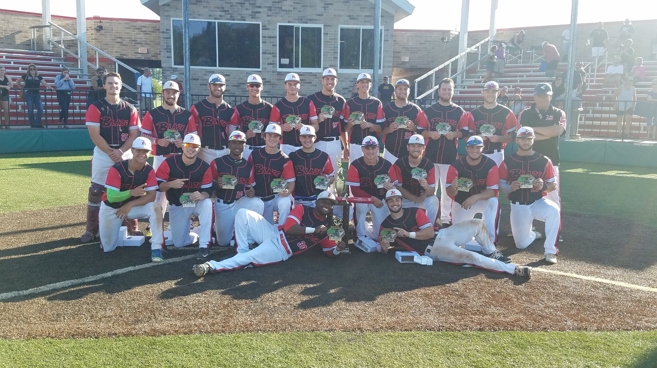
(2017 NABF College World Series Champions)
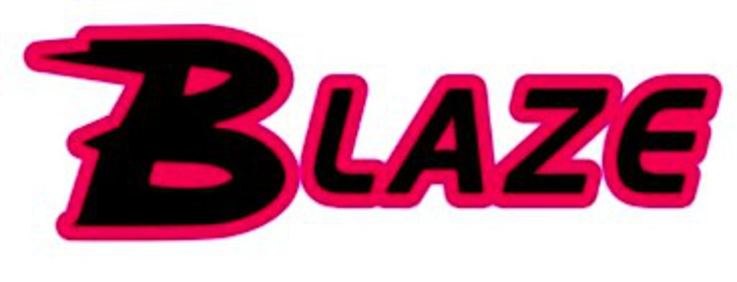 Player Name:

Date/Year of Birth: Position:
Jersey Number (1st Preference): Cap Size (S/M, M/L, L/XL):
Jersey Number (2nd Preference): Jersey Size: (M, L, XL, 2X, 3X):
Jersey Number (3rd Preference): Pant Size:
Height: Weight:
Home address (as shown on your drives license):
Email Address: Phone Number:
Previous Summer team(s):
High School: HS Graduation Year:
College: Exp Grad Year:
College Major/Cumulative GPA:
Summer Job +Location: Job Hours:

Would you like to be contacted for part-time job opportunities at Victory Park Ohio?

Tournament Availability:
(Please indicate yes or no to availability)
DATE TOURNEY (tentative) LOCATION YES OR NO
June 23-25 Columbus Braves- Columbus Ohio (mixed roster):
July 6-8 Diamond Blaze Northeast Ohio (both teams):
July 13-15 NABF 22u Mini-Regional Northeast Ohio (red team 22u):
July 19-22 NABF Regional* TBD (either team 22u if needed):
July 26-29 NABF 22u World Series Toledo (Black 22u team + adds):
Aug 2-5 NABF Major Regional** TBD (full red team+ adds):
Aug 9-12 NABF Major World Series** Battle Creek Michigan (full red team+ adds):
Aug 6-12 AAABA 21U Nationals Johnstown PA (mixed 21u + adds):

Please email this form to Brendon: bborkey@victoryparkohio.com

