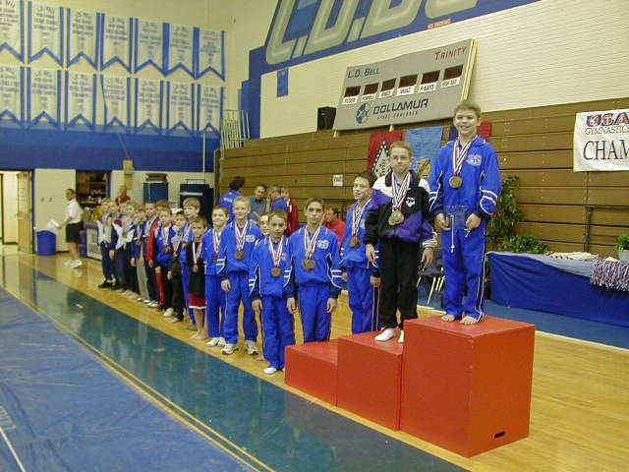 | Meet Results  Class 4 - 10-11  All Sessions Combined
Region 3 Championships (YELLOW - Region III Class 4 Junior Development Team)
L.D.Bell High School
Place | Num | Name  Gym | Floor | Pommel | Rings | Vault | P Bars | H Bar | AA
1 | 416 | Joshua Wilson  WOGA | 8.300  23T | 8.750  4 | 9.200  1T | 8.500  1 | 9.100  1 | 9.150  1 | 53.000  1
2 | 465 | Daniel Potemski  Acro Tex | 8.900  3T | 9.050  1 | 8.400  20T | 7.850  14T | 8.800  6 | 8.750  2 | 51.750  2
3 | 428 | Tony Duscio  WOGA | 8.800  5T | 8.800  3 | 9.000  3 | 8.400  2 | 8.900  3T | 7.450  38 | 51.350  3
4 | 424 | Eric Schryver  WOGA | 8.700  9T | 8.850  2 | 8.800  6T | 7.900  9T | 8.300  23T | 8.500  4T | 51.050  4
5 | 481 | John DePalma  WOGA | 8.900  3T | 7.800  21T | 8.800  6T | 8.000  5T | 9.050  2 | 8.450  7T | 51.000  5
6 | 474 | Ian Thompson  Gulf Gymnastics | 9.100  1 | 8.500  6 | 8.100  32T | 8.000  5T | 8.850  5 | 8.200  12T | 50.750  6
7 | 462 | Presten Ellsworth  WOGA | 8.600  15T | 8.600  5 | 8.400  20T | 8.100  3T | 8.700  7T | 8.000  18T | 50.400  7
8 | 456 | Tate Foley  Jennings Gym | 8.700  9T | 8.150  10 | 8.300  28T | 7.750  25T | 8.900  3T | 8.500  4T | 50.300  8
9 | 480 | Devin Burnett  WOGA | 7.900  38 | 8.300  8T | 9.200  1T | 8.100  3T | 8.350  22 | 8.250  9T | 50.100  9
10 | 488 | Corey Benefield  Northshore Gym | 8.300  23T | 8.300  8T | 8.850  5 | 7.650  29T | 8.550  12T | 8.250  9T | 49.900  10
11 | 430 | Joshua Steves  Houston Gym/JCC | 8.800  5T | 7.500  28 | 8.800  6T | 7.550  43T | 8.600  9T | 8.500  4T | 49.750  11
12 | 411 | Will Chandler  Capital Gymnastics | 8.500  18T | 8.100  11T | 8.400  20T | 7.900  9T | 8.550  12T | 8.200  12T | 49.650  12
13 | 455 | Brandon Foresman  Alamo Gymnastics | 8.800  5T | 8.350  7 | 8.400  20T | 7.750  25T | 8.400  18T | 7.850  26T | 49.550  13
14 | 415 | Clayton Doyle  Cypress Academy | 8.700  9T | 8.000  14T | 8.700  11 | 7.600  36T | 8.600  9T | 7.700  31T | 49.300  14
15 | 477 | C.J. Schaaf  Cypress Academy | 8.200  29T | 7.400  29T | 8.800  6T | 7.850  14T | 8.500  16T | 8.450  7T | 49.200  15
16 | 466 | Hunter Thompson  Acro Tex | 8.200  29T | 8.100  11T | 8.100  32T | 7.800  22T | 8.600  9T | 8.000  18T | 48.800  16
17 | 405 | Daniel Melby  Alamo Gymnastics | 8.700  9T | 7.900  19T | 7.800  43T | 7.900  9T | 7.800  35T | 8.550  3 | 48.650  17
18 | 407 | Dylan Akers  Champion Gymnastics | 9.000  2 | 7.200  35T | 8.200  30T | 7.850  14* | 8.250  27 | 7.900  23T | 48.400  18T
18 | 463 | Callen Hearne  Alamo Gymnastics | 8.200  29T | 7.000  43T | 8.950  4 | 7.850  14* | 8.300  23T | 8.100  14T | 48.400  18T
20 | 454 | Paul Hampoton  St. Louis-MO-M | 8.100  34T | 7.950  17T | 8.500  14T | 7.400  50T | 8.550  12T | 7.800  30 | 48.300  20
21 | 420 | Tyler Huebner  Alamo Gymnastics | 8.600  15T | 7.300  31T | 8.500  14T | 7.400  50T | 8.550  12T | 7.850  26T | 48.200  21
22 | 461 | Nicholas Barfield  Jennings Gym | 8.800  5T | 7.200  35T | 8.450  19 | 7.900  9T | 7.750  38T | 8.050  17 | 48.150  22
23 | 433 | Drake Sides  WOGA | 8.600  15T | 7.400  29T | 8.100  32T | 7.850  14T | 7.950  33 | 7.950  22 | 47.850  23
24 | 478 | Ryan Opalacz  Cypress Academy | 8.500  18T | 6.900  48T | 8.400  20T | 7.700  28 | 8.400  18T | 7.900  23T | 47.800  24
25 | 435 | Raymond White  Crenshaw Athletic | 8.700  9T | 8.100  11T | 8.400  20T | 7.550  43T | 8.700  7T | 6.300  45T | 47.750  25T
25 | 432 | Campbell Roper  Rolland Ballard | 8.000  36T | 7.100  40T | 8.500  14T | 7.650  29T | 8.500  16T | 8.000  18T | 47.750  25T
27 | 422 | Corbin Palmer  WOGA | 8.000  36T | 7.600  26T | 8.400  20T | 7.800  22T | 8.000  31T | 7.850  26T | 47.650  27
28 | 476 | Shane Martin  Eagle Wings | 7.500  46T | 7.800  21T | 8.500  14T | 8.000  5T | 7.900  34 | 7.900  23T | 47.600  28
29 | 487 | Jacob Giffin  Northshore Gym | 8.300  23T | 7.300  31T | 8.400  20T | 7.550  43T | 8.300  23T | 7.650  34 | 47.500  29
30 | 451 | Eric Campos  Northshore Gym | 7.800  39T | 6.800  52T | 8.600  12T | 7.750  25T | 8.400  18T | 8.100  14T | 47.450  30
31 | 414 | Brandon Garza  ASI Dallas | 8.400  22 | 7.000  43T | 7.900  40T | 7.800  22T | 8.400  18T | 7.700  31T | 47.200  31T
31 | 467 | Jon Mackay  Acro Tex | 7.800  39T | 8.000  14T | 7.800  43T | 7.300  54T | 8.300  23T | 8.000  18T | 47.200  31T
33 | 401 | Lucas Dartford  Champion Gymnastics | 8.300  23T | 8.000  14T | 8.000  37T | 7.550  43T | 7.800  35T | 7.500  37 | 47.150  33
34 | 437 | Justin Slade  St. Louis-MO-M | 8.700  9T | 7.900  19T | 8.500  14T | 7.400  50T | 7.700  40T | 6.900  43 | 47.100  34
35 | 417 | Jeffery Becker  Kraft | 8.300  23T | 6.500  56 | 8.800  6T | 7.850  14T | 8.000  31T | 7.600  35 | 47.050  35
36 | 439 | Walter Meierarend  GAGE-MO-M | 7.400  49T | 7.800  21T | 8.200  30T | 7.600  36T | 8.200  28 | 7.700  31T | 46.900  36
37 | 453 | Ryan Irick  Air Capital Gym | 8.500  18T | 7.950  17T | 8.100  32T | 7.500  49 | 7.300  45 | 7.300  40T | 46.650  37
38 | 402 | Winston Triolo  Arlington Fort Worth | 8.200  29T | 7.200  35T | 7.600  50 | 7.600  36T | 8.150  29 | 7.550  36 | 46.300  38
39 | 446 | Drew Archer  TIGAR | 8.100  34T | 7.200  35T | 8.100  32T | 7.850  14T | 7.800  35T | 7.200  42 | 46.250  39
40 | 479 | Sean Mokhtari  Cypress Academy | 7.200  52T | 7.000  43T | 8.600  12T | 7.650  29* | 7.400  42 | 7.850  26T | 45.700  40T
40 | 410 | Lamont Boykin  Arlington Fort Worth | 7.800  39T | 6.800  52T | 8.000  37T | 7.650  29* | 7.350  43T | 8.100  14T | 45.700  40T
42 | 404 | Dakota Strong  Alamo Gymnastics | 7.100  54T | 6.600  55 | 8.300  28T | 7.650  29T | 8.100  30 | 7.400  39 | 45.150  42
43 | 409 | Ryland Giminez  Champion Gymnastics | 7.700  42T | 7.300  31T | 7.400  53T | 7.600  36T | 6.850  52 | 8.250  9T | 45.100  43
44 | 460 | McKenzie Ogden  Rolland Ballard | 7.100  54T | 7.800  21T | 7.500  51T | 7.950  8 | 6.800  53T | 7.300  40T | 44.450  44
45 | 427 | Ryan Hartman  Juergen's | 8.300  23T | 7.000  43T | 7.800  43T | 7.850  14T | 6.900  51 | 6.400  44 | 44.250  45
46 | 441 | Cory Zech  GAGE-MO-M | 8.200  29T | 7.300  31T | 7.700  49 | 7.550  43T | 7.150  48 | 6.100  47T | 44.000  46
47 | 440 | Drake Duckworth  GAGE-MO-M | 7.400  49T | 7.200  35T | 7.800  43T | 7.650  29T | 7.750  38T | 5.900  49 | 43.700  47
48 | 464 | Branum Tanner  Jennings Gym | 7.500  46T | 7.650  25 | 7.800  43T | 7.650  29T | 7.200  46T | 5.400  51 | 43.200  48
49 | 468 | Brandon Stevens  Bill Austin's | 6.900  57 | 7.100  40T | 8.000  37T | 6.950  57 | 7.700  40T | 6.100  47T | 42.750  49
50 | 445 | Miciah Golson  Bart Conner Gymnasti | 8.500  18T | 6.800  52T | 7.300  56 | 7.900  9T | 6.500  55 | 5.500  50 | 42.500  50
51 | 412 | Keefer Caid-Loos  Gymnast Factory | 7.300  51 | 6.900  48T | 7.400  53T | 7.400  50T | 7.050  50 | 6.300  45T | 42.350  51
52 | 426 | Kevin Haseltine  Lobo Gymnastics | 7.200  52T | 7.600  26T | 7.500  51T | 7.300  54T | 6.800  53T | 5.300  52 | 41.700  52
53 | 421 | Casey Kukla  Lobo Gymnastics | 7.700  42T | 7.000  43T | 7.900  40T | 7.600  36T | 7.350  43T | 4.000  55 | 41.550  53
54 | 438 | Dylan Taschner  St. Louis-MO-M | 7.500  46T | 6.900  48T | 7.400  53T | 7.550  43T | 6.400  56 | 4.900  53 | 40.650  54
55 | 425 | Jared Scott  Bart Conner Gymnasti | 7.000  56 | 6.100  57 | 6.500  57 | 7.600  36T | 6.150  57 | 4.700  54 | 38.050  55
56 | 413 | Landan Quartemont  BCS | 7.700  42T | 7.100  40T | 7.800  43T | 7.600  36T | 7.100  49 | 0.000  56T | 37.300  56
57 | 406 | Joshua Moore  Champion Gymnastics | 7.700  42T | 6.900  48T | 7.900  40T | 7.300  54T | 7.200  46T | 0.000  56T | 37.000  57
58 | 449 | Toby Stanley  NLR Superstars | __.___  58 | __.___  58 | __.___  58 | __.___  58 | __.___  58 | __.___  56T | 0.000  58

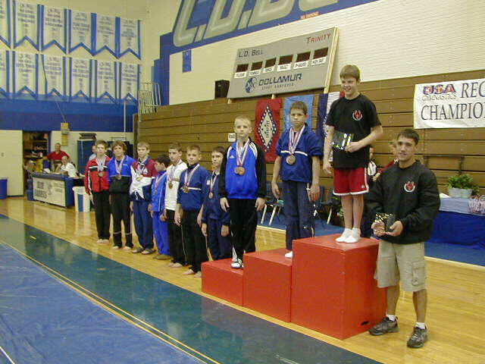 | Meet Results  Class 4 - 12+  All Sessions Combined
Region 3 Championships
L.D.Bell High School
Place | Num | Name  Gym | Floor | Pommel | Rings | Vault | P Bars | H Bar | AA
1 | 443 | Igor Kolesnichenko  Jennings Gym | 7.900  19T | 7.600  5T | 8.750  2 | 7.800  17T | 8.350  1T | 8.250  1T | 48.650  1
2 | 470 | Trent Bennett  Cypress Academy | 8.500  2 | 7.550  7 | 8.600  3 | 7.800  17T | 8.000  4T | 8.050  5 | 48.500  2
3 | 429 | Landry Watson  Capital Gymnastics | 8.400  3T | 7.900  2T | 8.300  4T | 7.800  17T | 8.150  3 | 7.650  9 | 48.200  3
4 | 472 | Michael Newburger  Crenshaw Athletic | 8.300  5T | 8.000  1 | 8.100  10T | 7.900  11T | 7.500  13T | 8.250  1T | 48.050  4
5 | 471 | Cory Barcus  Cypress Academy | 8.300  5T | 6.400  26 | 8.300  4T | 8.000  4T | 8.350  1T | 8.100  4 | 47.450  5
6 | 403 | Brian Trammell  Gulf Gymnastics | 8.000  13T | 7.900  2T | 8.200  7T | 7.400  29T | 8.000  4T | 7.850  7 | 47.350  6
7 | 492 | Bradley Dyess  Northshore Gym | 7.900  19T | 7.750  4 | 9.000  1 | 7.550  28 | 7.450  15 | 7.450  11T | 47.100  7
8 | 482 | Matthew Johnson  Alamo Gymnastics | 8.600  1 | 7.100  12 | 8.000  13T | 8.000  4T | 8.000  4T | 7.000  21 | 46.700  8
9 | 475 | Ben Monk  ASI Dallas | 8.200  8T | 6.700  21T | 8.300  4T | 8.300  1 | 7.600  12 | 7.400  13T | 46.500  9
10 | 431 | Phillip Hardaway  Achievers | 8.200  8T | 7.200  10T | 8.100  10T | 7.900  11T | 7.100  20T | 7.900  6 | 46.400  10
11 | 489 | Andy House  Gymnast Factory | 8.200  8T | 6.700  21T | 8.200  7T | 7.850  15T | 7.850  7 | 7.400  13T | 46.200  11
12 | 458 | Abram Holt  Tumbleweed | 8.200  8T | 7.000  13T | 7.800  17T | 7.750  20T | 7.000  23 | 8.150  3 | 45.900  12
13 | 469 | Hudson Rains  Cypress Academy | 8.000  13T | 7.600  5T | 7.700  19T | 7.750  20T | 7.100  20T | 7.700  8 | 45.850  13
14 | 444 | Ryan Noe  Eagle Wings | 8.000  13T | 6.700  21T | 7.600  22T | 8.050  2T | 7.800  8T | 7.100  18T | 45.250  14
15 | 434 | Bruce Lott  Crenshaw Athletic | 7.900  19T | 7.500  8 | 7.800  17T | 7.900  11T | 7.400  16T | 6.600  22T | 45.100  15
16 | 418 | David Finning  Kraft | 8.400  3T | 6.100  28 | 7.200  28 | 7.950  9T | 7.800  8T | 7.600  10 | 45.050  16
17 | 423 | Hunter Atchison  Crenshaw Athletic | 8.300  5T | 6.900  15T | 7.900  15T | 8.000  4T | 6.400  27 | 7.450  11T | 44.950  17
18 | 484 | Sean O'Mahoney  Northshore Gym | 7.200  28T | 7.300  9 | 8.100  10T | 7.900  11T | 6.950  24 | 7.250  17 | 44.700  18
19 | 490 | David Hart  Gymnastics Etc | 8.000  13T | 7.200  10T | 7.900  15T | 7.700  24T | 7.700  11 | 6.100  29 | 44.600  19
20 | 419 | Wesley Hejl  Crenshaw Athletic | 8.000  13T | 6.500  25 | 7.600  22T | 7.750  20T | 7.300  18T | 7.400  13T | 44.550  20
21 | 483 | Benson Coleman  ASI Dallas | 7.600  24T | 6.300  27 | 8.200  7T | 7.600  27 | 7.500  13T | 6.600  22T | 43.800  21
22 | 485 | Hank Ulmer  Kraft | 8.100  12 | 6.000  29 | 7.500  24T | 8.050  2T | 7.400  16T | 6.500  24T | 43.550  22
23 | 436 | Jesse Bourgeois  Jennings Gym | 7.800  23 | 6.900  15T | 7.700  19T | 8.000  4T | 6.600  25 | 6.500  24T | 43.500  23
24 | 473 | Morgan Williamson  Crenshaw Athletic | 8.000  13T | 6.600  24 | 7.300  27 | 7.950  9T | 6.500  26 | 7.100  18T | 43.450  24T
24 | 442 | David Pitcher  Eagle Wings | 7.500  26 | 5.800  30 | 7.700  19T | 7.850  15T | 7.300  18T | 7.300  16 | 43.450  24T
26 | 450 | Michael Killeen  McCracken's | 7.600  24T | 6.900  15T | 8.000  13T | 7.400  29T | 5.850  29 | 7.100  18T | 42.850  26
27 | 486 | Stephen Contreras  International Gymna | 6.400  30 | 6.800  19T | 7.400  26 | 7.700  24T | 7.800  8T | 6.400  26T | 42.500  27
28 | 447 | Matias Rodriguez  Emerald City | 7.900  19T | 6.900  15T | 7.000  29 | 8.000  4T | 7.100  20T | 4.700  30 | 41.600  28
29 | 459 | Travis King  Texas Elite | 7.200  28T | 7.000  13T | 7.500  24T | 7.750  20T | 5.400  30 | 6.400  26T | 41.250  29
30 | 448 | Conner Green  Gymnastics Plus | 7.300  27 | 6.800  19T | 6.200  30 | 7.700  24T | 5.900  28 | 6.200  28 | 40.100  30
This web page was generated by ProScore 4 ™

