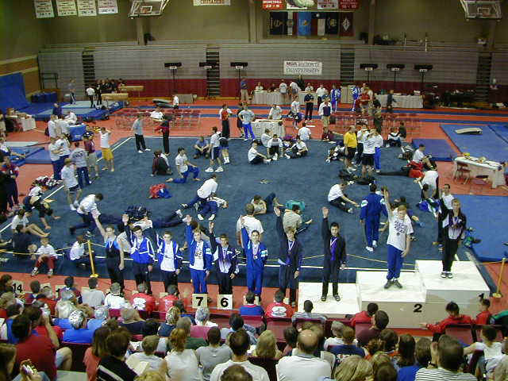 | Meet Results  2001 Region III Championships  Alamo Gymnastics Center  Class 4 - 14+  Session 3

Place | Num | Name  Gym | Floor | Pommel | Rings | Vault | P Bars | H Bar | AA
1 | 806 | Light Townsend  Central TX Gymn. | 8.700  1 | 7.050  6T | 8.100  4T | 7.400  18T | 8.250  1 | 8.500  1 | 48.000  1
2 | 811 | Kevin Murphy  Flips | 8.400  3T | 7.200  5 | 7.900  6T | 7.700  3T | 8.050  4 | 7.750  9 | 47.000  2
3 | 814 | David Legler  GAGE | 8.150  7T | 7.550  2 | 7.450  16 | 7.650  6T | 8.100  2T | 8.000  6T | 46.900  3
4 | 812 | Billy Hay  GAGE | 8.350  5 | 7.750  1 | 7.850  8T | 6.600  29 | 8.100  2T | 8.200  3 | 46.850  4
5 | 829 | Jason Garcia  Titans | 8.000  11T | 6.800  11 | 8.250  2 | 8.000  1 | 7.150  16T | 7.800  8 | 46.000  5
6 | 805 | Clay Gregory  Central TX Gymn. | 7.900  13T | 6.650  14T | 7.850  8T | 7.250  26 | 7.500  9 | 8.100  4T | 45.250  6
7 | 830 | Aaron Viles  Titans | 8.050  10 | 6.650  14T | 7.300  21T | 7.600  9T | 7.000  20T | 8.450  2 | 45.050  7
8 | 816 | Josh Loeser  Gulf Gymn. | 8.100  9 | 6.900  10 | 8.150  3 | 7.550  12T | 7.250  12T | 6.850  18T | 44.800  8
9 | 817 | Chris Freed  Gulf Gymn. | 8.200  6 | 6.650  14T | 7.900  6T | 7.700  3T | 7.550  8 | 6.700  22 | 44.700  9
10 | 821 | Justin Bair  Internl Gymn Academy | 7.750  16T | 7.250  4 | 7.400  17T | 7.350  22T | 6.400  24 | 8.100  4T | 44.250  10
11 | 804 | Ryan Weber  Capital | 7.900  13T | 7.350  3 | 7.500  14T | 6.500  30 | 7.600  7 | 7.350  13 | 44.200  11
12 | 809 | Paul Rebottaro  Emerald City | 7.500  20 | 7.050  6T | 7.400  17T | 7.450  17 | 7.450  10 | 6.850  18T | 43.700  12
13 | 807 | Quentin O'Bryan  Dolphin | 8.400  3T | 7.050  6T | 7.850  8T | 7.950  2 | 5.450  27 | 6.950  16T | 43.650  13
14 | 818 | Travis Sexton  Gymnastics, Etc. | 7.700  19 | 6.700  12T | 7.500  14T | 7.600  9T | 7.650  6 | 6.300  23 | 43.450  14
15 | 815 | Josiah Loeser  Gulf Gymn. | 8.450  2 | 6.400  20 | 8.100  4T | 6.700  28 | 6.100  26 | 7.650  10 | 43.400  15
16 | 826 | Chris Kurkjian  MEGA | 8.000  11T | 5.850  23 | 7.350  19T | 7.650  6T | 7.200  14T | 7.200  14T | 43.250  16
17 | 813 | Kyle Morse  GAGE | 7.850  15 | 6.950  9 | 7.300  21T | 7.500  16 | 7.150  16T | 6.200  26 | 42.950  17
18 | 802 | Aaron Cohen  Achievers | 7.200  23T | 6.500  19 | 6.750  27 | 7.550  12T | 6.850  23 | 8.000  6T | 42.850  18
19 | 803 | A.J. Hampton  Achievers | 8.150  7T | 6.150  21 | 5.800  30 | 7.700  3T | 7.200  14T | 7.600  11T | 42.600  19
20 | 822 | Chris Nickels  Jennings | 6.550  28 | 6.650  14T | 7.350  19T | 7.350  22T | 7.400  11 | 6.950  16T | 42.250  20
21 | 819 | Dusty Karlin  Heartland | 7.350  22 | 6.600  18 | 6.250  29 | 7.550  12T | 7.250  12T | 7.200  14T | 42.200  21
22 | 824 | Matthew Arnold  Lobo | 7.200  23T | 6.050  22 | 7.300  21T | 7.400  18T | 7.750  5 | 6.250  24T | 41.950  22
23 | 808 | Joey Cusachs  East Jefferson | 7.750  16T | 5.700  26 | 6.950  25 | 7.600  9T | 7.100  19 | 6.250  24T | 41.350  23
24 | 801 | Blair Coble  Achievers | 6.900  25 | 4.900  29 | 7.300  21T | 7.400  18T | 7.150  16T | 7.600  11T | 41.250  24
25 | 827 | Bubba Huval  TEGA | 7.750  16T | 5.100  27 | 6.800  26 | 7.400  18T | 7.000  20T | 6.800  20 | 40.850  25
26 | 820 | Nick Citro  Internl Gymn Academy | 7.450  21 | 5.750  24T | 7.750  12T | 7.350  22T | 6.300  25 | 5.650  27 | 40.250  26
27 | 825 | Devin DeBacker  MEGA | 6.850  26T | 6.700  12T | 7.750  12T | 7.150  27 | 6.950  22 | 4.350  29 | 39.750  27
28 | 810 | Daniel Beam  Flame | 6.100  29 | 5.050  28 | 7.850  8T | 7.300  25 | 4.600  29 | 6.750  21 | 37.650  28
29 | 828 | James Anderson  Team Olympiad | 6.850  26T | 5.750  24T | 6.350  28 | 7.550  12T | 4.800  28 | 5.550  28 | 36.850  29
30 | 831 | William Hall  Juergens | 0.000  30 | 0.000  30 | 8.650  1 | 7.650  6T | 1.850  30 | 0.000  30 | 18.150  30
This web page was generated by ProScore 4 ™

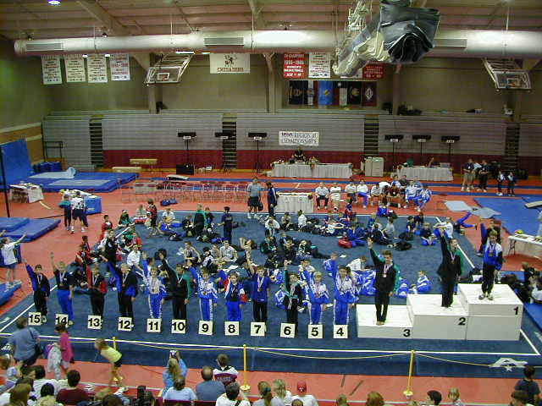 | Meet Results  2001 Region III Championships  Alamo Gymnastics Center  Class 4 - 12-13  Session 1

Place | Num | Name  Gym | Floor | Pommel | Rings | Vault | P Bars | H Bar | AA
1 | 927 | Scott Bregman  Lawrence | 9.000  1 | 6.500  29T | 8.200  1T | 8.000  5T | 8.700  1 | 8.300  2 | 48.700  1
2 | 919 | Kelly Marx  Emerald City | 8.700  3 | 7.400  8T | 7.600  14 | 7.800  11T | 7.900  13T | 8.100  5 | 47.500  2T
2 | 921 | Linus Silvey  Emerald City | 8.050  16 | 7.500  5T | 8.100  3 | 7.750  14T | 8.300  6T | 7.800  10T | 47.500  2T
4 | 941 | Nick Cedillo  World Olympic | 8.000  17T | 7.600  4 | 8.000  4 | 8.300  1 | 8.300  6T | 7.050  22 | 47.250  4
5 | 943 | David Bulkeley  World Olympic | 8.500  5T | 7.100  14T | 7.100  32T | 8.000  5T | 8.400  4T | 7.950  7T | 47.050  5
6 | 902 | Austin Thomas  ASI | 8.000  17T | 7.800  1T | 7.500  16T | 7.550  22T | 8.500  2T | 7.600  13T | 46.950  6
7 | 936 | Andrew Schulz  PowerSports | 8.300  7T | 7.800  1T | 7.900  5T | 7.600  20T | 7.300  25T | 8.000  6 | 46.900  7
8 | 909 | Aaron Fleshner  Basel's | 8.250  9T | 6.800  18T | 7.500  16T | 7.950  8 | 8.500  2T | 7.700  12 | 46.700  8
9 | 940 | Wesley Cox  World Olympic | 8.300  7T | 7.500  5T | 7.500  16T | 7.500  26T | 7.400  20T | 8.200  4 | 46.400  9T
9 | 944 | Barrett O'Neill  Emerald City | 7.800  22T | 6.700  22T | 7.900  5T | 8.050  3T | 8.000  12 | 7.950  7T | 46.400  9T
11 | 942 | Cody Mains  World Olympic | 7.900  19T | 7.300  11T | 7.700  11T | 7.550  22T | 7.500  16T | 8.250  3 | 46.200  11
12 | 912 | Jacob Ives  Cypress | 8.550  4 | 7.200  13 | 7.300  25T | 8.050  3T | 8.100  8T | 6.000  36 | 45.200  12T
12 | 918 | PJ Archer  East Jefferson | 8.100  13T | 6.800  18T | 7.800  9T | 7.650  17T | 7.400  20T | 7.450  15 | 45.200  12T
14 | 934 | Jeremy Smith  North Shore | 8.200  12 | 6.800  18T | 7.900  5T | 7.050  41 | 8.100  8T | 7.100  21 | 45.150  14
15 | 914 | Chad Silverman  Cypress | 8.100  13* | 5.600  38T | 7.500  16T | 7.450  28T | 7.800  15 | 8.400  1 | 44.850  15T
15 | 929 | Brian Smith  Lone Star | 8.100  13* | 7.500  5T | 7.300  25T | 7.800  11T | 6.800  35T | 7.350  18T | 44.850  15T
17 | 901 | Clay Burch  ASI | 7.500  28T | 6.900  17 | 7.400  22T | 7.300  35 | 7.900  13T | 6.900  23T | 43.900  17
18 | 925 | Justin Corpuz  HGA/GymMasters | 8.250  9T | 7.300  11T | 7.550  15 | 7.450  28T | 6.700  38T | 6.600  28 | 43.850  18
19 | 911 | Collin Dalton  Cypress | 8.250  9T | 7.400  8T | 7.300  25T | 7.650  17T | 8.100  8T | 5.100  42 | 43.800  19
20 | 922 | Brandon Pence  GAGE | 7.400  30T | 6.500  29T | 7.700  11T | 7.750  14T | 7.000  31T | 7.400  16T | 43.750  20
21 | 939 | Scott Hayes  Team Central, MO | 8.500  5T | 6.000  35 | 7.400  22T | 7.450  28T | 7.500  16T | 6.850  25 | 43.700  21
22 | 924 | Andy Austin  Gymnastics, Etc. | 7.800  22T | 6.700  22T | 7.500  16T | 7.100  39T | 8.100  8T | 6.200  31T | 43.400  22
23 | 931 | Sam Hellerman  MEGA | 7.100  35 | 7.100  14T | 7.300  25T | 7.450  28T | 6.800  35T | 7.600  13T | 43.350  23
24 | 932 | Travis Deshotel  MEGA | 7.300  33T | 6.300  32T | 6.400  42 | 8.150  2 | 7.200  28 | 7.850  9 | 43.200  24
25 | 935 | Steven Berggren  North Shore | 6.800  36T | 7.800  1T | 7.100  32T | 7.350  34 | 7.500  16T | 6.500  29 | 43.050  25
26 | 913 | Jared Astle  Cypress | 6.800  36T | 6.300  32T | 8.200  1T | 7.850  10 | 6.500  40T | 7.350  18T | 43.000  26
27 | 945 | Derek West  American | 7.900  19T | 6.600  26T | 7.300  25T | 7.550  22T | 7.300  25T | 6.100  35 | 42.750  27
28 | 933 | Chester Smithart  MEGA | 6.600  40 | 7.400  8T | 7.100  32T | 7.750  14T | 7.500  16T | 6.300  30 | 42.650  28
29 | 905 | Stefan Wallof  Aerial Works | 6.700  39 | 6.700  22T | 6.900  37 | 7.600  20T | 8.400  4T | 6.200  31T | 42.500  29T
29 | 903 | Tyler Morris  ASI | 7.400  30T | 5.600  38T | 7.900  5T | 7.150  38 | 7.300  25T | 7.150  20 | 42.500  29T
31 | 930 | Scott VanArsdale  MEGA | 7.300  33T | 6.600  26T | 7.200  30T | 7.250  36 | 6.700  38T | 7.400  16T | 42.450  31
32 | 904 | Grant Gunstream  Acrosports | 7.900  19T | 6.600  26T | 6.500  40T | 7.800  11T | 7.400  20T | 6.150  34 | 42.350  32
33 | 917 | Jeremy Cavalier  East Jefferson | 7.800  22T | 6.500  29T | 7.800  9T | 7.500  26T | 6.800  35T | 5.600  40 | 42.000  33
34 | 907 | Christopher Muniz  Alamo | 7.700  25T | 7.100  14T | 7.700  11T | 6.700  42 | 6.500  40T | 6.200  31T | 41.900  34
35 | 906 | Steven McCarthy  Alamo | 7.500  28T | 4.700  42 | 7.400  22T | 7.200  37 | 7.100  29T | 7.800  10T | 41.700  35
36 | 938 | Tim Cline  Team Central, MO | 8.800  2 | 5.200  41 | 7.000  35T | 8.000  5T | 6.900  33T | 5.550  41 | 41.450  36
37 | 920 | Marc Walton  Emerald City | 7.400  30T | 5.300  40 | 7.500  16T | 7.450  28T | 6.900  33T | 6.800  26 | 41.350  37
38 | 928 | C.J. Grimes  Littlestar, KS | 6.800  36T | 6.700  22T | 6.800  38T | 7.550  22T | 6.500  40T | 6.900  23T | 41.250  38
39 | 908 | Karl Slater  Alamo | 7.700  25T | 5.800  36 | 7.200  30T | 7.450  28T | 7.000  31T | 5.850  37 | 41.000  39T
39 | 910 | Garrison Kriegel  Capital | 7.600  27 | 5.700  37 | 6.500  40T | 7.100  39T | 7.400  20T | 6.700  27 | 41.000  39T
41 | 926 | James Mastroni  Heartland | 6.300  41 | 6.800  18T | 7.000  35T | 7.650  17T | 7.100  29T | 5.800  38 | 40.650  41
42 | 923 | Nick Franklin  Gymnast Factory | 6.000  42 | 6.100  34 | 6.800  38T | 7.900  9 | 7.400  20T | 5.700  39 | 39.900  42
This web page was generated by ProScore 4 ™

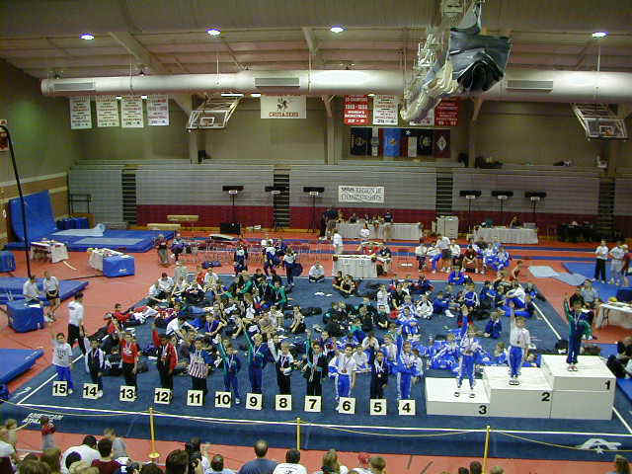 | Meet Results  2001 Region III Championships  Alamo Gymnastics Center  Class 4 - 10-11  Session 1  Region III Junior Development Team is highlighted in Blue.

Place | Num | Name  Gym | Floor | Pommel | Rings | Vault | P Bars | H Bar | AA
1 | 115 | Jacob Houder  Flips | 9.050  1 | 8.200  3 | 8.300  13T | 7.700  17T | 8.750  1 | 8.000  4T | 50.000  1
2 | 158 | Cory Baumgarten  World Olympic | 8.400  25T | 8.450  2 | 8.400  12 | 8.050  1T | 8.450  3 | 8.100  3 | 49.850  2
3 | 161 | Derek Meadows  World Olympic | 9.000  2T | 7.400  18T | 8.900  1 | 8.050  1T | 7.400  31T | 8.800  1 | 49.550  3
4 | 156 | Mason Morrison  World Olympic | 8.100  37T | 8.500  1 | 8.200  16T | 7.850  9T | 8.300  7 | 8.200  2 | 49.150  4
5 | 129 | Matthew D'Herbes  HGC | 8.950  4T | 7.700  9T | 8.700  2T | 7.950  5T | 8.350  6 | 7.300  22 | 48.950  5
6 | 160 | Phillip Onorato  World Olympic | 8.900  6T | 7.400  18T | 8.700  2T | 8.000  3T | 8.100  10T | 7.800  10T | 48.900  6
7 | 165 | R.J. Mullaney  Bart Conner | 8.650  16 | 7.400  18T | 8.500  7T | 7.650  20T | 8.100  10T | 7.700  12T | 48.000  8
8 | 116 | Michael Waldon  Flips | 8.700  13T | 7.800  7T | 8.500  7T | 7.900  7T | 8.000  14T | 6.900  31T | 47.800  9
9 | 101 | Jacob Medina  ASI | 8.700  13T | 6.900  36T | 7.800  32T | 7.800  12T | 8.55  2 | 7.900  6T | 47.650  7
10 | 114 | Alex Watson  Flips | 8.550  22T | 7.600  13T | 8.550  6 | 7.500  30T | 8.400  4T | 7.000  29T | 47.600  10
11 | 132 | Marcus Gonzalez  Juergens | 9.000  2T | 6.900  36T | 8.450  11 | 7.750  14T | 8.250  8 | 7.200  23T | 47.550  11
12 | 123 | Timothy Pittman  HGA/GymMasters | 8.800  10T | 7.200  24T | 8.700  2T | 7.900  7T | 8.400  4T | 6.100  46T | 47.100  12
13 | 126 | Keith Eschler  HGA/GymMasters | 8.800  10T | 7.600  13T | 7.200  56T | 7.850  9T | 7.700  25T | 7.600  17 | 46.750  13
14 | 128 | Zachary Lebovitz  HGC | 8.600  17T | 6.800  42T | 8.600  5 | 7.400  39T | 7.700  25T | 7.400  20T | 46.500  14T
14 | 139 | Thomas Meeks  Olympia | 8.300  29T | 6.900  36T | 8.300  13T | 7.700  17T | 7.600  27T | 7.700  12T | 46.500  14T
16 | 127 | Andres Guerra  HGA/GymMasters | 8.700  13T | 7.300  23 | 7.800  32T | 7.750  14T | 8.200  9 | 6.700  36T | 46.450  16T
16 | 155 | Corey Dennis  World Olympic | 8.000  41T | 7.400  18T | 7.500  43T | 7.950  5T | 7.600  27T | 8.000  4T | 46.450  16T
18 | 162 | Luke Lofman  World Olympic | 8.200  32T | 7.100  30T | 7.800  32T | 7.350  44T | 8.050  13 | 7.900  6T | 46.400  18
19 | 131 | Adam Particka  Juergens | 8.600  17T | 6.500  49T | 8.000  22T | 7.600  23T | 7.900  17T | 7.700  12T | 46.300  19
20 | 133 | Eli Richardson  Juergens | 8.300  29T | 7.200  24T | 8.500  7T | 7.450  32T | 7.000  38T | 7.700  12T | 46.150  20
21 | 105 | John Haines  CG's | 8.750  12 | 6.500  49T | 8.200  16T | 8.000  3T | 7.400  31T | 7.200  23T | 46.050  21
22 | 145 | Alex Lemp  St. Louis, MO | 7.900  48T | 7.700  9T | 8.200  16T | 7.450  32T | 8.100  10T | 6.500  39T | 45.850  22
23 | 163 | Mark Murdock  World Olympic | 7.900  48T | 7.500  15T | 8.000  22T | 7.250  50T | 7.300  34 | 7.800  10T | 45.750  23
24 | 109 | Christopher Hillin  Capital | 8.600  17T | 7.100  30* | 8.000  22T | 7.450  32* | 8.000  14* | 6.500  39T | 45.650  24T
24 | 141 | Brice Wilkinson  Olympia | 8.200  32T | 7.000  33T | 7.700  40T | 7.450  32* | 7.400  31T | 7.900  6T | 45.650  24T
24 | 102 | Ian Osborne  ASI | 8.100  37T | 7.100  30* | 7.900  27T | 7.350  44T | 8.000  14* | 7.200  23T | 45.650  24T
27 | 111 | Jake Rady  Crenshaw | 8.850  8T | 7.200  24T | 8.100  19T | 7.750  14T | 6.800  46T | 6.900  31T | 45.600  27
28 | 108 | Matthew Duane  Capital | 8.100  37T | 7.700  9T | 7.900  27T | 7.100  55T | 7.850  21T | 6.900  31T | 45.550  28T
28 | 148 | Billy Whitford  Team Central, MO | 7.700  57T | 7.900  4T | 7.400  49T | 7.550  25T | 7.600  27T | 7.400  20T | 45.550  28T
30 | 151 | Mike Castelli  Team Central, MO | 8.400  25T | 7.200  24T | 7.500  43T | 7.350  44T | 7.900  17T | 6.700  36T | 45.050  30
31 | 118 | John Humpton  Folger's | 8.000  41T | 7.500  15T | 7.100  58T | 7.250  50T | 7.900  17T | 7.100  27T | 44.850  31
32 | 125 | Francisco Guerra  HGA/GymMasters | 8.950  4T | 7.200  24T | 8.100  19T | 7.850  9T | 7.000  38T | 5.700  52T | 44.800  32
33 | 153 | Kyle Fox  Team Central, MO | 7.800  54T | 7.500  15T | 7.800  32T | 7.400  39T | 7.850  21T | 6.400  42 | 44.750  33
34 | 119 | Travis Higginbotham  GAGE | 8.000  41T | 6.300  54T | 7.800  32T | 7.800  12T | 7.900  17T | 6.900  31T | 44.700  34
35 | 164 | Elliott Hardy  World Olympic | 7.700  57T | 7.900  4T | 7.900  27T | 7.550  25T | 5.900  59 | 7.700  12T | 44.650  35
36 | 146 | Jimmy Lowe  St. Louis, MO | 7.900  48T | 7.900  4T | 8.100  19T | 7.450  32T | 6.900  43T | 6.300  43 | 44.550  36
37 | 157 | Patrick Harper  World Olympic | 8.000  41T | 7.400  18T | 7.300  53T | 7.450  32T | 7.800  23T | 6.500  39T | 44.450  37
38 | 120 | Brian Trammell  Gulf Gymn. | 8.000  41T | 7.000  33T | 7.200  56T | 6.900  62 | 7.200  35T | 7.900  6T | 44.200  38
39 | 134 | Ryan Feaster  Lone Star | 8.500  24 | 6.900  36T | 7.900  27* | 7.100  55T | 6.900  43T | 6.700  36T | 44.000  39T
39 | 147 | Nick Armstrong  Team Central, MO | 7.500  62 | 7.700  9T | 7.900  27* | 7.200  52T | 7.500  30 | 6.200  44T | 44.000  39T
41 | 152 | Justin Firth  Team Central, MO | 8.200  32T | 7.800  7T | 7.800  32T | 7.550  25T | 6.750  48 | 5.700  52T | 43.800  41
42 | 136 | Brendan Pechon  North Shore | 8.300  29T | 6.700  45 | 6.700  62T | 7.350  44T | 7.100  37 | 7.500  18T | 43.650  42
43 | 106 | Joshua Bonadona  CG's | 8.850  8T | 6.100  58T | 7.300  53T | 7.300  49 | 6.600  51T | 7.000  29T | 43.150  43
44 | 104 | Chris Cutlip  Allen Gymnastics | 8.350  27T | 6.600  46T | 8.000  22T | 7.600  23T | 7.000  38T | 5.500  54T | 43.050  44
45 | 143 | Andrew Ayars  Richardson | 8.900  6T | 6.100  58T | 8.000  22T | 7.650  20* | 6.700  49T | 5.400  56* | 42.750  45T
45 | 137 | Nicholas Sanchez  North Shore | 8.600  17T | 6.800  42T | 7.500  43T | 7.650  20* | 6.800  46T | 5.400  56* | 42.750  45T
47 | 140 | Wyatt Richmond  Olympia | 7.800  54T | 6.500  49T | 8.300  13T | 7.700  17T | 6.400  55 | 6.000  49 | 42.700  47
48 | 138 | Blake Rolston  North Shore | 8.350  27T | 6.300  54T | 7.800  32T | 7.450  32T | 6.300  56 | 6.200  44T | 42.400  48
49 | 110 | Danny Harrell  Crenshaw | 8.600  17T | 6.800  42T | 7.700  40T | 7.100  55T | 6.600  51T | 5.500  54T | 42.300  49
50 | 124 | Michael Spigener  HGA/GymMasters | 7.700  57T | 6.900  36T | 7.800  32T | 7.550  25T | 7.200  35T | 5.100  59T | 42.250  50
51 | 103 | Ricky Greer  Achievers | 7.900  48T | 4.700  64 | 7.000  60 | 7.150  54 | 7.800  23T | 7.500  18T | 42.050  51
52 | 159 | Alex Munoz  World Olympic | 8.000  41T | 6.200  57 | 7.500  43T | 7.400  39T | 5.500  61 | 7.100  27T | 41.700  52
53 | 149 | Dustin Smith  Team Central, MO | 7.700  57T | 5.900  60 | 7.400  49T | 7.050  58T | 6.700  49T | 6.900  31T | 41.650  53
54 | 142 | Brian Phillips  Richardson | 8.100  37T | 6.600  46T | 7.400  49T | 7.550  25T | 6.000  58 | 5.300  58 | 40.950  54
55 | 135 | Seth Beckman  Meyer's, MO | 7.800  54T | 5.700  61 | 7.500  43T | 7.050  58T | 7.000  38T | 5.800  50T | 40.850  55
56 | 130 | Dante Jones  Jefferson City Y | 8.200  32T | 7.000  33T | 7.100  58T | 7.500  30T | 5.800  60 | 5.100  59T | 40.700  56T
56 | 107 | Nick Pratt  Capital | 8.000  41T | 6.400  53 | 7.400  49T | 7.400  39T | 6.600  51T | 4.900  62 | 40.700  56T
58 | 121 | Jason Hollis  Gulf Gymn. | 7.900  48T | 5.500  62 | 6.800  61 | 7.400  39T | 6.900  43T | 6.100  46T | 40.600  58
59 | 122 | Charles Butler  Gulf Gymn. | 7.900  48T | 5.300  63 | 7.500  43T | 7.000  61 | 5.400  62 | 6.100  46T | 39.200  59
60 | 112 | Brett Thiele  East Jefferson | 7.600  61 | 6.900  36T | 6.300  64 | 7.050  58T | 5.100  63 | 5.800  50T | 38.750  60
61 | 144 | Richard Lowe  St. Louis, MO | 8.200  32T | 7.200  24T | 8.500  7T | 7.200  52T | 6.200  57 | 0.000  64 | 37.300  61
62 | 150 | Brett Willard  Team Central, MO | 4.300  63 | 6.300  54T | 6.700  62T | 7.350  44T | 7.000  38T | 4.300  63 | 35.950  62
63 | 117 | Michael Staab  Folger's | 8.550  22T | 6.600  46T | 7.300  53T | 4.500  64 | 3.500  64 | 5.100  59T | 35.550  63
64 | 154 | Nick Czapinski  Team Central, MO | 0.000  64 | 6.500  49T | 7.600  42 | 6.800  63 | 6.600  51T | 7.200  23T | 34.700  64
This web page was generated by ProScore 4 ™

