CBSA Hoyas AAU Basketball
Sponsorship Letter & Application

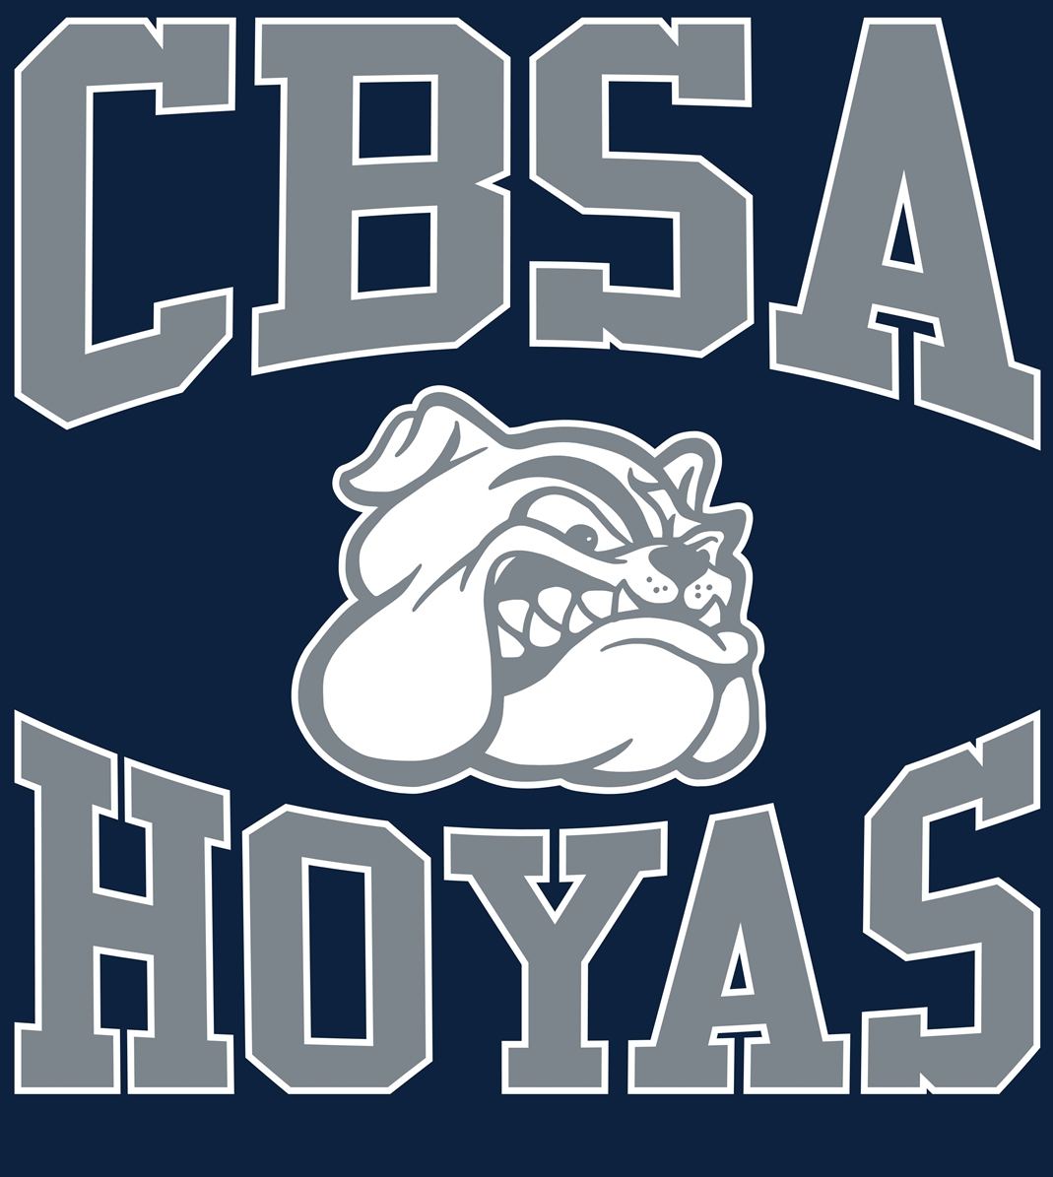

“By contributing today, you will help us build for tomorrow”
College Bound Student Athletes appreciates your support this season and seasons to come.

Dear Hopeful Sponsor,
College Bound Student Athletes (CBSA) sets out to benefit youth through the sport of basketball. We would appreciate your help for this upcoming year’s campaign. Our AAU season will be scheduled to begin in January of 2017, our fundraising efforts begin now. Our goal is to raise money so that travel accommodations, tournament fees, practice time as well as equipment and uniform expenses can be subsidized by various donations. This will enable our teams to participate, compete and gain prominent exposure in the Amateur Athletic Union. Our coaches, volunteers and members, are committed to seeing that our children are trained in an environment that emphasizes educational and athletic excellence, physical and mental discipline, self-esteem, leadership and sportsmanship.

Our Goals:

*Encourage the pursuit of achieving both individual and team goals.
*Promote sportsmanship and conflict resolution.
*Show respect for individuals, including teammates and competitors alike.
*Develop core individual and collective fundamentals.
*Provide a fun and winning environment for players.
*Learn and teach discipline and respect for all.

Our teams will travel and compete throughout the Mid-Atlantic region. When opportunities present themselves, the teams will play nationally to expand the level of exposure they receive from institutions of higher education and ideally an opportunity to explore the possibility of athletic scholarship offers. In addition to providing the highest quality of coaching and fundamental skill development, our ambition is aimed toward keeping the youth of today in the classroom and steered away from negative influences.
We value the importance of education on and off the court, service and appreciation for the community and our team philosophy will embody these elements of emphasis. Thank you for considering the College Bound Student Athletes' program for sponsorship. If you can help us out in any way it would be greatly appreciated.
Sincerely,
Anthony Bowie
Vice President, CBSA Hoyas
(240) 626-1622

College Bound Student Athletes Sponsorship Form
College Bound Student Athletes
2110 Chestnut Lane
240-626-1622
www.collegeboundstudentathletes.org

“By contributing today, you will help us build for tomorrow”
College Bound Student Athletes appreciates your support this season and seasons to come.

What’s in it for you and your business?
*Show your commitment and continual support of your local area and community.
*Help to bridge the gap between local businesses, the community and its patrons.
*Demonstrate your willingness to invest in today's youth.
*Take advantage of the opportunity to market your company's products and/or services.

Contact Person’s Name: _______________________________________________________
Contact Person’s Address: _____________________________________________________
City: ______________________ State: _____ Zip: __________ Home Phone: ______________
Business Name: ________________________________________________________________
Business Address: ______________________________________________________________
City: ______________________ State: _____ Zip: __________ Home Phone: ______________
Business Phone: __________________ Fax: _________________
What will be your level of sponsorship? ___________
Platinum Sponsorship: $1,000  - Company banner hung at all CBSA Hoyas  Basketball events  - Company logo on T-Shirts and hyperlink placed on CBSA Hoyas website | Silver Sponsorship: $500  - Sponsor team for 1 to 2 tournaments  - Company name placed on CBSA Hoyas Basketball website  Company logo on T-Shirts
Gold Sponsorship: $750  • Company logo on T-Shirts and hyperlink placed on CBSA Hoyas Basketball website  • Sponsor the team for 3 tournaments | Bronze Sponsorship: $300  - Company name placed on CBSA Hoyas  Basketball website  - Sponsor 1 to 2 practices
CBSA Hoyas Player Sponsorship: $100  •Company name placed on CBSA Hoyas Basketball website | In kind sponsorship:  Donation of any amount, Goods and/or Services

Payment Information
Method of Payment:
Check or Money Order Payable CBSA Hoyas enclosed in the amount of: _____________
MasterCard / VISA / American Express / Discover Card number: _________________________________
Exp. Date: _____________ Card Verification Number: _____________ Amount: ___________________

