HOW TO REDEEM SCHOLARSHIPS

- Patron arrives with scholarship email/letter from volunteer resources as verification of receipt of award OR email is received from volunteer resources directly.

From: Kim.Shealy@gwinnettcounty.com <Kim.Shealy@gwinnettcounty.com>
Sent: Monday, September 19, 2016 2:46 PM
To: tdchesney@hotmail.com
Subject: Scholarship
Thank you for your request for Mustang basketball scholarship for Tykell Graham. Your request has been granted in the amount of $39 and expires on 10/2/16. Please register in person for the program and provide this email as verification of the award when registering.

Kim B. Shealy
Volunteer Resources Coordinator
678.277.0900
Fax: 678.277.0917
gwinnettcountyparks & recreation

- Verify the person they are registering is the name on the email/letter and they are registering for the class/camp listed and that the scholarship has not expired.

- Pull up parents name in REC1. The amount of the scholarship will be in BLUE in the upper right hand corner. Register participant in program as you would register anyone by clicking on catalog.

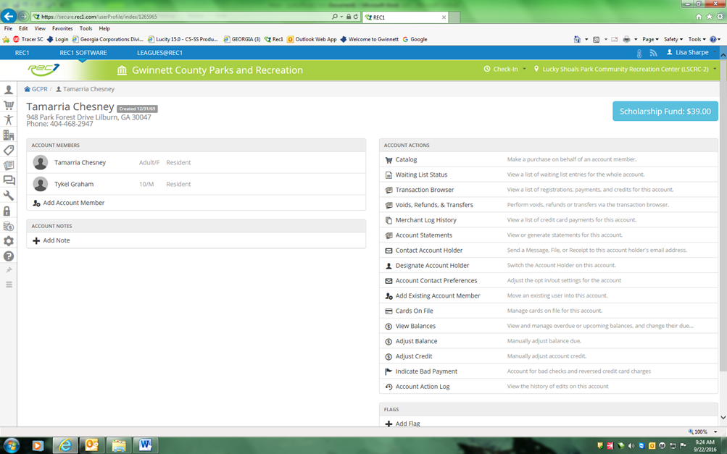

- Enter information in prompts as requested.
- On the payment screen you will see a line for the scholarship fund that was awarded and the total due from the parent.

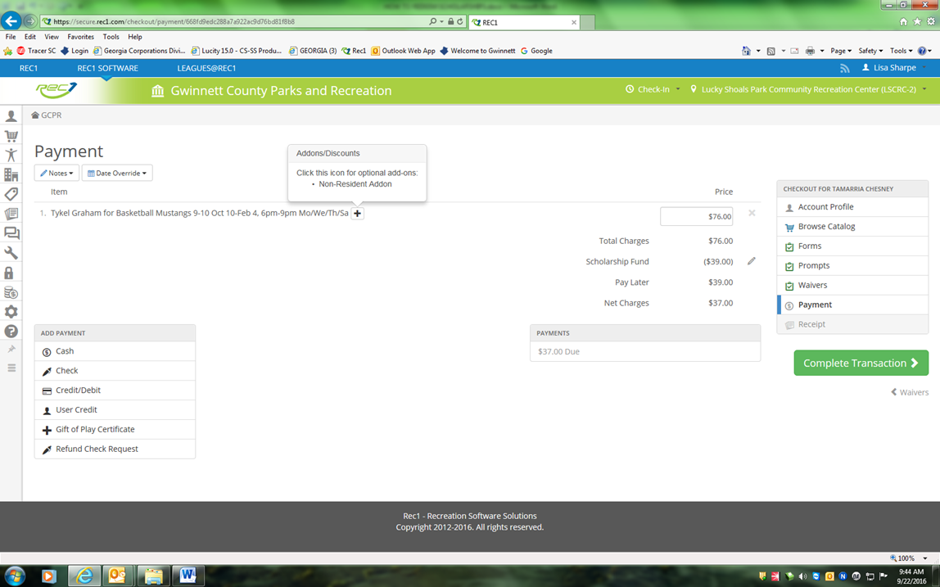

- Finish the payment as you would normally by clicking on the payment from the parent.
- Amount owed is fee minus the scholarship awarded.

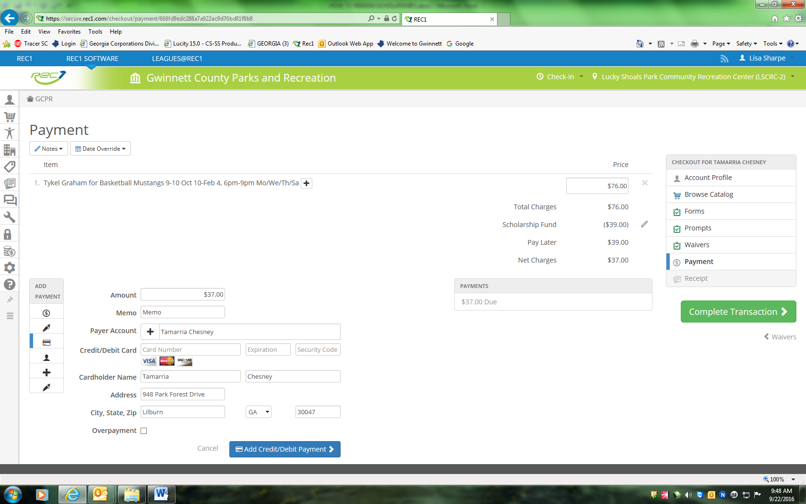
Amount owed

- Collect amount owed and complete transaction.
- Scholarships CAN NOT be used for program deposits/supply fee or any other fee than registration fees.
- Scholarships MUST BE used for the class/camp/activity listed on the email/letter. If classes are cancelled or full, the customer MUST contact Volunteer Resources to alter use of the award.
- MUSTANG funding cannot be used for anything but MUSTANG athletics.
- Camp deposits cannot be paid from scholarship dollars.
- SCHOLARSHIPS ARE NOT REFUNDABLE.
- WHEN IN DOUBT CALL VOLUNTEER RESOURCES at 678-277-0902.

