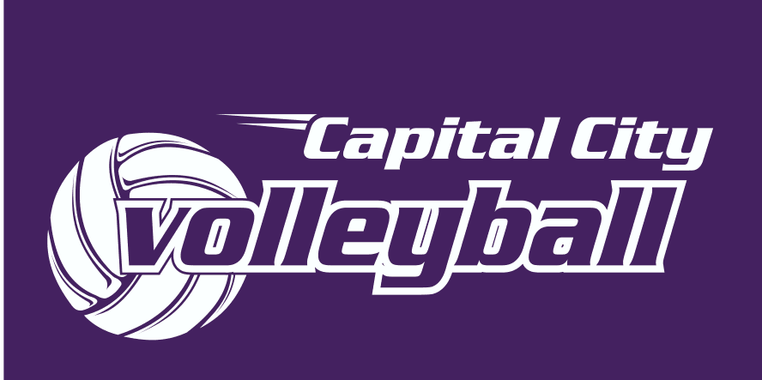
Sponsor Form
Company Name: __________________________________________________________________
Contact Person: ___________________________ Title: ___________________________________
Company Address: _________________________________________________________________
Name of contact person for logo/ ad: ____________________________________________
Title: ______________________ Name of Company: ________________________________
Address: ____________________________________________________________________
Phone Number: ____________________ Fax Number: _______________________________
E-mail: _______________________________________________
Website Address: _______________________________________

Sponsorship Level:
- ____ $1,000 Gold
- ____ $500 Silver _________ Requested Featured Month
- ____ $250 Bronze
______ Number of Team Pages ($25/ page after 1st page) Requested Team Pages_________________________________

Please return this form with payment (checks made payable to Capital City Volleyball Club).
Or credit card AMEX MC VISA (circle one)
Credit Card Number: ________________________________ Expiration Date: __________
Name on Credit Card: __________________________________________ CCV Cod:_____
Advertisement Amount: _______________________________________________________
Signature: _________________________________________________________________

Please return forms to: Jonie Fader, Capital City Volleyball Club, 9 South Hills Rd, Clancy MT, 59634. capitalcityvbclub@gmail.com
Capital City Volleyball Club Sponsorship Levels 2017
In appreciation for their donation, companies sponsoring the 2017 Spring Club season shall receive:
$1,000 – Gold
- Your Full company logo on home page of website
- Your Full company logo, business description, and website link on the bottom of each page of the Capital City Volleyball website
- Your Full company logo, business description, and website link on advertisers/sponsors page of Capital City Volleyball website
- Banner with business name and logo for hosted tournament in March/April (approx 3,000-5,000 parents and athletes)
- Your Website logo to run from January 1, 2017 to December 31, 2017
$500 – Silver
- Your Full company logo, business description, and website link on advertisers/sponsors page of Capital City Volleyball Club website
- Banner with business name for hosted tournament in March/April (approx 3,000-5,000 parents and athletes)
- Your business will be featured on home page for 30 consecutive days (may request specific month but CCVB cannot guarantee the availability for that specific month)
- Your Website logo to run from January 1, 2017 to December 31, 2017
$250 – Bronze
- Your Company name and website link on advertisers/sponsors page of Capital City Volleyball Club website
OR
- Your Name and encouraging phrase posted on specific team page (additional $25 per team page after first page)
- Website logo to run from January 1, 2017 to December 31, 2017

Sponsors must submit all camera-ready artwork / logos.
All advertisers/sponsorships purchased will have a 7 day turn-around time for logo and/or business description to be featured on website.

