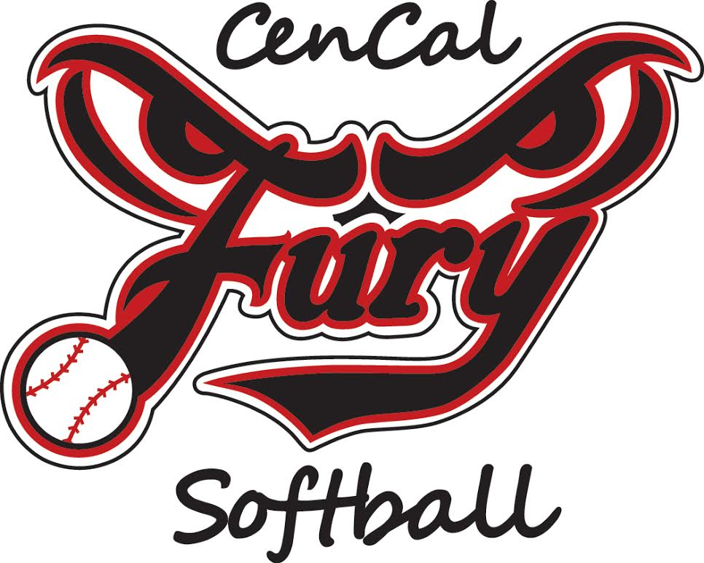
Mission Statement
CenCal Fury Softball Organization

CenCal Fury is a softball organization dedicated to providing female fast pitch softball players the opportunity to grow and become great players as well as great leaders through the game of softball.
First and foremost, we are a softball family. We put family first, education second, and softball third. By that we promote the belief that encourages the player and their family to participate with us in softball and promote family values. Education is the way to the future and we encourage our players to be great students. All students will be encouraged to have a 3.0 GPA but must maintain a 2.5 GPA to participate on the field with us. Our Coaches are some of the finest coaches and teachers in the area. All teams are expected to work hard, play hard, and have a great time playing the fantastic game of softball. Team Building through competition and participating in team activities are an integral part of our organization. The game teaches all players to succeed, deal with failure, and keep fighting to win. Learning, “how to win with humility, and lose with dignity” are also great lessons taught well by our coaches.
Through our great sponsor support we have a new heated and cooled indoor training facility for our teams. This allows us to train our teams and provide the opportunity for one on one coaching with our coaches. The facility has batting cages, a pitching cage, workout area, and team store for the players. There is also a large training area outside for our teams.
Giving back to the community is also very important as it helps our players to be a part of the great community in which we live. We conducted a book drive for Valley Children’s Hospital in which our organization donated over 800 books. We participated in the Susan G. Komen Breast Cancer Awareness “Race for the Cure” fundraiser.
We encourage players and their families to participate in continuing to build our organization. Come and join our Fury Family!

