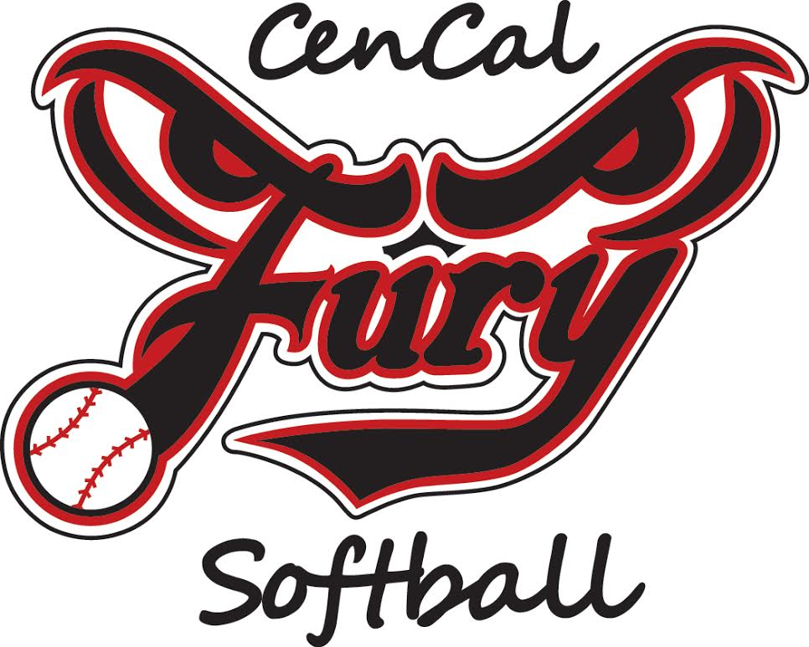
MEMBERSHIP & CODE OF CONDUCT
CenCal Fury Softball Organization League
For Parents, Players and Coaches
Parents, players, coaches and fans represent the CenCal Fury Girls Softball Organization. When our teams play and practice. The actions of one of us affect the image of all of us. As a reminder, we are dealing with “amateur athletic activity, strictly for enjoyment… not a life and death matter.” This Membership/Code of Conduct encourages us to work together to play with good sportsmanship and to treat players, parents, fans, coaches, and umpires with respect. This Code also identifies the possible consequences we will encounter when we do not behave appropriately.
Treat Umpires with Respect
• There are no circumstances in which a coach, parent, fan or player should confront an umpire during or after a game. Coaches must engage umpires in a respectful manner consistent with the rules of the sanctioning body (e.g., National Softball Association, etc.).
•Do not verbally harass an umpire. If you disagree with a call, do so quickly, calmly and let it go. Umpires will make mistakes and it is only a game.
•Coaches will be held responsible for ensuring that parents comply with this portion of the Code of Conduct. A coach who, in the opinion of the Umpire Director or other FURY Board Member, fails to control unruly parents / fans will be subject to suspension.
Treat Your Team with Respect
•Softball is not an individual sport – it is a team sport. Bear this in mind always.
• Ensure that your child/player and all her equipment get to games and practices on time.
• Pick up your child/player promptly at the end of games, practices or other team functions. Do not make the coaches wait for you.
• Disagreements with the coach do not belong on the field before, during or after a game or practice. Questions and comments should be voiced later in an adult atmosphere.
• A coach’s decision about position, strategy, tactics, etc., consistent with this Code of Conduct and the rules set are final.
Treat Our Coaches, Players and Opponents with Respect
•Whether you win or lose, do so with class. When you interact with others, do so with class.
• Encourage each and every player with positive comments.
•Coaches oversee overall team direction and instruction during play and practice. Parental criticism or advice for other players is usually not well received by the player, coach or the player’s parents.
• Never criticize or yell at a player on your team or the opposing team. Consider how you would feel if you were that player’s parent.
• Avoid confrontations or shouting matches with coaches, parents or fans from your team and an opposing team.
• Constant yelling is very irritating to the people around you (even if you think your comments are positive).
• Coaching your child or any other player from the stands is not permitted.
• Standing directly behind home plate on the outside of the fence and commenting to players or umpires is not permitted.
• Alcohol, tobacco, drugs, profanity or fighting are never permitted at softball games or practices.
Conflict and Complaint Resolution Procedure
- If a personality conflict arises between yourself and another Manager, Coach, Player, Parent/Guardian, Board Member, or spectator, follow the procedure below:
• Contact that person directly and attempt to resolve the problem, away from the players.
• Contact the appropriate Director for assistance.
• Submit complaint in writing to a Board member for evaluation, include the following:
- Date & time of offense
- Details of the event
- Names & phone numbers of witnesses

- If someone disregards or breaks the “Zero Tolerance” Policy:
• Submit complaint in writing to the Board for review, include the following:
- Date & time of offense
- Details of event
- Names & phone numbers of witnesses

- Accusation of misbehavior shall be handled in the following manner:
• Allegations will be set forth in writing within 48 hours and given to the Board President.
• President will call a special Board meeting within 5 days to act on the allegation.
• All participants involved and any person with testimony that has a bearing on the case will attend the meeting.
• After the completion of the hearing, the Board will do one of the following: admonish, suspend, expel, establish probationary period, or acquit the accused.
• President has the power to immediately suspend any person with serious enough charge against the person to warrant such action, until after the hearing.
Signature: As a coach or parent of a player in the CenCal Fury Softball Organization, I acknowledge:
•That I have read, understand and will adhere to this Code of Conduct;
•That my continued participation in association activities, including voting in the organization elections, as well as the participation of my children, is contingent upon my ability (and that of my immediate and extended family) to adhere to this Code of Conduct; and
•That I will help my fellow parents and coaches when, in the heat of the moment, they need to be reminded of their commitment to this Code of Conduct. I understand that I am signing this form on behalf of my spouse, relatives or friends that attend any Fury Organization function. I further attest that it is my responsibility to inform these individuals of the Code of Conduct, as they too will be held to the Fury Code of Conduct.

__________________________________ ________________________________________ #1 Signature- Parent / Guardian #1 Print Name – Parent / Guardian __________________________________ ________________________________________ #2 Signature- Parent / Guardian #2 Print Name – Parent / Guardian
________________________________________ Player’s Name/Division

****At least one parent/guardian must have a signed Membership/Code of Conduct on file with the CenCal Fury Organization to be eligible to vote in the elections of board members

