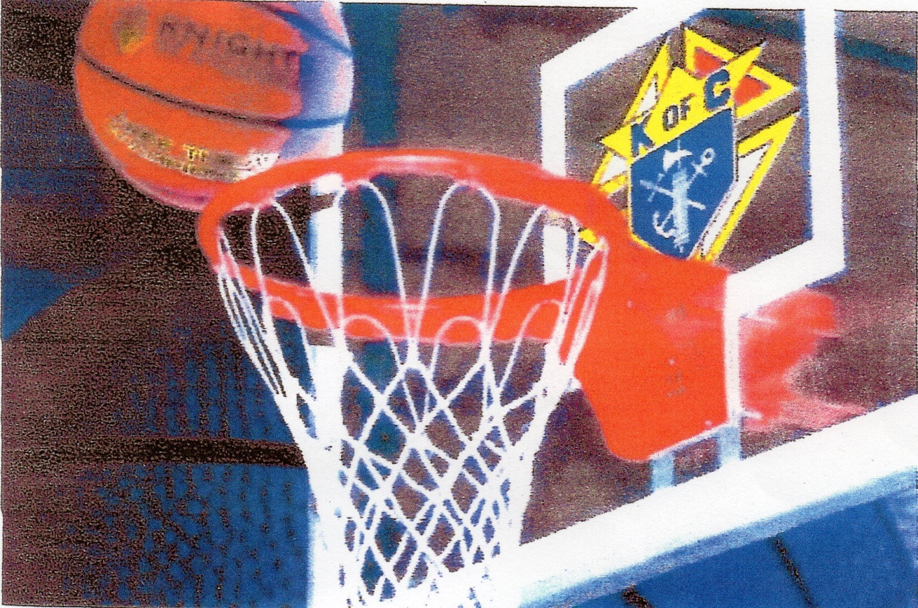

Knights of Columbus Basketball Free Throw Championship

Boys and Girls ages 9 – 14. The competition will be held at (BVM) church gymnasium (Hanlon Center gym) in Colesville, PA on January 29, 2017. This is the weekend between the NFL division championships and the Super Bowl.
Registration begins at 5:30 p.m. in the gym which is located behind St. Michael School at 4121 Old Bethlehem Pike, Bethlehem, PA 18015.
The contest will begin at 6:00 p.m. There will be a boy & girl winner in each of the six age groups. For the winners, the District contest will start after the first session at 7:00 p.m. Participants are required to fill out a registration form and show a copy of their birth certificate for proof of age at the time of competition.
For more information contact Bernie Mikulski at Sacred Heart Knights of Columbus Council 15682 at 610-691-6054.

