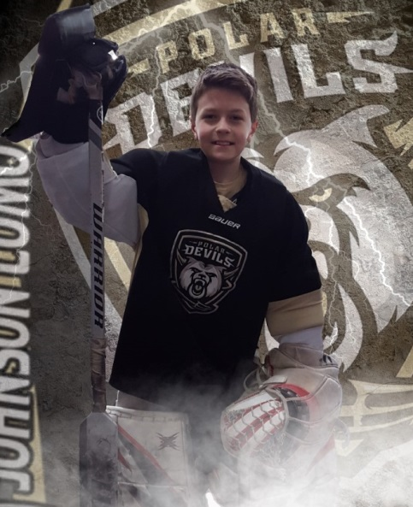
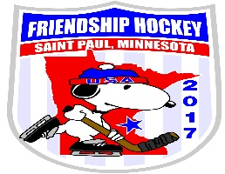
JAHA (JOHNSON AREA HOCKEY ASSOCIATION)

Dear Community Member:

Hello, my name is Dylan Weldon and I play for JCNSP Hockey association. I have been given the great opportunity to play in the International Friendship Tournament being held in March. I will get to play against kids from all over the world. Would you like to sponsor me for this opportunity of a lifetime? A $200.00 sponsorship gets your name on a banner that will hang in our arena’s for 2 years. Please see below for all the information. Thank you.

We would like to introduce you to the 2017 International Peewee Friendship Hockey Tournament committee. There are 10 of us and we have volunteered to host the 2017 Friendship Tournament on behalf of peewee hockey players from St. Paul and North St. Paul. This tournament is totally self-funded with a budget in excess of $70,000.00 including ice time and all expenses. This tournament is an opportunity for us to showcase Minnesota, our culture, our hockey and the Twin Cities. We would like to invite you to join our team and help make this a memorable experience for all the players.

The Peewee International Friendship Tournament was started in 1989 in Hachinohe, Japan and is held every two years alternating venues North and South. This is a tournament that we have participated in and hosted twice since its inception (once in 1991 and then again in 2003). This will be our third opportunity to host this wonderful event and we are excited to have this opportunity. Families welcome players into their homes for the duration of the tournament. The team that wins the hockey tournament is not necessarily the team that wins the most games, penalties have a big impact on total points and help determine the tournament champion. The venue is hockey but the message is friendship, fair play and respect for each other and the countries represented. Besides the hockey games there are many activities that the teams participate in such as skit night where each team does a 5-minute skit about their country, state or community and auction night when items supplied by all countries are auctioned off with the proceeds going to pay for the tournament. Peewee hockey players playing out of St. Paul and North St. Paul will represent Minnesota and the United States in this tournament. Teams from all over the world participate including the United States, Japan, Korea, Australia, Canada, and New Zealand. There will be 11 teams from six countries playing hockey at Phalen Arena in St Paul and getting acquainted with Minnesota.

The tournament will begin with opening ceremonies at Phalen Area beginning March 12, 2017. Closing ceremonies will take place March 21, 2017.

As this tournament is self-funded we need many things to help us reach our fundraising goal. There are only a couple of fundraising events that will have a big impact on meeting our goal and player sponsorships are a big for us. A sponsorship is $200.00 and buys you a place on our sponsorship banner which hangs at the rink until the next Friendship Tournament which is two years. Your business name, family name or group name will be listed on the banner with the name of the player you sponsored. This year we will also include a list of sponsors in the tournament program. This is a great way to put a name out in front of a large audience without a big cost.

The committee and the peewee players and families would appreciate any help that enables us to meet our goal. Every donation is appreciated and gets us closer to the opportunity to host a quality tournament. If you have questions that you need answered to allow you to make a donation a committee member is certainly available to answer them. Please send questions to LPogreba@aol.com or contact a co-director at 651-315-9251. You can make your donation check out to Johnson Area Hockey and either give it to your requester or mail it to the address below. Remember to get a receipt for your donation from your requester.

Thank you so very much for consideration.

Tournament co-directors: Lynn and Greg Pogreba, 902 E Hyacinth, St. Paul, MN 55106

