


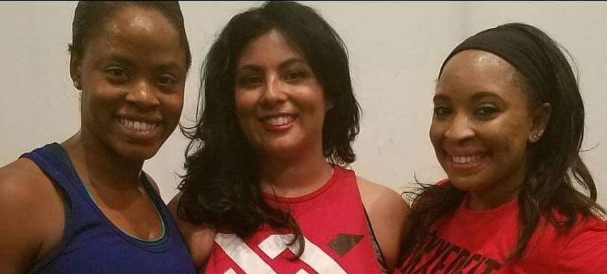

DECEMBER 11TH
2:00-4:00PM
Mission Middle School Gym
(2202 Washington Street – Gym Entrance and parking located on the East side of the building across from the fire station)

$10 donation at the door
Drawings, Fun, Fitness

Support Bellevue Bruins 11U Baseball

Bring a friend and join the fun along with Fitssential instructors, Naviere & Adrienne, and other guest instructors.

