McFarland Boys’ Basketball Team Shoe Ordering Instructions:

- Please visit eastbayteamsales.com
- Click on Team Store at the top of the page.

- Enter the team code: OFMWMFBK

- This should take you directly to our McFarland Team Store where you can purchase your shoes!!

- The shoes are listed below. Youth sizes are available for most, but not all.

Under Armour Curry 2.5 White/Black Under Armour Curry 2.5 Graphite

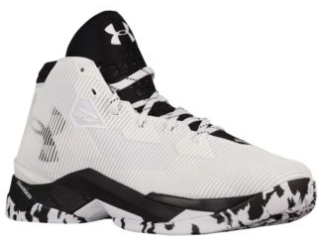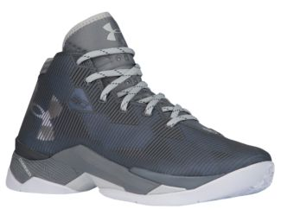

Under Armour Clutchfit 3 Low Black/White
