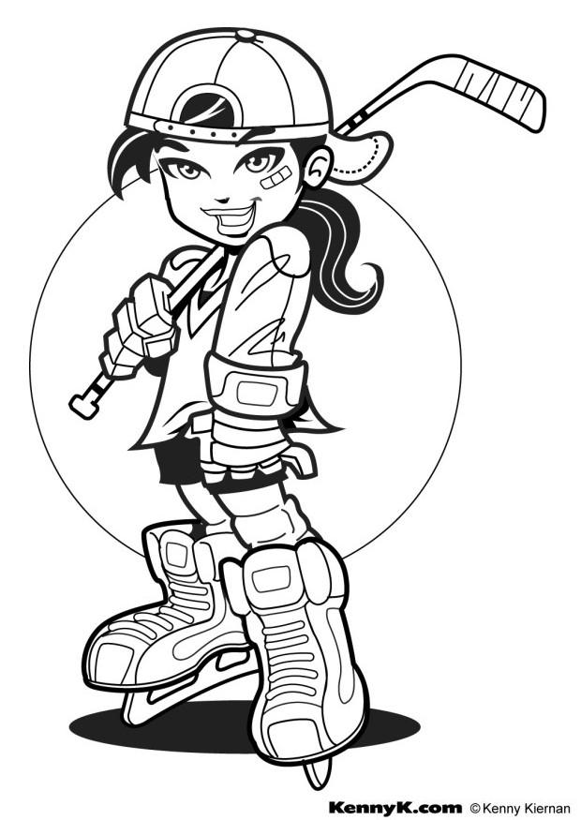
ALLEGHENY HOCKEY ASSOCIATION

BADGER SISTERS
TRY HOCKEY FOR FREE DAY

Calling all little sisters, and big sisters !
Come Try Hockey for Free !
Every player will get a jersey and a stick.

SUNDAY, OCTOBER 9
3:10 PM – 4:20 PM

Email to register: ahascheduling@gmail.com
Name, birthdate, phone, mom/dad’s name

Players must have a helmet of some kind – Skates (rental skates available at no charge) – Borrow stuff from brother – AHA has some equipment available to use – ice or dek hockey shin and elbow pads, gloves, ok – wear warm clothes



