Michigan Amateur Hockey Association
- DISTRICT 4 ROUND 2 TOURNAMENT INFORMATION SHEET -
The following information is required by District 4 prior to approval of a Host Association.
Print or type all entries. Complete all pages of this form and return to the District 4
Chairperson no later than December 01, 2016

DIVISION TO BE HOSTED: X
TOURNAMENT DATES: X
HOST ASSOCIATION NAME: X .
ARENA: NAME: X . ARENA PHONE: X
STREET: X
CITY & ZIP: X

ARENA: NAME: X . ARENA PHONE: X
STREET: X
CITY & ZIP: X

TOURNAMENT COMMITTEE:
ASSOCIATION DIRECTOR IN CHARGE HOST COMMITTEE
NAME: X NAME: X
CELL PHONE: X CELL PHONE: X
E-MAIL: X E-MAIL: X

HOST COMMITTEE HOST COMMITTEE
NAME: X NAME: X
CELL PHONE: X CELL PHONE: X
E-MAIL: X E-MAIL: X

HOST ASSOCIATION DISTRICT 4 CHARGES: (from Allowed Charges Worksheet)
Round Robin per team cost: $_______
Semi Finals per team cost: $_______

Per USA Hockey Rules:
In order to eligible to host a National bound State Playoff or a USAH National Championship, all programs, leagues, etc. at the host facility must be USA Hockey registered and the facility must be a member of the USA Hockey S.T.A.R. (Servicing The American Rinks) rink program.

STAR Rink (check one): YES: _____ NO: _____

All programs, leagues etc. at the host facility are USA Hockey registered (check one): YES: _____ NO: _____
Michigan Amateur Hockey Association
- DISTRICT TOURNAMENT INFORMATION SHEET -
Organizations hosting a District 4 Playoff are required to provide certain features and services. The manner in which these requirements are carried out and the addition of any of the optional items will greatly affect the quality of your tournament. Direct questions to the District 4 Chairperson.

REQUIRED ITEMS: Explain if unable to provide. Check all that apply.
☐ 1. Experienced, mature, time keeper - scorekeeper for each game.
☐ 2. Mature penalty box attendants for each game.
☐ 3. Large standings board maintained up to date throughout the tournament.
☐ 4. Individual player introductions before the championship game.
☐ 5. Locker rooms for each team and the referees. All rooms with showers.
☐ 6. Teams separated when leaving the ice after each game.
☐ 7. Personnel for crowd control.
☐ 8. Per team cost for round robin games, semi-final games, and final game posted.
Identify to the participating teams who checks should be made out to.
☐ 9. Rules posted on site, viewable by attendees.
☐ 10. Association representatives on site for the entire event.

OPTIONAL ITEMS: Check all that apply.
☐ 1. Certified athletic trainer, EMT, paramedic, or medical or osteopathic physician at each game.
☐ 2. National Anthem played before the first game of each day.
☐ 3. Referees introduced before each game.
☐ 4. Team name posted at their respective bench area.
☐ 5. A welcome sign at the arena entrance.
☐ 6. Apparel and Photo vendors. They must use the approved MAHA logo.
☐ 7. Public address announcer for each game.

REFEREES:
Referees will be scheduled by the District 4 Referee In Chief. Hosts will pay the referees at the time of the event at the fee schedule below.

AWARDS
District 4 will supply Championship and Runner Up awards.

ADDITIONAL ITEMS BEING PROVIDED:
X

EXPLANATION / ALTERNATIVE FOR REQUIRED ITEMS THAT WILL NOT BE IN COMPLIANCE:
X

DISTRICT 4 ALLOWED CHARGES WORKSHEET
Host: X
Age Division: X
 | Round Robin | Semi Finals
Ice allocated per game (hours) [1] | ______ | ______
Cost of ice per hour | $ ______ | $ ______
Cost of ice per game | $ ______ | $ ______
Referee cost per game (total) [1] | $ ______ | $ ______
Cost of time keeper per game | $ ______ | $ ______
Cost of score keeper per game | $ ______ | $ ______
Other (must be identified )
*
*
Total cost per game | $ ______ | $ ______
Cost per team | $ ______ | $ ______
Cost per team for 3 game round robin | $ ______ | n/a
Total cost per team, round robin plus semi finals | n/a | $ ______
[1] see schedule below
EXAMPLE:
Host: ABC Association
Age Division: Pee Wee B
 | Round Robin | Semi Finals
Ice allocated per game (hours) | 1.5 | 1.5
Cost of ice per hour | $200 | $200
Cost of ice per game | $300 | $300
Referee cost per game (total) | $64 | $64
Cost of time keeper per game | $10 | $10
Cost of score keeper per game | $0 | $0
Other (must be identified )  *  * | $0 | $0
Total cost per game | $374 | $374
Cost per team | $187 | $187
Cost per team for 3 game round robin | $561 | n/a
Total cost per team, round robin plus semi finals | n/a | $748

District 4 Tournament Schedule Form
Hosts are to complete the Schedule Form showing the days and times of the games.
Scheduling criteria:
Four (4) hour rule between games in the same day
Twelve (12) hour rule between games the following day
Games should not be scheduled before 5:00 pm on weekdays
Squirt (10U) games should not start after 8:00 pm
Consider referee and volunteer schedules and attempt to have at least two games back to back; no single games
Games on Super Bowl Sunday must be completed by 12:00 pm
It is preferred to have Round 2 games start no earlier than Thursday;. Round 2 games can be scheduled as early as Wednesday with the agreement of the District 4 Tournament Director assigned to your event
Whenever possible, Complete Round 2 games on Sunday; Monday games require the agreement of the District 4 Tournament Director assigned to your event

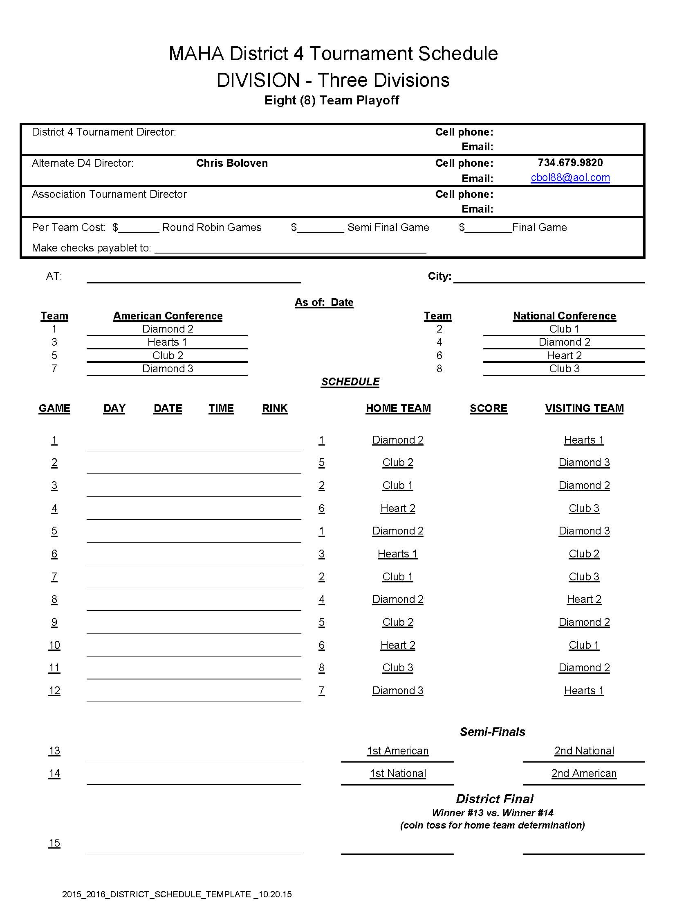 | 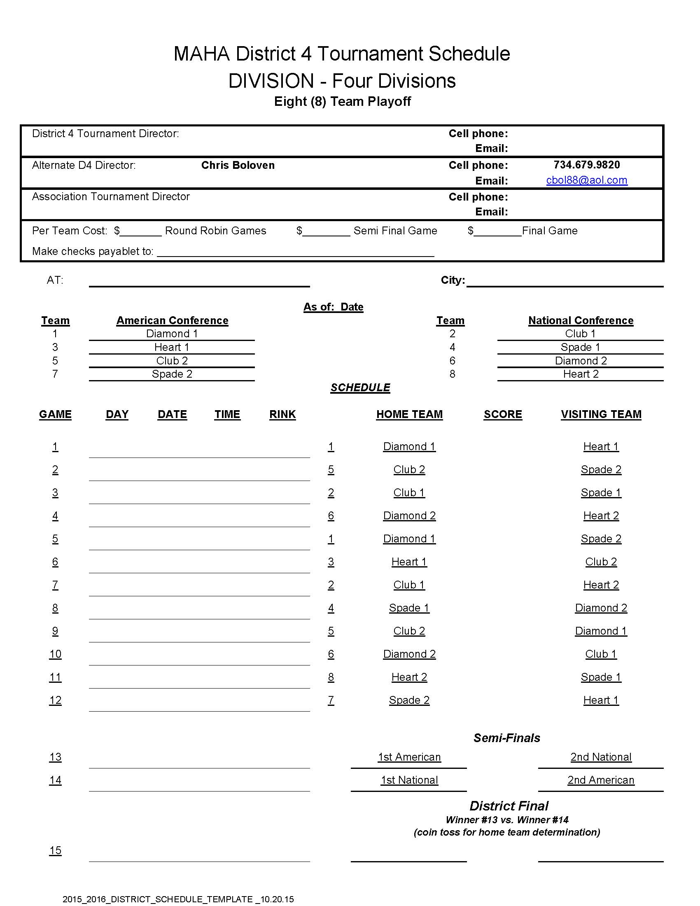

Approved by D4 Council: Yes_____ No: _____ Approver:
Comments:

Game Format for Round Robin
Updated September 15, 2016

1. Games will be played under the following time format.
DIVISION | PERIODS | Ice Resurface | Overtime | Curfew | Hours/ Game | Referees
Squirt B (10U) | 12 min | Before game only | None | None | 1.25 | 2 referees  $42 ($21 each)
Squirt A (9U) | 12 min | Before game only | None | None | 1.25 | 2 referees  $46 ($23 each)
Squirt AA (10U) | 12 min | Before game only | None | None | 1.25 | 2 referees  $50 ($25 each)
PeeWee B (12u) | 15 min | Before game only | None | None | 1.5 | 2 referees  $64 ($32 each)
PeeWee A (11U),  AA (12U) | 15 min | Before game only | None | None | 1.5 | 2 referees  $74 ($37 each)
Bantam B (14U) | 15 min | Before game only | None | None | 1.5 | 2 referees  $80 ($40 each)
Bantam A (13U) | 15 min | Before game only | None | None | 1.5 | 2 referees  $90 ($45 each)
Bantam AA (14U) | 16 min | Before game only | None | None | 1.5 | 2 referees  $90 ($45 each)
Midget B (16U) | 15 min | Before game only | None | None | 1.5 | 2 referees  $94 ($47 each)
Midget BB (18U) | 15 min | Before game only | None | None | 1.5 | 2 referees  $94 ($47 each
Midget A (16U) | 17 min | Before game  After 2 periods | None | None | 2.0 | 2 referees  $94 ($47 each)
Midget AA (18U) | 17 min | Before game  After 2 periods | None | None | 2.0 | 1 referee ($60)  2 linesmen ($45 each)  $150 total

2. Referees will be scheduled by D4 under the above format. The cost of the referees should be included in the tournament fee.

3. Resurfacing of the ice.
Midget A, AA - Resurface after every two periods. Additional resurfacing will be at the discretion of the MAHA District 4 Representative(s), with the advice of the referee(s).

4. (5) second drop of puck rule in effect for all games – USA Rule 204.

5. One timeout (60 seconds) per team, per game is allowed in the Second Round.

6. Running Clock - For Non-National Bound divisions ONLY - In the 3rd Period if the goal differential reaches 8 goals, the clock goes to running clock. If the differential drops to 6 goals, the clock returns to a stop clock.

Game Format for Semi-Final Round
Updated September 15, 2016

1. Games will be played under the following time format.

DIVISION | PERIODS | Ice Resurface | Overtime | Curfew | Hours/ Game | Referees
Squirt B (10U) | 12 min | Before game only | 10 min | None | 1.25 | 2 referees  $42 ($21 each)
Squirt A (9U) | 12 min | Before game only | 10 min | None | 1.25 | 2 referees  $46 ($23 each)
Squirt AA (10U) | 12 min | Before game only | 10 min | None | 1.25 | 2 referees  $50 ($25 each)
PeeWee B (12u) | 15 min | Before game only | 10 min | None | 1.5 | 2 referees  $64 ($32 each)
PeeWee A (11U),  AA (12U) | 15 min | Before game only | 10 min | None | 1.5 | 2 referees  $74 ($37 each)
Bantam B (14U) | 15 min | Before game only | 10 min | None | 1.5 | 2 referees  $80 ($40 each)
Bantam A (13U) | 15 min | Before game only | 10 min | None | 1.5 | 2 referees  $90 ($45 each)
Bantam AA (14U) | 16 min | Before game only | 10 min | None | 1.5 | 2 referees  $90 ($45 each)
Midget B (16U) | 15 min | Before game only | 10 min | None | 1.5 | 2 referees  $94 ($47 each)
Midget BB (18U) | 15 min | Before game only | 10 min | None | 1.5 | 2 referees  $94 ($47 each)
Midget A (16U) | 17 min | Before game  After 2 periods | 10 min | None | 2.0 | 2 referees  $94 ($47 each)
Midget AA (18U) | 17 min | Before game  After 2 periods | 10 min | None | 2.0 | 1 referee ($60)  2 linesmen ($45 each)  $150 total

NOTE: Sudden victory overtime periods are stop-time. Teams do not switch ends after the 3rd period, but will switch ends after the 1st Overtime period. Teams will remain in that end until the game in concluded.

2. Referees will be scheduled by D4 under the above format. The cost of the referees should be included in the tournament fee.

3. Resurfacing of the ice.
Midget A, AA - Resurface after every two periods. Additional resurfacing will be at the discretion of the MAHA District 4 Representative(s), with the advice of the referee(s).

4. (5) second drop of puck rule in effect for all games – USA Rule 204.

5. One timeout (60 seconds) per team, per game is allowed in the Semi-Finals. No additional timeout is allowed in the overtime periods.

6. Running Clock - For Non-National Bound divisions ONLY - In the 3rd Period if the goal differential reaches 8 goals, the clock goes to running clock. If the differential drops to 6 goals, the clock returns to a stop clock.
STANDINGS & TIE BREAKER RULES TO DETERMINE STANDING POSITIONS
ALL DIVISIONS
STANDINGS:
The standings shall be determined on the basis of two points for a win and one point for a tie. There is no overtime in round-robin play (Round 1).
A score of 0-1 will be recorded on the official game sheet(s) for all games if any game is forfeited.
If two or more teams have an equal number of points, their position in the standings shall be determined by the following tie-breaking format. If one tie-breaker establishes a position for one or more teams, each team is placed in the applicable position. Once a team is placed or all teams are placed, the remaining tied teams shall start the tie-breaking process over again at step 1a. The tie-breaker formulas are as follows:
(Note: For tie-breaker purposes in determining the standings in preliminary round play (Round 1 & Round 2), a maximum six goal differential will be used regardless of the greater goal differential; example 15 – 2 becomes an 8 – 2 score.)
- 1. The results of the HEAD to HEAD games played between the teams tied in the standings shall be used in the following order:
        - (If all tied teams have not played each other, skip step 1 and proceed to step 2.)
- a. Standings—Most points in Head to Head games.
  - b. Most wins in Head to Head games.
  - c. Differential - Subtracting goals scored against from goals scored in these Head to Head games, the positions being determined in order of the greatest surplus.
  - d. Quotient - Dividing the goals scored in these Head to Head games by the goals scored against, the positions being determined in order of the greatest quotient. A quotient involving dividing by zero (0) has a higher standing than a quotient from dividing by any number other than zero. Where two or more teams have no goals against and the quotient tie-breaker is required, the teams shall be ranked high to low in descending order of “goals for”.
- 2. If after applying the formulas of 1 a, b, c, or d the tie still exists, the results of ALL the GAMES PLAYED by the teams tied in the standings shall be used in the following order.
  - a. Most wins in All the Games Played.
  - b. Differential—Subtracting goals scored against from goals scored in All the Games Played, the positions being determined in order of the greatest surplus.
  - c. Quotient— Dividing the goals scored in All the Games Played by the goals scored against, the positions being determined in order of the greatest quotient. A quotient involving dividing by zero (0) has a higher standing than a quotient from dividing by any number other than zero. Where two or more teams have no goals against and the quotient tie-breaker is required, the teams shall be ranked high to low in descending order of “goals for”.
  - d. Most periods won—In All the Games Played by each tied team, points will be awarded for each regulation period won (2 points) and for each regulation period tied (1 point). Positions shall be in the order of highest point total.
  - e. Quickest first goal—The team that scored the quickest goal in All the Round Robin Games Played shall be ranked highest.
3. The team with the fewest total penalty minutes in All the Games Played will be ranked the highest, etc.
4. If the above procedure does not break the tie, the teams shall use a shoot out procedure. This will involve each team selecting five (5) players who will alternate taking penalty shots. A toss of the coin will determine which team will take the first shot. If after five (5) players from both teams have completed the procedure the tie still has not been broken, it shall be repeated with five (5) different players until the standings are determined.

