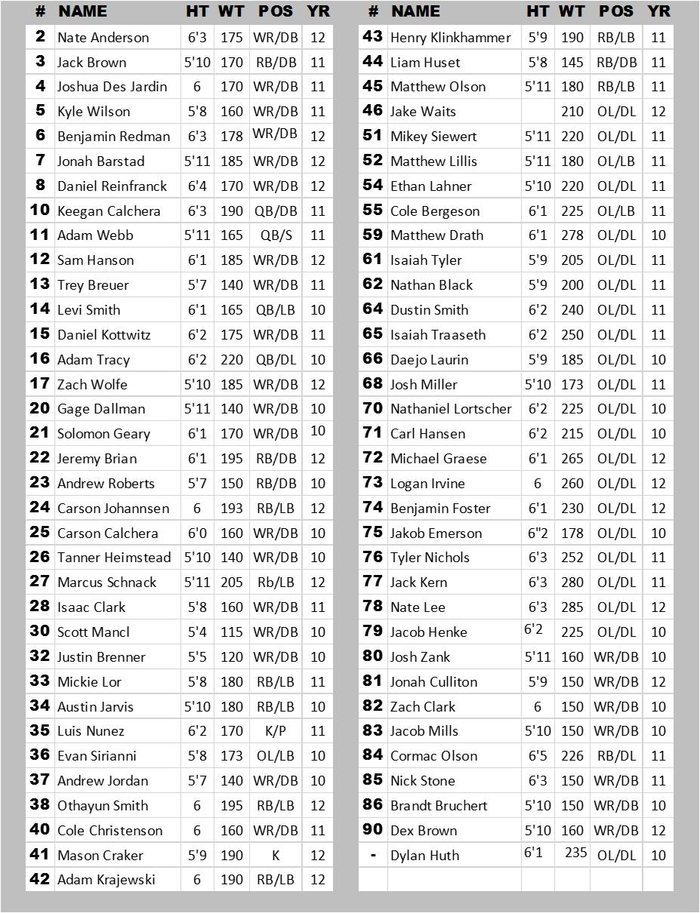


HEAD COACH: Steve Crutchley
VARSITY ASSISTANTS: Eric Traxler, Ben Ganske, Sean Hoolihan, Dave Sampson, Steve English, Adrian Logan, Josh Murray
JV/ VARSITY ASSISTANTS: Tyler Vonhaden, Vince Furby, Kellen Lager
FROSH ASSISTANTS: John Samb, Gary Pszeniczny, Zach Ruhland, Tyler Lee
STUDENT ASSISTANTS: Alexa Julson, Sophia Ziehr, Danielle Kvapil, Lexi Klatt, Baily Hazuga, Alyson Ness, Josie Weiss
ATHLETIC TRAINERS: Heather Dayton, Lynn Reuss
ATHLETIC DIRECTOR: Kevin Thompson
PRINCIPAL: Trevor Kohlhepp

