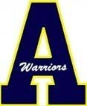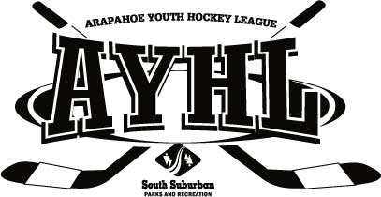

AYHL Photographic and Recorded Images Consent Form

AYHL recognizes the need to ensure the welfare and safety of all young people in sport. In accordance with our SafeSport Program, we will not permit photographs, video or identifying information of players to be taken or shared without the consent of the parents and players.
AYHL will follow the guidance for the use of photographs and recording images as described in the SafeSport Program.
AYHL will take all steps to ensure these images are used solely for the purpose intended. If you become aware of images being used inappropriately, you should inform AYHL immediately.
I _______________________________________________________ (parent) consent to AYHL photographing or videoing my child _____________________________________________________ (player) for the purposes of training, recruiting, marketing and promoting for further hockey development.
Signature_____________________________________________ Date _______________________

