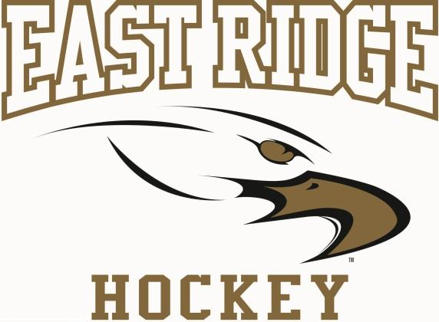
East Ridge RAPTORS Girls High School Hockey Sponsorship Opportunities
Dear Potential Sponsor,
Our girls sincerely appreciate all of the support we receive from organizations like yours in our community. One of the best ways to help our team is to sponsor a partial or full page in the program that each attendee receives at every home game. This offers great visibility for your business to much of the target audience you’re looking to reach, and helps our team fund things like tournament costs, additional training equipment, team building, and the videotaping of games.
Sponsorship Options*:
- ¼ Page $150
- ½ Page $250
- Full Page $500
*One time cost – covers placement in program at all home games
We rely on business sponsorship and fundraising to keep costs down so more girls are financially able to participate in high school hockey. We’d really appreciate your consideration. Please let me know if you have any questions or would prefer to support or team in other ways.

Sincerely,
Erin Peterfeso
East Ridge Girls High School Hockey Booster Club

Once you have selected the option you’d prefer, please send your content in jpeg or high-resolution PDF format to erin.peterfeso@outlook.com
Checks should be made out to “ERHS Girls Hockey” can be mailed to:
East Ridge Girls Hockey Booster Club
c/o Erin Peterfeso – Fundraising Chair
9589 69th St So
Cottage Grove, MN 55016

