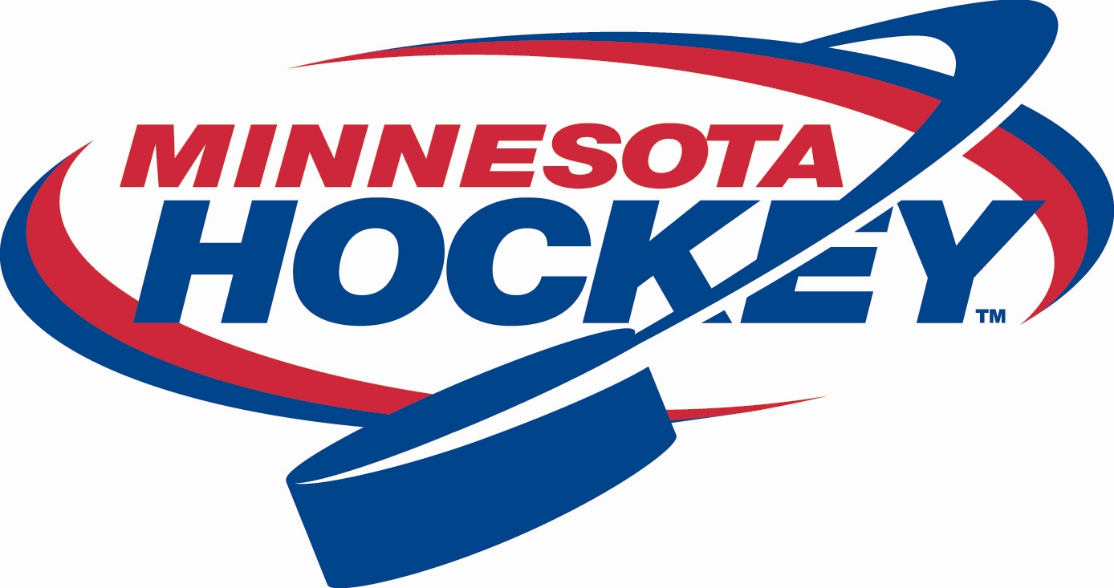
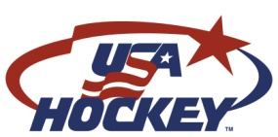
Minnesota Hockey
Membership Development Report
January 23, 2016

We are excited to report that we have achieved a third consecutive season of growth at the 8 & Under level. We are currently at 17,355 8U players, which is up 725 (4.4%) compared to last year at this time and 507 more than last year’s final total. This also marks the first time ever Minnesota has exceeded 17,000 8U players so we will set a new state record for 8U players this season. We will also set a new record for first time 8U players with 6,678 entering our game and making this the best recruiting season in our organization’s history.

The Minnesota Hockey Membership Development Committee continues to make a significant effort to increase the awareness of and participation in hockey through the utilization of available Minnesota Hockey and USA Hockey growth programs. Here is a recap of some of our efforts.

November 7, 2015 - Try Hockey For Free Results

On Nov. 7th, there were 53 sites in Minnesota that hosted Try Hockey For Free Day and a total of 1,048 participants were reported. These numbers represent a decrease compared to previous seasons. We attributed most of the decrease to conflicts with deer hunting opener and an increase in other recruiting programs such as Total Hockey’s First Stride program.

February 20, 2016 – Try Hockey For Free

On February 20th, USA Hockey is hosting the second Try Hockey For Free day of the season in conjunction with Hockey Weekend Across America. As of January 21st, Minnesota has a total of 29 associations hosting events at 30 sites. Here is a summary of the participating associations by district:
District 4

District 5
Litchfield-DC
River Lakes
Sartell
Willmar

District 6
Bloomington Kennedy
Eden Prairie
Shakopee

District 10
Andover
Mora
Princeton

District 11

District 15
Alexandria
Fergus Falls
Little Falls
Park Rapids

District 16

District 8
Apple Valley
Eagan
Sibley
South St. Paul

District 9
La Crescent
Owatonna
Waseca
District 1
City of Lakes
Edgcumbe
Langford Park

District 2
Roseville
St. Paul (Highland)

District 3
Delano
Osseo-Maple Grove
Orono

Minnesota Hockey Growth Grants

The Membership Development Committee has received 16 grant applications and reviewed 15 applications already in the 2015-16 season. 10 associations have been approved for funds through our grant programs totaling $12,700.

Little Wild Learn to Play

The Little Wild program will be expanding its impact in the fall of 2016. We are planning to host the Learn to Play program at 16 locations, and most of the locations have been finalized. More details will be available at the annual meeting.

Total Hockey First Stride

Total Hockey has developed a recruiting program for youth hockey associations in Minnesota as well. The First Stride program is a try hockey style event in which Total Hockey provides full equipment for players that participate. Any players who register with the host association are allowed keep the equipment, but players who don’t sign up are required to return the equipment or pay for it. We assisted Total Hockey in targeting 12 communities for these events, and many of them were extremely successful.

The popularity of this program did reduce the number of Nov. 7th Try Hockey For Free hosts we had as several associations told us directly they were choosing to host First Stride instead. Overall, we viewed that as a positive situation since First Stride tends to attract more initial participants and improves associations’ conversion rates.

