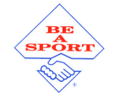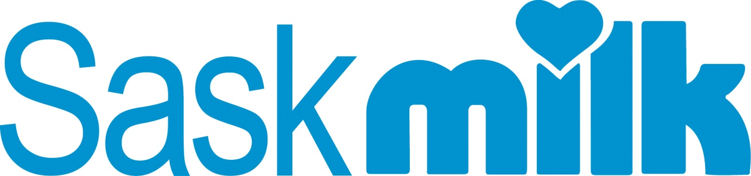SHSAA_logo_new_color***‘Speak up for Sportsmanship’***

**SHSAA / Sask Milk Sportsmanship Award Nomination Form**

There are numerous examples of school athletic programs that have not reached a provincial championship but have displayed the values of sportsmanship throughout the season and would be a worthy recipient of the SHSAA / Sask Milk Sportsmanship Award.

Please use this form to nominate a school program that through their efforts in the current school year have demonstrated the values of sportsmanship aligning with the beliefs and objectives of the SHSAA.

**SCHOOL:**

**ACTIVITY:**

***Please indicate how the actions of each of the following areas have contributed to the nomination of this school:***

**Team members -**

**Coaches -**

**School Personnel -**

**Community -**

After completion, please submit the form to the SHSAA office by email [shsaa@shsaa.ca](mailto:shsaa@shsaa.ca)

Thank you for taking the time to submit the nomination recognizing outstanding efforts toward sportsmanship in the SHSAA.