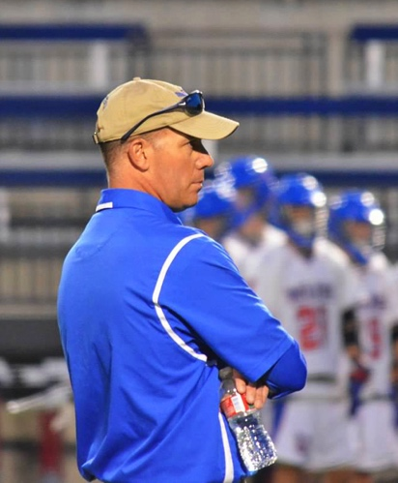
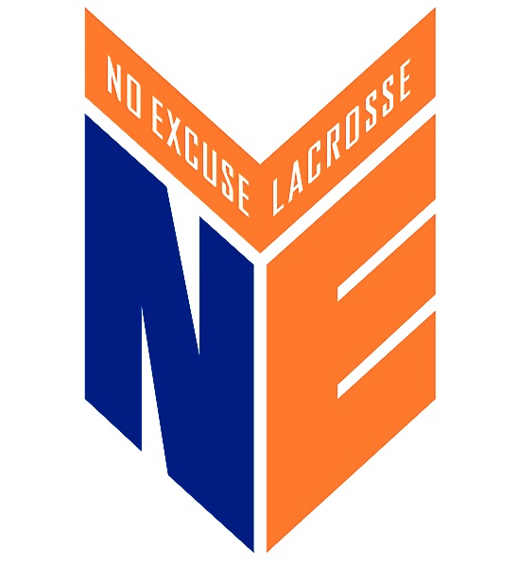

Pat DiMento
Director, No-Excuse Lacrosse

Pat completed his 22nd and final season as an assistant coach at Memphis University School (MUS) in the spring of 2016 with his 11th State Championship.

The Islip, NY native played for Islip HS before heading out to The United States Air Force Academy to play for the Falcons. Graduating in 1986 from the Academy, and after completing pilot training, Pat was assigned to fly the B-52 Stratofortress in Blytheville, AR, at Eaker Air Force Base (60 miles north of Memphis).

Pat retired from the active duty Air Force in 1991 after flying seven combat missions in Operation Desert Storm. He was hired by FedEx in 1995 and is now an Assistant Chief Pilot and Boeing 757 Captain.

Coach DiMento got the coaching bug helping his HS teammate and best friend Scott Mullins coach at Levittown MacArthur HS on Long Island in 1993. He then moved to Memphis to pursue a career at FedEx and began coaching with Coach David Gearhardt in the spring of 1994 at MUS. In 1995 his son Patrick was born, and with him the drive to help bring lacrosse in the Mid-South to the next level.

Pat helped found the Memphis Lacrosse Youth League and the Buzzards Lacrosse program. In 2008, he and his wife Kristen put together a summer travel team for Patrick and his buddies -- the start of No-Excuse Lacrosse.

Coach DiMento has coached 18 HS All-Americans at MUS and won 11 State Championships. Finishing his HS coaching career with four straight championships with his son on the field. He is a past-president of the Tennessee Chapter of US Lacrosse and is the US Lacrosse HS Area Chairman.

The name No-Excuse Lacrosse comes from his experience at the Air Force Academy where the only answer to a "why" question is "No-Excuse, Sir". He is known for his commitment to discipline (fundamentals), and his insistence on character and leadership development.

He and his extremely supportive wife Kristen have been married for 26 years and have three kids, Patrick, Nick and Katherine.

