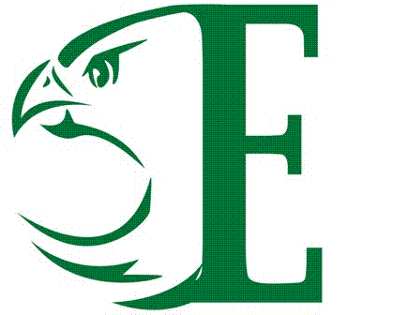
Enloe High School
2015-2016 Varsity & JV Men’s Soccer

Date | Opponent | JV | Varsity
August 13 | Apex (Scrimmage) |  | 5:00pm
August 17 | @Southeast Raleigh | 4:30pm | 6:30pm
August 27 | @Rolesville High School | 4:30pm | 6:30pm
August 31 | Jordan High School | 4:30pm | 6:30pm
September 1 | @ Knightdale | 4:30pm | 6:30pm
September 3 | Rolesville High School | 4:30pm | 6:30pm
September 9 | Leesville | 4:30pm | 6:30pm
September 14 | @Millbrook | 4:30pm | 6:30pm
September 16 | Wakefield | 4:30pm | 6:30pm
September 21 | @Heritage | 4:30pm | 6:30pm
September 24 | Knightdale (varsity Only) |  | 4:00pm
September 28 | @Sanderson | 4:30pm | 6:30pm
September 30 | @Broughton | 4:30pm | 6:30pm
October 5 | Wake Forest | 4:30pm | 6:30pm
October 7 | Millbrook | 4:30pm | 6:30pm
October 12 | @Wakefield | 4:30pm | 6:30pm
October 14 | Heritage | 4:30pm | 6:30pm
October 19 | @Leesville | 4:30pm | 6:30pm
October 21 | Sanderson | 4:30pm | 6:30pm
October 27 | Broughton | 4:30pm | 6:30pm
October 29 | @ Wake Forest | 4:30pm | 6:30pm
November 4 | 1st Round of Playoffs  Head Soccer Coach  Andrew Womble | N/A | TBD

All Home Soccer Games played in Len Bauer Stadium-Enloe

