PITCHING DRILLS TO BECOME A BETTER PITCHER

Pitching Drill - One Knee Drill

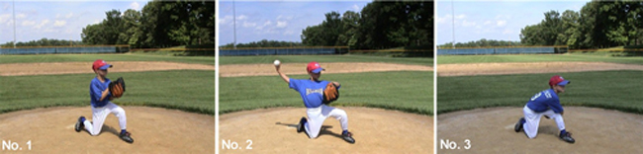

Purpose:
Isolate the lower body to focus on developing proper arm action.

Setup:
Pitchers pair up and kneel on their posting leg (right knee for right-handers, left knee for left handers).

How to perform drill:
Players get on one knee about 45 to 55 feet from each other. The pitcher with the ball will rotate his shoulder toward his throwing partner, bring his arm back with his hand on top of the baseball, use a good circular arm motion, and throw the ball, making sure the pitcher bends his elbow and finishes throwing elbow past the opposite knee.

Pitching Drill - Bucket Drill

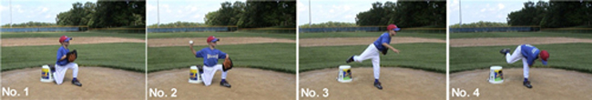
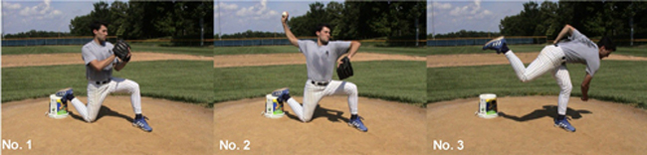

Purpose:
Learn how to brace up over front leg once pitch is made, to encourage a correct follow through.

Setup:
Pitchers pair up and kneel on their posting leg (right knee for right-handers, left knee for left handers) while placing their kneeling foot on an upside-down 10 gallon bucket.

How to perform drill:
Players get on one knee about 45 to 55 feet from each other, kneeling foot on upside-down 10-gallon bucket. The pitcher with the ball will rotate his shoulder toward his throwing partner, bring his arm back with his hand on top of the baseball, use a good circular arm motion, and throw the ball, and popping up and over the bent stride leg, making sure the pitcher bends his elbow and finishes throwing elbow past the opposite knee.

Pitching Drill - The High-Cock Position Drill

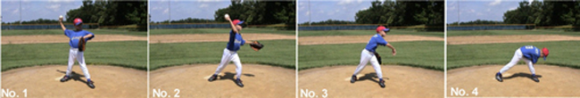

The High-Cock Position Drill is used by youth, college, and professional pitchers looking to specifically address the release of the baseball from a high-¾ arm angle. This drill teaches pitchers to "get on top" of the ball.
To get the lower body ready to begin, the pitcher will spread his feet into a permanent throwing-position, slightly wider than shoulder-width apart with the toes of the lead leg pointing to the target.
The back foot, whose only movement during the drill is to turn over to onto the toes when the baseball is released, stays in contact with the ground at all times.
The elbow of the throwing arm should be level with the shoulders which brings the entire arm into the high-cock position.
Remember, in the high-cock position, the right-handed pitcher shows the ball to the shortstop; lefty's show the baseball to the second baseman. The elbow of the glove arm side should also be level with the shoulders and the glove arm elbow itself should point directly to the target like a "rifle site."
From this starting position, simply “pull” the glove arm back into the body while rotating the hips and pivoting on the back foot to release the baseball. Follow the motion all the way through after the ball is thrown to ease the stress on the arm.
A good follow-through consists of a pitcher bending his back and bringing his throwing arm elbow to the opposite knee.

Pitching Drill - The Quick Hands Drill

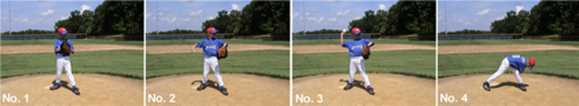
Pictured is a youth pitcher performing The Complete Pitcher's quick hands drill.

The Quick Hands Drill is for the development of pitching velocity through muscle-memory.
Think about this: the actual mechanical act of pitching a baseball takes place in the subconscious mind. When on the mound, a pitcher is not literally thinking, "OK, now I have to lift my leg and speed up my arm" – it just happens because of the body's muscle-memory from hours and hours of practice.
This drill attempts to address that muscle-memory "imprint" by teaching the body to have quick hands. Quick hands directly correlate into increased pitching velocity.
Start with the hands together, ball in the glove. The legs are positioned in the exact same manner as the high-cock drill, toes of the lead leg facing the target. The legs remain in this permanent, shoulder-width-apart position throughout the drill. However, the back foot will pivot onto its toes when the ball is released (like when you pivot your back foot during a golf swing or baseball bat swing). However, the distance of the two feet remain the same.
The key here is not to step.

As fast, and controlled, as possible, the pitcher will break the hands, turn the hips, throw the baseball from a high-¾ arm slot and follow-through by bringing the elbow of the throwing arm to the opposite knee.

Pitching Drill - The Pause And Balance Drill

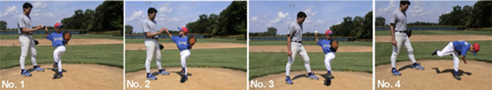
Pictured is former pro Steven Ellis, left, and a youth pitcher, right, performing The Complete Pitcher's pause and balance drill.

The Pause and Balance Drill is the single most effective drill to get a pitcher into a controlled and balanced balance position.
This drill is particularly effective for pitchers who "rush" their motion, fall forward too soon, have trouble getting "on top" of the baseball into a high-¾ arm slot, or are imbalanced in the balance position.
A coach or another player is needed for this drill.

To begin, a pitcher will go through his full wind-up without the baseball. When he gets to the balance position, the pitcher will stop, hold, turn his head and wait for the coach to hand him the baseball.

The coach should vary how quickly he hands his pitcher the ball from three- to five-seconds.

Once the pitcher has received the ball from his coach from the balance position, he will turn his head again and throw to his target emphasizing a good follow-through.

Pitching Drill - The Shadow To Balance Drill

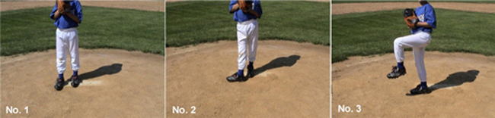
Pictured is a youth pitcher performing The Complete Pitcher's shadow to balance drill.

The Shadow to Balance Drill is highly effective in getting pitchers to "learn" the all-important first stages of the pitching motion – getting from the stance to the balance position in a controlled and balanced manner. Because no baseball is used in this drill, a pitcher can practice this beneficial exercise on a daily basis, regardless of when he is pitching during a particular week.
Many professional pitchers perform this drill 25 times, five to six times a week prior to throwing.
To start, righties should take their sign from their catcher from the right side of the rubber, lefties from the left (No. 1). Take a controlled, small step back keeping the weight of the upper body over the pivot leg (No. 2). Turn your hips to the catcher and lift your lead leg from the knee into the balance position (No. 3). Do not swing the lead leg into the balance position, it's simply a "lift."
Pause in the balance position for five seconds or more and repeat.
Pitching Drill - The Leverage Drill
"drop and drive" is not a correct pitching mechanic because your pitcher will lose out on the all-important attributes of pitching leverage by dropping (and thus lowering his release-point).
Drop and drive guys typically have flat fastballs. (Of course, there are always exceptions like Sandy Koufax and Tom Seaver, but typically, the hardest throwers all stay tall to take advantage of the leverage on their fastball.)
Here's a baseball pitching drill, called The Leverage Drill, that may be helpful:
Get your baseball pitcher into his balance position, have the pitcher post on a slightly bent back leg and have him bring his knee to the height you'd like to see it during his pitching delivery. Measure the height by placing your hand palm-facing down.
Next, without a baseball, have your baseball pitcher go through his pitching delivery(as a coach, you should stand to the side out, of your pitcher's way, but in a spot where you can easily put your hand out to the spot where you initially measured your pitcher's high-knee to be in the balance position).
Have your pitcher go through his pitching delivery and have the top of his knee touch the bottom of your extended hand. This will force your pitcher to stay tall on the back leg. If he collapses, your pitcher won't be able to bring his front knee to the same height that you had previously measured when he was in the balance position.
After a few sessions without a baseball, have your 10-year-old pitcher perform the drill throwing the baseball 35-feet, and then move the catcher back to 45-feet.
Pitching Drill - The Stride Drill
The Stride Drill is designed to train a pitcher's body to get into the proper throwing position enabling him to maximize velocity while minimizing the risk of injury during game situations. This drill can be performed without a baseball and can be done individually by a pitcher if a throwing partner is not available.
First, let's take a closer look at the stride phase of the pitching motion.
A pitcher's should stride at a minimum 80% his height towards home plate during his fastball delivery. On the curveball and change-up, his stride should be six to eight inches less than his height. For example, if a pitcher is 5 feet, 10 inches tall, then his stride toward home plate on the release of the baseball should be 5 feet, 2 inches (or thereabouts).
In the stride phase of the pitching motion, a pitcher should be able to draw an imaginary line from the heel of his back foot, through the ball of his stride foot, and onward to the target. Keeping the lower body aligned in a straight line closes a pitcher's hips, directs the shoulders, and allows the throwing arm to reach the "high cock phase" of its arm path in the back of the pitcher's body. Additionally, if a pitcher lands too far to the glove-side of his body, he will open the shoulder too soon. This causes the pitch to be low and outside while creating stress on the arm and reducing velocity. If a pitcher lands too far to the throwing-side, he will inevitably have to throw across his body making the outside part of the strike zone difficult to hit. Plus, if a pitcher throws across his body, he creates an increased amount of stress on the arm.
Let's begin. A pitcher will stand perpendicular to a straight line (like a foul line in the outfield grass or line on a gym floor). If the pitcher is on the pitching mound itself, he can use his spikes to drag out a straight line in the dirt 8-feet long and perpendicular to the rubber (i.e. directly in line with home plate). Then, he simply marks out the distance of his height and drags out a second line in the dirt--only this one is parallel to the pitcher's rubber. If the pitcher is not on a mound, he will simply place a second object like his hat on the ground. This will mark the distance he should be striding toward his target.
Now, the "markings" he will have on the mound should create an imaginary letter "H" if one looks from the side. The pitcher then goes through his entire delivery (with or with out throwing the baseball at the end of the motion) and looks to see where his front foot lands in relation to the two lines he has etched out in the dirt. He can use either his full or set wind-up in this drill. Did the pitcher land the length of his height? Did the pitcher stride in a straight line toward his target? If not, a pitcher should perform this drill 50-times a day without throwing the baseball.

