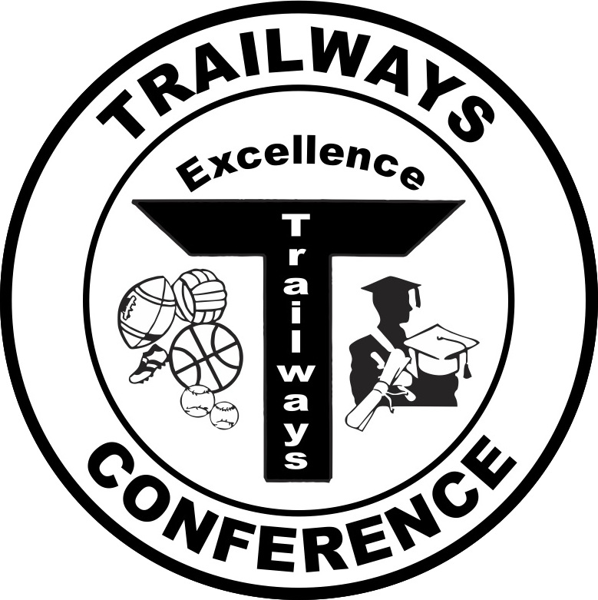

Rich Fronheiser, Commissioner
550 Vista Cir
Columbus, WI 53925
trailwayscommish@gmail.com
(920) 623-9660 - office

2015 Trailways North Softball All-Conference Teams

First Team
Player of the Year – Lauren Schiek, Sophomore, Lourdes Academy

Player | Class | School
Maddy Ryan | Senior | Oakfield
McKaela Ryan | Senior | Oakfield
Alyssa Sabel | Junior | Oakfield
Brianna Sabel | Junior | Oakfield
Mollie Bartlett | Sophomore | Lourdes Academy
Lauren Schiek | Sophomore | Lourdes Academy
Ciarra Zemke | Sophomore | Lourdes Academy
Hailey Drager | Senior | Markesan
Hanna Gibbons | Freshman | Markesan
Emma Klapper | Senior | Montello
Courtney Peterson | Freshman | Pardeeville
Olivia Bancroft-Hart | Sophomore | Cambria-Friesland
Brenna Huizenga | Sophomore | Randolph

Second Team

Player | Class | School
Michaela Kindler | Sophomore | Oakfield
Mikayla Newton | Sophomore | Oakfield
Karissa Ryan | Freshman | Oakfield
Paiton Proud | Junior | Lourdes Academy
Stephanie Mahl | Senior | Markesan
Aryanna Arnone | Senior | Montello
Bailey Hunter | Senior | Montello
Alysha Smith | Senior | Montello
Becca Ives | Sophomore | Pardeeville
Lauren Perrett | Junior | Pardeeville
Emma Grahn | Junior | Cambria-Friesland
Madison Ferron | Junior | Randolph
Brooke Roberts | Junior | Randolph
Kristen Baranowski | Junior | Princeton/Green Lake

