Enthusiasm, Knowledge and Organized Chaos

Developing Soccer Players for the Future

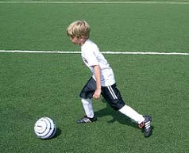

Table of Contents

Introduction

Mission

Problems in Youth Coaching

Developmental Approach

Small Sided Play

Parents Education

Coaching a Training Session

Club Coaching Vocabulary

Technique

Tactics

Coaching a Game

Characteristics of U7 and U8 Soccer Players

Technique Directory

Additional Sample Model Sessions

Gender Differences

Observations and Suggestions from U7 and U8 Games

Introduction

Thank you for volunteering to coach a U7 or U8 soccer team. I am sure you will find your efforts rewarding. The players you will work with and the community at large well benefit from your unselfish gift of time, energy and knowledge.

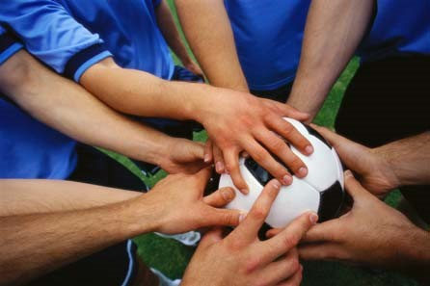
This manual has been written to help you face the challenges of coaching a U7 and U8 soccer team. You will find information to help you along the way. Refer to this manual throughout the year. After reading this manual, you will see that players that receive the information provided will be prepared for the challenges they will face is subsequent years. Keep in mind all players may not master the content presented but being exposed to the material will help in their development. The players also need to be exposed to the terminology used in this manual as coaches at all levels of club will continue to use the same terminology.

We also recommend taking the time to go to as many coaching clinics as possible. Read coaching manuals, access the internet, watch coaching DVD’s, observe peers while coaching, and ask others for feedback in an effort to become the best soccer coach possible.

Your players will benefit from your efforts and you will find the experience more rewarding.

Mission

The mission of the youth soccer coach is to be a role model, teacher of soccer, and facilitator of fun. This manual addresses each of these areas.

Role Model
As a role model, the coach, needs to be aware that players will look up to you and are influenced by your behavior. This pertains to all behaviors done in player’s presence. Players will observe your language, treatment of your peers, their peers, officials and parents. Players learn through their observations.

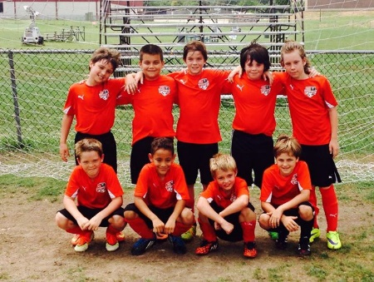
Teacher of Soccer
Teaching requires the coach to know who they are teaching, what they are to teach, and methods to teach.

The U7 and U8 Soccer Coach needs to narrow their focus to ten topics. Five of these topics are technical and five are tactical.

Techniques to be developed:
Dribbling
Passing
Receiving
Shooting
Goalkeeping

Tactics to be developed:
Transition
Splitting
Spatial Awareness
Risk Taking/ No Fear of Failure
Directional Possession
Team Shape/Connection

Each player at the U7 and U8 age group must be introduced to all of these topics and have time on task to improve in all ten areas of the game. As the players move up in age, these ten topics will form the building block of player development.

Facilitator of Fun
Players participate in sports to have fun. The game of soccer is the most popular youth sport in the country because if offers young players of all abilities excitement. The coach needs to be enthusiastic and conduct all activities in the spirit of enjoyment. Each training session needs to have the game as the largest portion of the session as this is the reason player’s play.

Problems in Youth Coaching

Intimidation/Anger
You do not have to look far for an example of negative coaching. Anger used towards young children has been documented in the newspapers, television and the internet. This method of coaching forces players to adopt a fear of failure. Players do not experiment, take risks, develop, or enjoy their soccer experience. Children that play in an anger filled environment are more likely to not return to the sport the following year.

Meeting the Needs of Only a Few
There is a wide range in player’s soccer ability at this age. Children who physically mature early and those with older siblings often are more developed in their soccer abilities.

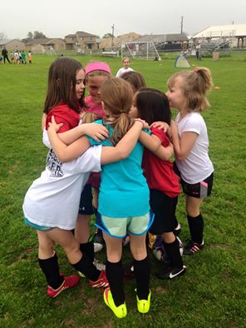
Do you know of any teachers that walk into a classroom and structure the class work, homework, and testing to only meet the needs of the top two or three students? The goal of the coach needs to be the same as the goal of teacher: to challenge and develop all the players. Meeting the needs of all players on your team can be the greatest challenge you will face in coaching at this age level. I and almost all child experts do not recommend sifting players on ability. Tryouts are needed to sift players and children at this age are not prepared to be told they are not good enough. No one at any degree of success has been able to predict player’s futures at this early age.

Coach Driven Drills
Drills designed by coaches that do not allow for players to make decisions on where to run, or how to manipulate the ball are coach driven activities.

Coaching Moments Not Principles
Coaches must give information that is specific to the situation with specific information that pertains to the principles of play. Most coaching is general to the moment and players do not understand how to differentiate this information in other situations.

General Example: Go to the ball.

Specific Example: When the ball is not in possession go to it as quickly as possible:

General Example: Do not fall for fancy footwork.

Specific Example: When the opponent has the ball, be patient and only commit to gain possession when they loose control.

As you can see specific information gives the player knowledge and general information presents problems for the future. A player that was just told to not fall for fancy footwork may think to themselves, but coach you just told me to go to the ball.

Coaching with Lines, Laps and Lectures

The three ‘L’s’ in coaching need to be eliminated. All three prevent players from playing and getting better in soccer. While players are in line they are not on task. Eliminate lines by having multiple groups. Laps may develop fitness but at the expense of time with the ball. Eliminate laps by using activities in the warm up and throughout the training session that require movement. Lectures bore players. These same players have been lectured to all day in school and have
come to training to play. Eliminate lectures by limiting yourself to giving twenty seconds of information at a time.

Developmental Approach

Develop Your Philosophy

Philosophy-

The U7 and U8 soccer players appear to be mature soccer players because some of these players have been involved in youth soccer for a few years. These players are not mature soccer players and cannot be treated as such. A better approach is to treat the players close to the way beginners would be treated. The approach needed to this age group is that of a teacher. The coach/teacher needs to make an effort to reach all players on their team. Winning games cannot be at the expense of player development. Coaches need to develop player’s movement ability, soccer techniques, and game understanding.

The Slanting Line Concept
When a coach sets up activities that have one standard of measurement or one winner, many players are not challenged. Players that can perform the task are often bored, while anxiety sets in with players that are not able to perform at the desired level. This method of coaching is similar to a setting up a parallel line for the high jump. A group of athletes will get over the line easily and be bored with the activity, another group of players will be challenged by the height, and the final group of players will not be able to get over the pole and be anxious over the activity. The height of the pole can be lowered or raised and it will only challenge a small group of the players.

Coaches need to set up activities that challenge all the players. The pole or line of success can not be parallel to the ground but must be slanting. By changing the angle every player can find a challenge in the activity and no players are anxious or bored.

Movement Education Approach
Players need to be challenged in movement while at the U7 and U8 age group. These children need to be able to change speeds, change direction, keep balance while moving, and have control of their bodies all with their head up. A portion of each practice can be given to developing basic movement skills. Use of hopping, skipping, galloping, moving backwards, sideways, running and walking can fill this portion of the practice. Players can not control the ball until they can control their body. Teams can not control the game until they can control the ball.

Importance of Technique
Developing the player’s comfort level with the ball through maximizing the player’s opportunity to touch the ball needs to be the largest portion of each practice. Technical development is also dependent on players being encouraged to use the techniques performed in practice into the games. Dribbling was the main and only focus of the U5 and U6 program. At the U7 and U8 age group it is still recommended to concentrate on developing the player’s dribbling ability more than any other technical component of the game. Passing, receiving and shooting also need to be introduced. The players are ready to share the ball and passing can occur. Place players in groups of two whenever possible. Repetition can be maximized while sharing is likely to occur as the player with the ball can expect to get the ball back. Shooting activity can be added to each practice as players can shoot off the dribble, pass or receiving touch. It is important that coaches can explain to the players why each technique is performed. Included in this manual is a paragraph on technique that included, a technical directory and progressive practice plans to develop dribbling, passing, receiving, and shooting.

Game Awareness
Every practice needs to end with a small sided game. While players are participating in small sided games their game awareness grows intuitively. Weekend games also develop player’s game awareness. The coach can also find short cuts to foster player’s game awareness. When a coach attempts to teach game awareness they must make sure the topic is age appropriate and the players are not told how to react to each action. Situational responsibilities need to take the place of positional responsibilities at the U7 and U8 age group. Coaches need to ask players for their thoughts, reasons, and insight to develop a thinking player. Giving players visual signs to look for will also prepare players to problem solve. Language command training is also needed to allow the players to understand simple soccer terms. This manual includes a game awareness section with coaching methods to allow for players to develop special awareness, progress to a team shape, introductory defending principles, and the use of flexible responsibilities. A visual sign section is also included.

Development vs. Winning
The emphasis at the U7 and U8 age group must be on player enjoyment and player learning. Winning cannot sacrifice player development. Coaches must create an environment that allows for experimentation. U7 and U8 players will not get every, or even most situations correctly. We need to allow for players to learn through trial and error. A guided discovery approach allows for players to enjoy their soccer and learning experience.

The most important factor in player development is the use of age appropriate activities and teaching methods. The characteristics of the age group needs to be understood and all activities used with players must adhere to the characteristics of the age group.

Small Sided Play

The reason U7 and U8 soccer players play a smaller game than young adults and adults is the full sided game of 11v11 was developed by adults for adults. The characteristics of U7 and U8 soccer players show us the children are selfish by nature at this stage in their development. The adult eyes see a 4v4 or 5v5 game with teams designated by color. The child’s eyes often see 7 to 9 players inhibiting their chance to play with the toy (ball). By making the game smaller we have allowed for more chances for success.

The 4v4/5v5 game:

- Allows players to frequently touch the one toy on the field; the ball.

- Presents many opportunities to score goals.

- Encourages and permits regaining possession of the ball.

- Maximizes active participation while minimizing inactivity and boredom.

- Provides an age appropriate organization to the playing environment.

- Reflects the philosophy of player development expressed in state and national coaching schools as well the philosophy of the overwhelming majority of the world.

- Eliminates complicated rules, and allows children to play while relegating the role of adults to a facilitator of fun.

- Allows the game to be the teacher.

Reducing the number of players to 4 and 5 players per team allows for all of the components that are present in the adult game.

- The ball

- Teammates and opponents

- Appropriate space

- Guidelines

- Direction of play

- The combination of length and width

Small Sided Play develops:

- Skill that is realistic to the game of soccer.

- Motor ability; balance, agility and coordination.

- Perception, insight, and awareness.

- Vision.

- Problem solving: choices and decisions.

- Physical fitness.

Learning by discovery, trial and error: playing!

Basic rules for the 4v4 and 5v5 game

Part of the effectiveness of modifying the game to small sided play is also modifying the rules. These rule changes contribute to small sided play meeting the needs of the U7 and U8 player. The adult version of soccer includes adult oriented rules that provide playing guidelines suitable for adult understanding, behavior, performance, and competition.

The basic rules for 4v4 and 5v5 are:

- When the ball goes out of play over a touch line or end line it is put back into play with a kick or dribble.

- After a goal is scored it is put back into play by a kick or dribble.

- There are field supervisors or managers instead of referees. The intent of the adult supervision must be to ensure a safe environment and to facilitate continuous play and fun.

- Players can score a goal from anywhere on the field.

Parent Education

Each coach will soon learn that parents play a far greater role in youth sports than in the past. Think about the effort a school makes to inform parents on the curriculum and procedures of the school year. Countless papers are signed, a back to school night is presented, and individual parent-teacher conferences are held. All of this is completed and it is ironic that the parents do not observe their child in the classroom. The complete opposite occurs on most youth teams. While all practices and games are observed by the parents, very little communication is presented to the parents on what it is they are observing.

As the leader of the team, the coach must take a direct role in educating the parents on the objectives of the team and youth sports. A parent’s meeting is a great start to educating the group of parent’s on their child’s participation on your team. During the course of the season, the coach may need to have follow up parent meetings, have discussions with individual parent’s, or use support services in dealing with parental concerns.

Agenda for a preseason parents meeting:

- Coaching Philosophy- Be sure to emphasize the priority on development over winning. Mention philosophy in regards to playing time.
- Coaching objectives of the season and year.
- Team Schedule, practice date/time, game date/time
- Team rules- This may include participating in practice, communication, equipment, and behavior.
- Role referee/facilitator plays in the game. Expectation of the behavior in regards to the referee.
- Expectation in regards to treatment of the opposition.
- League Rules
- Recommend soccer parent education tools available. Sports Path Fee Soccer Parent Education Course
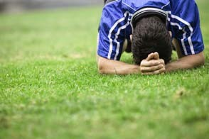
During the course of the season, the coach may need to have follow up parent meetings, have discussions with individual parent’s, or use support services in dealing with parental concerns. Your age group coordinator is the first step in reaching out to support services.

Coaching a Training Session

Each training (practice) session needs to meet two objectives that lead to player development. The first goal is to make the session enjoyable. When players enjoy their soccer training they look forward to coming back, are more likely to practice on their own, and are more likely to watch games when possible. The second goal of the training session is to challenge the players to become better. When both of these goals are realized a model session has occurred. Your goal is to make every practice session a model session. The following information will help making your training session model sessions.

Equipment
In order to run a model session the coach will need at least twenty cones, five training vest, and some extra size three soccer balls. The coach will also need to have a pump and medical kit. Players need to bring a size three soccer ball and water supply to every practice. Use the pump to make sure all balls are inflated properly.

Topics
Current research from players in England and France has shown that players at the U7 and U8 age level progress more rapidly when the session does not have an overriding technical theme. That is to say, each session should have activities that allow players to dribble, shoot, pass, and receive. Activities that allow for all techniques are ideal.

Progression
The training session needs to follow a simple to complex progression. A popular method of achieving this progression is to have a warm up period, individual activity period, small group activity, and game.

Warm Up- The warm up can start as soon as players arrive. The warm up can be done with or without the ball, or the ball can be added during the warm up. The warm up does need to get the players physically and mentally prepared for the session. Dynamic movement is required.

Individual Activities- Individual activities allow for repetition as every player has plenty of time with the ball. These activities need to be structured so that players are moving and making decisions. Opposition does not need to be present in the individual portion of the session.

Small Group Activities- These activities include opposition. The groups do not need to be even. Two versus one, three versus two, one versus three are examples of small group activities.

The Game- Ending each training session with a soccer game is needed. The game needs to be the largest part of the practice session and can be as much as half of the training time. The game is the best teacher and players come to training to play. Again teams do not need to be even. Coaches are also encouraged to vary the size of the field and use conditions to challenge the players.

Recognizing Coaching Moments

Coaches that do not find opportunities to give feedback to their players are leaving all learning up to trial and error. Your ability to recognize coaching moments gives players a short cut to learning. It is important to note that the best coaches recognize that player can not only learn from corrections but also learn from good examples. Make corrections but also highlight positive play. Pick a good coaching position to allow you to see your entire team. Coaches that position themselves with their back to players cannot evaluate the entire team. Once your position has been established give the players some time to acclimate to the activity. Use this time to recognize patterns that can be corrected or publicized. After a few moments have passed you can begin to act on coaching moments. Determine the method of distributing the information from the list below. Remember to be as unobtrusive to the players as possible.

Methods of Coaching

Coaching moments need to be as unobtrusive as possible to the children’s play. Almost every adult soccer player remembers the times when their fun was constantly interrupted by the coach. The following methods of coaching are listed in the preferred order of use.

Coaching over the Top-Provides players with information they can use during the activity. The coach states observations or instructions as the activity progresses. This coaching tool must be used sparingly as players tend to stop listening to a constant stream of instructions.

Coaching during Natural Stoppages-Natural stoppages occur throughout a practice. Every time players switch roles, the ball goes out of play, and a goal is scored a natural stoppage occurs. You can use this time to give the players information they need to improve their play.

Coaching the Individual- Every player can be given information during the activity. You as a coach can enter the field and give specific information to players that pertain to their play. Timing is important as this tool disrupts the play for the individual player.

Stop/Freeze Coaching Method- This tool is most often used in the small group and game portion of the practice. The coach projects his/her voice with the command stop and freeze. Once the players have frozen the coach shows the players the coaching moment. Players must be trained to stop and freeze as their attention is on the soccer activity. The coach must also make sure the players do not move throughout the coaching to gain an advantage. Once the information has been given the play can be rehearsed to check and see if the players gained the information.
Club Coaching Vocabulary

Most youth clubs offer soccer to players age 4-19. Once players reach the soccer age of U9, different levels of play are often offered. Players move throughout each level throughout their soccer career as well as experience different coaches. Playing for a different coach benefits the players as they are forced to adapt to differing personalities, coaching methods, as well as communication methods.

We recommend the use of a common coaching vocabulary throughout each club to allow players to move from one level to another and one coach to another without having to adapt to different soccer terminology.

At each age level we will introduce a group of terms that need to be used throughout the club. This new list will build upon the group of terms the players have already been exposed to.

Terms for U7/8

Push- Move towards the goal your team is attacking

Drop- Move towards the goal your team is defending

Shift- Move across the field closer to the ball

Dribble- Advance the ball with short kicks

Goal Side: Positioning body between the opponent and goal your team is defending

Recover: Get back in a position to help your team gain possession of the ball.

Splitting: A defender against two opponents

Each player needs to be introduced to the terms and concepts. We do not expect all players to understand or master the terms, but by introducing the concepts with common terminology the player will be more prepared to learn in future soccer seasons.

Technique

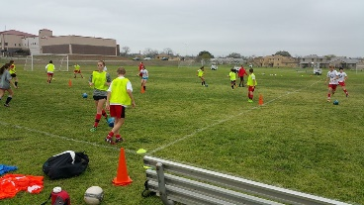
Technique is the defined as the ability to manipulate the ball. The U7 and U8 soccer player will not master the ability to manipulate the ball, but must be introduced to five technical topics so that their ability begins to progress. These technical topics include, dribbling, passing, receiving, shooting, and shot stopping.

Dribbling
Dribbling is the most important technique for the U7 and U8 soccer player. Every player needs to spend plenty of time on dribbling. Players at this age are selfish and are not as open to passing the ball to team mates as they will be later. Do not attempt to change this, instead embrace their selfishness and show them ways to keep the ball.

Keys to Dribbling

Change Direction- The foot can be compared to a steering wheel. When kicking the middle of the ball with the shoe laces the ball will go straight. When kicking the side of the ball with the inside and outside of the foot the ball go to the side. The bottom of the foot can be used to change directions as well.

Encourage players to use different parts of the foot. They can be challenged to repeat patterns and make up their own patterns.

Change Speed- Players need to be encouraged to change speeds. Changing speeds creates problems for opponents that must adjust to the change in rhythm. The bottom of the foot can be used to stop the ball. Players also need to be aware that every time they change direction they should increase their speed. Refer to this as ‘get away speed’.

The use of opposites can be used to get players to change speeds. Stop/Go and slow/fast are good examples of opposites that can be used.

Body Position- Player can be shown that keeping the body between the ball and opponent helps in maintaining possession.

Players will need some spatial awareness to master the use of their body to protect the ball. Spatial Awareness is addressed under tactics.

Sample Session with Dribbling as the Theme

Warm Up  “Everybody’s  It” | Tag game in a 15 yard by 10 yard grid that has player able to tag any player. If a player is tagged they continue playing. As a variation make a condition that the players can only tag a player below the knees.  Introduce the ball. | 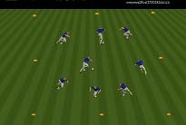
Individual  Activity  “Bumper  Cars” | Players dribble their soccer ball in the same grid from above while attempting to bump their soccer ball into other player’s balls with a pass. | Find opportunities to show players the use of the body to protect the ball from opponents.
Small Group  Activity  “2v1 ladder” | Every player gets a partner and two groups of two play against each other in a 5 by 10 yard grid. The first group of two attempts to get past the first defender who is limited to defending in a 5 yard by 5 yard portion of the grid. When they get through the first portion of the grid they then attempt to get by the second defender who becomes live. | 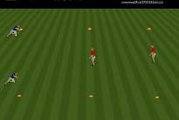  Show the players they can use their team mate to pass the ball to or fake a pass and dribble.  Make sure to change roles.
Game 1  Activity “4v4 to wide  line” | Play 4v4 on a field 25 yards long by 40 yard wide. A goal is scored when the ball is stopped on the line each team is attacking. | 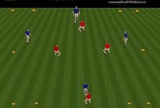  Because the defending team is spread out to defend the entire line, many dribbling opportunities are presented to the players.
Game 2  Activity  “ Traditional  4v4” | Change the direction of the field to 40 yards long by 25 yards wide and place a goal on each end line. | 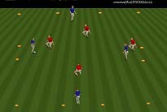  Recognize when players are not dribbling when they have the opportunity.

Passing

The concept of passing the ball to a team mate needs to be introduced. Players can pass the ball with their shoelaces and outside of the foot while in natural running motion. These are the two types of passes coaches can highlight to the remainder of the team when a good example is found. The inside of the foot pass is not natural to the young soccer player and will be introduced at a lager stage in their development.

Keys to Passing

Accuracy
An accurate pass can go to either a team mates feet or to space the team mate is moving into. Accuracy comes from the point the ball is struck with and the follow through.

Pace
The pace of the ball needs to allow for the ball to get to the intended target quickly but not to fast that the player receiving the ball cannot get the ball under control.

Deception
Trickery in passing needs to be encouraged. Passing in natural running motion allows for deception.

Sample Session with Passing as a Theme

Warm Up  “Cone  Knock  Down” | Set up a 10 yard by 15 yard grid with nine inch cones spread through grid. Players dribble through the grid and attempt to knock the cones over with a pass. Players that are successful attempt to pass the ball from further distances. Have players take turns setting the cones back up. | 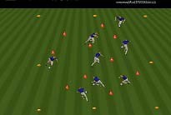  Do not allow the players to stop the ball before making a pass. In the game the ball is always moving.
Individual  Activity  “Gate  Passing” | In the same grid set up groups of two cones spread out a yard apart to represent gates. Groups of two are formed and groups attempt to pass the ball through as many gates as possible. | 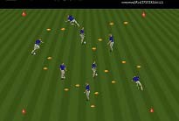  Players keep score and attempt to beat their own record. Show players that they can pass the ball while their partner is still moving towards the gate.
Small  Group  Activity  “2v1” | Groups of four are sub divided into two’s and placed in a ten yard by five yard grid. The team without the ball has one player sit out while the team with the ball attempts to keep possession. When the ball changes possession the player sitting out enters the game and their opponents lose a player. | 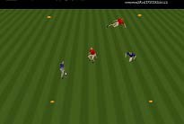  Recognize the issue with poor passing. Was it due to poor accuracy, pace, or a lack of deception?
Game 1  “4v4 altered methods of scoring” | Players play 4v4 to goals on a 40 yard by 25 yard field. Teams that achieve two passes get credit for a goal. Goals can also be scored the traditional manner. | Encourage players to move into open space.
Game 2  “Traditional  4v4” | Conditions are taken off and the only manner to score is to have the ball go through the goal. | Encourage players to move into open space.

Receiving

Receiving needs to be seen as a means to an end and not an end in itself. That is to say receiving the ball is done to get the ball under control so that the ball can be passed, dribbled, or shot. It is also noted that receiving is the #1 reason why possession is lost in the game. Players that have a poor first touch never get the opportunity to dribble, pass, or shoot the ball.

Keys to Receiving

Cushion Control: Players cushion the ball when they space. When cushioning the ball players need to have the ball controlled about a yard in front of them. This allows for the player to be able to have their head up to make decisions while still be able to see the ball.

Wedge Control: Redirecting the ball into open space where the receiver can be the first to the ball is done when the player does not have space. This touch is usually larger than one yard.

Sample Session with Receiving as the Theme

Warm Up  “Self  Serve” | Each Player has their own five yard by five yard grid that they throw the ball up into. They decide when the ball is in the air if they want to receive the ball so that it stays inside the grid or if they want to redirect the ball slightly outside the grid. | 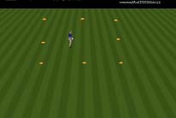  Make sure players get in move their body in line with the ball.
Individual  Activity  “Partner In or Out” | Each player gets a partner who throws or rolls the ball to them and calls inside or outside. On this command the receiving player attempts to follow the directions with one touch. | 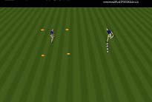  Does the player change relax or tighten their controlling surface depending on the demand of the touch.
Small  Group  Activity  “two touch  3v1” | In a six yard by six yard grid one player defends against three attackers. The three attackers attempt to keep possession. When a player receives a pass they must take a receiving touch before passing. When the defender wins the ball they attempt to dribble the ball outside of the grid. | 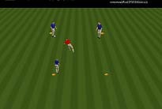  Is the first touch away from pressure?
Game 1  “4v4 with conditions” | Players play 4v4 on a traditional field. When the ball goes out of bounds the ball must be thrown in to players even when the ball goes over an end line. The ball should be thrown to players in a manner that they must take a receiving touch out of the air. | Do the players recognize the appropriate time to cushion the ball and wedge the ball?
Game 2  “traditional  4v4” | Conditions are taken off and the players play a traditional 4v4 game. | Has your session had an impact on the game?

Shooting

Receiving needs to be seen as a means to an end and not an end in itself. That is to say receiving the ball is done to get the ball under control so that the ball can be passed, dribbled, or shot. It is also noted that receiving is the #1 reason why possession is lost in the game. Players that have a poor first touch never get the opportunity to dribble, pass, or shoot the ball.

Keys to Shooting

Low: Players need to understand that shooting the ball low eliminates one way of missing. The ball cannot be shot to low. It is also difficult for the goalkeeper to get their hands down to stop a ball lower than the knees.

Early: Time is at a premium around the goal area. Players that are looking for the perfect shot will not find it as the ball will be disposed. Players need to shoot a moving ball often while they are not balanced.

On target: Shots on target have a chance to go in. Shots off target have no chance to go in. Goalkeeping error and deflections are some of the reason why goals are scored.

Sample Session with Shooting as the Theme

Warm Up  “Fence  Shooting” | Players are taken over to a fence and stand five yards apart from each other and one yard from the fence. They shoot the ball into the fence. | 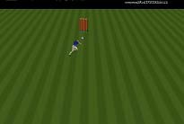  Does the ball stay on the ground? Can the players figure out how to keep the ball low without your help?
Individual  Activity  “Find a  Goal” | Four goals are set up in the corners of a 25 yard by 25 yard diamond grid with a goalkeeper. Surplus of ball are kept in the center of the grid. All other players begin in the middle and attempt to score as many goals as possible in 30 seconds. They cannot go to the same goal consecutively. Have goalkeepers restock ball that are saved. Use parents to restock goals and shots off of target. Roles are switched each 30 seconds and players attempt to beat their own record. | 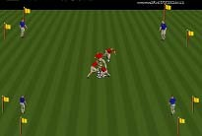  Do player have a sense of urgency? Are they striking a moving ball?
Small Group  Activity  “1v1 to  Goal” | Groups of four are subdivided into groups of two and are separated by a goal. Each group of two plays 1v1 to the goal. When the ball crosses the line the goal is on with a goal being scored or the ball going out of play the group on the side the ball just came to play with this ball. | 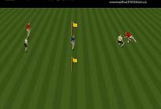  Do players recognize the half chance? Do players anticipate where the ball will be played?
Conditioned  Game  “4v4 on small field” | Players play 4v4 on a twenty yard by twenty yard field. | 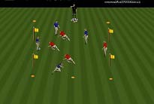  Are the players thinking about scoring a goal each time they get the ball?
“Traditional  Game” | Enlarge the field to 40 yards by 25 yards and continue to play 4v4. | 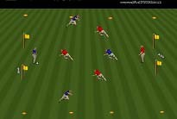  Has your session had an impact on the players?

Sample Session with Shot Stopping as a Theme

Warm Up  “Hot Potato” | All players begin in a grid with three soccer balls. They throw and catch the soccer balls to each other while moving. Each player must hold the ball for three seconds in order to make sure they secure the ball before beginning their throw. | 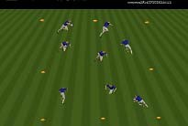  Are the players getting in the path of the ball?
Individual  Activity  “Keeper in the Middle” | Groups of three are formed and are given a goal. One player stands in goal while the other two players go to opposite sides of the goal. The players not in goal take turns shooting while the player in goal plays keeper. | 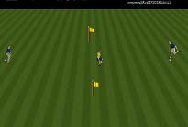  Make sure you rotate the keeper. Is the keeper securing the ball?
Small Group  Activity  “Goalkeeper Wars” | Groups of two are placed on a field that has two goals separated by ten yards. Each player defends a goal while attempting to score in their opponent’s goal. | 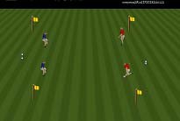  Are the keepers hands relaxed?
Conditioned Game  “2v2 to goal” | Players play 2v2 with one of these players playing the position of keeper on a field 15 yards by 15 yards. | 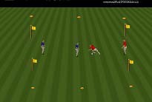 Does your keeper move their feet to stay in position?
Traditional  Game  4v4 + keepers | End your session with a traditional 4v4 game on a field 25 yards by 40 yards. | 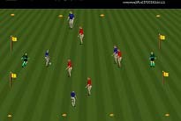  Has your session had an impact on the players?

Tactics

Tactics are defined as decisions players make. For the U7 and U8 age group coaches need to build a foundation that allows players to use their technical abilities while setting up the players to be ready to progress to older levels. Not all players will master the topics, but by introducing the players to these concepts we are planting seeds that will eventually grow.

The tactics that need to be introduced at the U7 and U8 age group are spatial awareness, transition, splitting, team shape, risk taking, and possession with a purpose.

Spatial Awareness

While watching a high level soccer game we sometimes notice a player looking over their shoulder before they receive the ball. This player is trying to gain information to allow him/her to make a good decision in regards to playing the ball. Checking while the ball is almost in possession is late. The player needs to be aware of the space around him/her prior to the ball being played. Scanning the field needs to be a constant at the highest level throughout the entire game. The requirements of the top level show that the best players have the ability to scan the entire field

When players are aware of their position on the field relative to the ball, opposition, team mates, and the goal they have all of the information in hand to put themselves in a position to help their team. Developing spatial awareness can start at the U8 age level by adding simple conditions to your activities. We can be satisfied with U8 players if they can scan a five yard radius around themselves.

Coaching with conditions: Activity or game has an objective but players are required to meet the demands of an additional rule within the game or activity

When using conditions at the U8 group it is important to note that not all players will be able to meet the demands of the additional rule. Do not make unrealistic demands of players that are not able to play by with the conditions. Find positive coaching moments that can highlight players that have been able to meet the conditions and point out the benefit they received by being able to recognize the space around them.

The condition recommended for U8 players to begin to develop spatial awareness is that during activities all players must point to the player or opponent closest to them. This requires the player to know who is in their immediate space. This condition can be used in any dynamic activity. During opposition activities the player will not only gain information about the closest opponent, but they will also be able to put this information into use.

Sample session with a Spatial Awareness Theme:

Warm Up ”Who is behind You” | Players run around a 15 by 15 yard grid. On the coaches command of freeze all players must look directly at the coach. The coach then asks some players who is behind them. The players attempt to tell the coach the name of the person out of their line of vision without turning. | 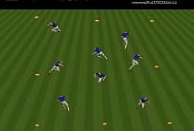  Are the players running with their head up and looking around?
Individual  Activity “Who is closest to you” | Each player dribbles the ball throughout the grid while pointing to the player in the gird they are closest to. The demands of the activity will require the player to constantly change who they are pointing to. | 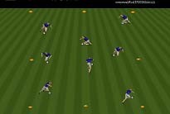  Can the speed be increased as the activity progresses?
Small Group  Activity  “Where are  You” | Make groups of four and play a 3v1. Each attacking player has a ball and dribbles in an 8 by 8 yard gird. The attacking players must point to the defender while they are dribbling in the space. | 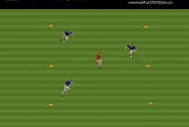  Are the players avoiding the defender when they are aware of his/her position?
Conditioned  Game | Players are required to point to the opponent in a small game.  Both teams attack a goal. Begin with the smallest number that allows all players to be on task. | 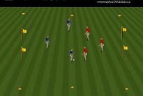  Are player turning into pressure?
Game | Take the restriction off of the players in the same game. | Has the session had an impact on the players?

The use of this condition can be used during the game portion of at every other practice

This condition allows the coach to see who can play within the new rules. The coach can also see the information the players have while they are playing. When a player turns into an opponent, the coach now knows if the player did not know the opponent was in this space or the player decided he had enough space to control the ball before the opponent could tackle.

Directional Possession

Possession in soccer comes in two varieties. The first variety is for a team to keep the ball while gaining territory in an effort to create a scoring opportunity. The second variety can be divided into two categories both of which should lead to the variety to gain territory in an effort to create a scoring opportunity. These two categories include passing the ball for the sole purpose of relieving pressure and passing the ball because a forward option is deemed to risky and the player receiving this pass will have a better chance to play a forward ball.

With this in mind, coaches must avoid having their team possess the ball for the sole purpose of possessing the ball. The best way a coach can avoid possession for the sake of possession is to put players in activities that have a direction to attack and a direction to defend. Reasons for directional possession include:
- More like the game
- Realistic Shape
- Realistic Defending
- Players must make decisions in regard to the variety of possession oriented passes
- Presents more realistic opportunities to effect players through coaching moments

Another point coaches need to emphasize in directional possession sessions is the need for diagonal balls. Square passes are very risky and do not create space or put defenders in a non-goal side position of the ball. Forward passes place defenders in a non-goal side position; while, negative diagonal balls force defenders to move up and over. When they move up space is created.

The final issue a coach needs to address in when coaching directional possession is the use of numbers down attacking. When a team possesses the ball in the attacking third they will be numbers down. When training a team with possessing the ball in the buildup make your session more realistic by having the attacking team play numbers down.

Warm Up  “Gate  Passing” | In 20 yard by 20 yard grid set up groups of two cones spread out a yard apart to represent gates. Groups of two are formed and groups attempt to pass the ball through as many gates as possible. | Players keep score and attempt to beat their own record. Show players that they can pass the ball while their partner is still moving towards the gate.
Small  Group  “Directional  2v2” | In the grid from above a target player is set up in each corner. Targets are designated by team color and are team mate targets are in opposite corners. 2v2 is played in the middle with the goal of playing to the feet of the target. When the  target is played the player who made the pass becomes the target and the | 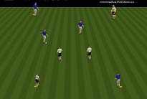  Are players looking to go forward?
 | target enters the field and play continues 2v2 to the opposite corner target. When possession is turnover the opponent plays in to their targets.
Small  Group  “Directional  3v3” | Same as previous but 3v3. | 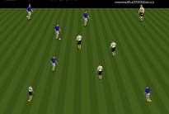  Coach must anticipate as numbers increase the chance for missed opportunities to miss forward passes increases.
Conditioned  Game  “3v3” | 3v3 on a field 25 yards by 40 yards with the condition that only forward passes can be made. | Enforce condition.
Game | 4v4 on a field 25 yards by 40 yards | Has the session had an impact on the players?

Splitting

Splitting is a defensive principle. Splitting occurs when one defender must cope with two attackers that are working together. The defender must split the attention he/she gives to each player. The defender must present take up an angle and distance that will allow them to stop the ball when dribbling is used to advance the ball, but also be in a position to stop the ball when passing is used.

When we introduce splitting at this age, the game begins to teach players concepts that will be needed later. Some of these concepts include:
- Patience
- Cover
- Balance
- Spreading Out
- Numbers Up/Numbers Down Principles

Warm Up 1v1 | In a 10 by 15 yard grid two players begin at opposite end lines. The player with the ball attempts to dribble the ball over the opposite end line. When the ball is first touched the defender becomes active. When the defender wins the ball roles are reversed. | 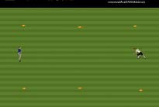  Make sure the defender assumes good a good defensive stance and position.
Small  Group  2v1 Splitting | In open space two attackers attempt to attack a small goal be protected by one defender. The defender cannot stay back at the goal. | 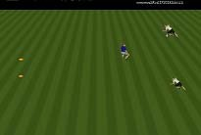  Does the defender pick a distance and angle that allows splitting to occur?
Small  Group  2v2 Splitting | In a 15 by 20 yard grid two attackers attack one defender and a target. When possession changes roles reverse. | 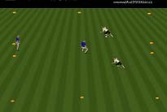  Does the defender pick a distance and angle that allows splitting to occur? Do they alter their angle
 |  | from the previous activity to prevent penetrating pass to the tarter?
Conditioned  Game  3v3v3 | In a 40 yard by 30 yard grid three teams of three are formed with a team defending each goal and the remaining team with a ball attacking either side. When a goal is scored, the ball is lost, or the ball is played out of play possession changes. These two teams change roles and the new attacking team engages the resting team. | 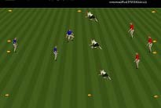  Do players recognize splitting opportunities?
Game | Players play 4v4 to goals on a 40 yard by 30 yard field. | Has your coaching had an impact on the players?

Transition

The game of soccer has been divided into attacking and defending by many coaches. For the purpose of coaching U7 and U8 we are not going to spend time on defense as the time is better spent on developing attacking play. But we do want to take advantage of the opportunity to establish the habit of transitioning between attack and defense in our players. Coaches can use a variety of coaching methods to introduce transition into existing activities in an effort to include the transition state. When transition is incorporated into an activity the game is more game like and players develop transition qualities in a habitual manner.

The first aspect of transition coaches need to address is the mental aspect. Players need to be able to switch their mindset from attack to defense as soon as possession of the ball is lost; and of defense to attack once possession is regained. Most coaches loose opportunities to train the mind to make the transition in stages during training sessions. A simple example of this is in the traditional 3v1. When the one defender wins possession of the ball the coach normally has the activity stop and either allows the defender to switch with an attacker or instructs the defender to give the ball back to the attackers. Neither one of these actions is game like. Do you want your players to give the ball back once the won possession from the opponent in a game? If your answer is no, and it needs to be, adapt the activity to allow for the players to transition in mind and action. A simple change in conditions instructs the player who wins the ball to attempt to dribble the ball outside of the boundaries will incorporate transition in that the original defender will attack open space while the three original attackers attempt to compact the space.

This same manner of adapting activities to allow for transition can be used in every activity that has opposition and even some activities without opposition. The coach must ask themselves the questions of ‘What are the demands of the activity on each side when possession is won or lost?’ Give each side an objective.

Although every activity with opposition needs to incorporate transition we have given a sample transition session that each coach can run with there team.

Sample session with a Transition theme

Warm Up  “Floating  Base Tag” | Each player gets a partner and they stand together shoulder to shoulder. One group divides with one player becoming the chaser and one player being chased. When a tag occurs the players switch roles (transition). At any time the player being chased can get out of being chased by standing next to a group of two. The player on the opposite side of the formerly chased player becomes the new chased player (transition). | 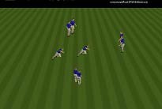  How quick do the player’s minds change when their roles switch.

Individual  Activity  “Knock Out” | Each player dribbles a ball in a 15 yard by 10 yard grid and attempts to kick the ball of other players out of the grid. When a player has their ball kicked out of the grid they must run after the ball and get to it before it stops rolling. If they get to the ball prior to the ball coming to a stop they can come immediately back into the grid, if they do not get to the ball in time they must perform a small penalty such as ten ball touches before re-entering the game. | 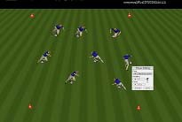  Do players immediately chase  the ball when they are disposed?
Small Group  Activity  “2v2” | Players play 2v2 possession in a 10 yard by 15 yard grid. | 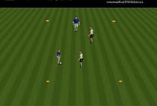  Can the players play away from pressure when the ball is won?
Conditioned  Game  “4v4 with alternative  scoring  method” | Any team that can score a goal within five seconds of winning the ball gets an additional goal. Variation: Give points for winning the ball back within five seconds. | Are the player’s minds transitioning between attack and defense and vice versa?
Traditional  Game  “4v4” | Traditional 4v4 game on a 40 yard by 25 yard field. | Has your session had an impact
 |  | on your players?

Risk Taking/No Fear of Failure

Risk taking is needed at the highest level and most coaches discourage risk taking at the lowest level. When coaching U7 and U8 players we need to create an environment that has no fear of failure when taking risks. Risk taking and creative play is most often found in dribbling, but coaches need to encourage players to take risk while passing and shooting.

Observations from U7 and U8 games in the past shows: In the games that had creative dribbling, the coach seemed frustrated that the player desired to use their individual talents to benefit the team. As teams get older, we see more organized defenses. Creativity breaks down organization. We need to encourage creativity and give players the green light to experiment throughout their younger years in the game.

A coach that encourages risk taking enthusiastically encourages players to dribble in 1v1 situations. When a player is able to beat an opponent on the dribble the defense is at a great disadvantage. The creative dribbler needs to be cultivated and encourages as success will not always come immediately.

A coach that encourages risk taking promotes players to look for and take scoring chances. Praise needs to be heaped on players that take risks in attempting to score goals.

A coach that encourages disguise in passing is promoting risk taking. Fake kicks, passes with the outside of the foot or heal are examples of creative play in passing.

Creating an environment that has risk taking and a lack of fear of failure needs to be cultivated throughout the players U7 and U8 soccer seasons in all practices and games.

Connection and Team Shape

Connection
A team that is separated has one or more players far away from the ball. This is usually seen by a defender staying very close to the goal they are defending while their team is on the attack or a forward player who does not recover while their team is defending.

No basketball teams attempt to score by leaving a player back to protect their basket. Soccer defending needs to start as far away from the defensive goal as possible. If the ball can be won close to the opponent goal your team has a short distance to go before a scoring opportunity is created. If your team makes a defensive mistake away from your goal they have the rest of the field to recover.

Allowing your attacking player to stay around the goal you are attacking does not make sense either. This player is not connected to the ball and cannot help in defensive duties. They are too far away from the goal to be an outlet and more than likely in an offside position.

A connected team is able to defend as a unit and support the ball in attack.

Team Shape
Beginning at the U7 age level players need to be introduced to the diamond shape. Do not spend much time on the concepts at the U7 age group as the players will not be able to put the diamond shape into play. Find positive coaching moments when players are in a diamond and positive results followed. As players progress through the end of the U8 season the players need to be exposed to all of the information below and coaches will see the diamond shape in games on an irregular basis.
The diamond shape in soccer is the basic tactical building block. In the diamond, all individual and group tactics can be executed. Before coaches use the diamond as a building block for teaching tactics the players must understand the body positions and specific roles to the positions in the diamond. It is important to note that players rotate positions throughout effectively played 4v4 or 4v4 + goalkeeper activities.

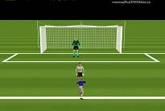
Body Positions

- Facing Goal – A player is facing goal when their hips are open to the goal they are attacking. The deep player in the diamond has the prominent body position is facing goal.
The player in blue is facing goal.
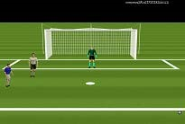
- Side On – Playing side on refers to a player who has their side facing the goal. By playing side on, the player can have their hips open to the majority of the field that will always include the ball and at times include a goal. The wide players in the diamond have the prominent body position of side on.
The player above in blue is in a side on position.
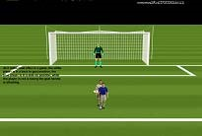
- Back to Goal – A player with their back to goal is facing the goal they are defending. The target player in the diamond has the prominent body position of back to goal.
The player in blue to the right has his back to goal.

The Role of the Deep Player
- Recognize visual signs- When in possession of the ball the opposition's position on the field dictate where the ball can be played. When the middle is cut off at least one wing is open. When the wings are cut off an angle in the middle can be found.
- Support- The deep player must support the ball. The angle and distance of the support is depending on the pressure on the ball. When the ball is under low pressure the deep player can go in advance of the ball.
- Connect/balance- By moving up and down the field in relation to the ball the deep player stays connected to the wide players and the target player.
- Circulating- The deep player must have the ability to play the ball away from pressure. Circulating the ball from one side to the other is a role provided by the deep player.

The Role of the Wide Players

- Support- The wide player must find passing angles when the deep and target player have the ball. The distance and angle of support changes according to the amount of pressure on the ball. Wide players need to understand the angle and distance relationship to pressure.
- Connect- The wide players connect the deep player to the target player. This transitional component is tested when the ball is played from the back to the target player. The wide players act as a piston throughout the game. • Timing of Runs- The wide player needs to time runs when on non ball side. Runs are set up to arrive to the space as the ball arrives. Wide players are also encouraged to make early runs for the defense and late runs for the ball.
- Support to feet or to Space- Wide players must know when the player with the ball needs them to stay and support the ball for a pass to feet and when they can make a run for a ball to space.

The role of the Target Player

- Check to the ball- The target player must be able to check to the ball effectively. Checking to the ball separates the player from the opposition and creates space. • Playing with back to goal- The target player must be able to hold possession of the ball until help arrives. The back to goal position is used to hold possession. The target player must be strong on the ball to play with their back to goal and must be able to find supporting player while under pressure.
- Diagonal Runs- The target player needs to be able to time diagonal runs to receive the ball on the move near the sideline. Diagonal runs are also used to create space in the middle of the field for team mates.
- Runs for through balls- The target player must be able to time runs to stay on side for through balls. The target player needs to understand when to make runs from the defenders blind side and when the run can be made in front of the opposition.
We have not given a team shape progression as the coach can develop the player’s knowledge of the diamond throughout the game portion of every practice.

Coaching in a Game

Coaching during the league games is the most difficult challenge you will face. Your expectation combined with parent and player expectations often conflict with the developmental approach that is needed for players to thrive and play in a risk free environment. Many of the issues addressed in the Problems of Youth Coaching section are found in game coaching.

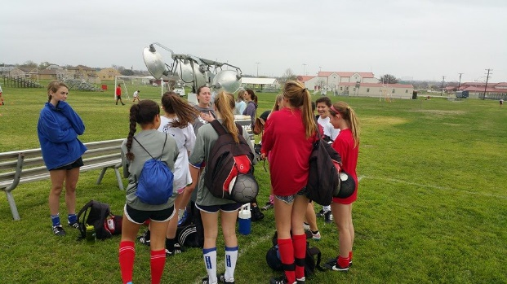
Over coaching is a major problem. The game of soccer is different than most American sports in the fact that the role of the coach is extremely limited. You will not have time to call plays and do not have the option of calling a time out. Soccer is a game for the players. The players need to be able to play in the game without directions on the decisions they face. Do not tell the player to pass, dribble or shoot. By the time they have received the information the situation has changed. As a general rule, coach within your personality. Some may sit and watch the game without giving any directions. Some may coach over the top. Be careful not to coach over the top constantly as the players will turn your voice off. When coaching over the top limit the information to directing players on staying involved in the game. You will need to go over soccer vocabulary.

Restarts

Prior to the first game you will need to rehearse restarts. Restarts occur every time the ball goes out of play and when the referee blows the whistle to make a call. You need to encourage your players to get the ball back into play as quickly as possible. Restarts are usually lost possessions as the defensive has time to get in position. Instruct the player closest to the ball when the restart occurs to get the ball back into play immediately.

You can show the players the correct method of throwing the ball back into play. A throw in occurs every time the ball goes over a sideline. The ball is always kicked back into play when it goes over an end line. When the attacking team plays the ball over an end line a goal kick is taken by the defending team from inside the goal box. When the defensive team plays the ball over the end line a corner kick is taken by the attacking team from the corner of the side the ball was played over.

Your team will gain an advantage by getting the ball back into play as quickly as possible and the players will develop the habit of not resting mentally during stoppages. This also keeps the ball in play longer which allows the players to play more and develop their soccer abilities.

Pre-Game Warm up

The purpose of the warm up is to prepare the players physically and mentally for the game. It is not advisable to have your players stand in line waiting to take a shot during the warm up. The demands of the game are that players are moving while the ball is in play. Standing does not prepare the players for the match.

A proper warm up puts players in situations similar to the game. You can use directional possession games or even a small sided game.

During Play

Be calm, respect the referee, and measure your words. Each player must play half of each game, and you should prepare a substitution pattern before the game. This pattern may have to be adjusted for players that you planned on attending that failed to show. It is appropriate to give players information on improving their play when they come off the field, but keep in mind they have a short memory and may not be able to relate to the specific situation you refer to. This brief conversation can establish a good relationship between player and coach when the information is positive in nature.

Half Time

Make sure all the players have had time to get a drink. Ask the players on their thoughts on the game. The first few times these questions are asked you will not receive much feedback, but as the season progresses the players will get better at communicating their thoughts. It is also a good idea to ask specific questions to help in the dialog. Limit your feedback to one or two areas that can be improved and be sure to be positive.

Post-Game

Focus on the process and not the result. Give your team a positive greeting after the game regardless of the outcome. Focus on positives and areas the team can improve upon. Keep the team talk brief as the children have a very short attention span.

Characteristics of U7 and U8 Soccer Players

Physical

Characteristics | Implications for Soccer Coaches
Skeletal System is still growing; growth plates are near joints. | Injuries at or near joints need special attention.
Cardiovascular system is less efficient than an adult’s, a child’s heart rate peaks sooner and takes longer to recover | Activities need to have a work to rest ratio of 1:1, or when all players are active frequent breaks are needed.
Temperature regulation system is less efficient than an adult’s children elevate their core body temperature more quickly and take longer to cool down than adults | Activities need to have a work to rest ratio of 1:1, or when all players are active frequent breaks are needed.
There is perceivable improvement in pace and coordination from U6 to U8, however the immaturity of a U8’s  physical ability is obvious | The player’s head is still not proportionate to their body when compared to older children. Keeping the head steady in movement needs to be an emphasis.
Movement education approach is still important | Functional balance and changing speeds needs to be an integral part of every coach’s seasonal plan

Cognitive

Characteristics | Implications for Soccer Coaches
Concrete operational stage of cognitive | Players can understand the reasons for
development (Piaget). Children begin thinking logically about concrete events, but have difficulty understanding abstract or hypothetical concepts. | skill acquisition but will not understand team concepts.
Limited ability to attend to more than one task at a time the simple task of controlling the ball demands most of the attention capacity, thereby leaving little or no capacity for making tactical decisions. | The simple task of controlling the ball demands most of the attention capacity, thereby leaving little or no capacity for making tactical decisions.
Concept of time and space relationship is just beginning to develop and will be limited by capacity to attend to multiple tasks | Spatial awareness can be introduced.
Limited experience with personal evaluations; effort is synonymous with performance, “if I try hard, then I performed well”, regardless of the  actual performance | Positive comments in regard to play and effort are needed.
Beginning to categorize information,  some relationships that “do not” exist  are assumed | Coaches need to be clear with information and can ask for feedback to determine players’ understanding
Players can recognize demands | Players can be held to standards in effort.
Attention can be grabbed, if something else is more interesting attention will go to it | Dynamic coaching is needed. Make sure when addressing players they are facing away from activities.

Psychosocial

Characteristics | Implications for Soccer Coaches
Self concept and body image are  beginning to develop, very fragile | Coaches should not make comments  about the children’s physical appearance.
Great need for approval from adults such as parents, teachers and  coaches, like to show individual skill | Showcasing players in front of their peers can be used. It is recommended when showcasing girls, more than one girl at a time performs the skill.
Easily bruised psychologically by both peers and adults negative comments  carry a great weight | Positive coaching is needed as negative comments carry a great weight
Like to play soccer because it is “fun”, intrinsically motivated | Team snacks can still be a part of the post game routine; however, the snacks should be nutritious and not over emphasized.
Their universe is expanded to the  neighborhood | As players become more independent they can be required to maintain equipment themselves. This includes carry bag to and from car.
Team identity is limited; “I play on coach Bob’s team” or “I play on the tigers” – club and league concepts are non-existent | Players can have input in team name and team cheers.
There is a desire for social acceptance, they want everybody to like them | Team building activities off the soccer field will build a closer team

Appendix 2

Technique Directory

Dribbling

Dribbling to beat an opponent

What: | Manipulation of the ball to beat an opponent by oneself
Where: | The attacking third and wide positions are the best places to take on opponents.
Why: | To unbalance the defense; create scoring opportunities.
When: | Space is open behind the opponent
How: | Step 1: Be relaxed and balanced on the ball  Step 2: Keep the head up in an effort to be able to see opposition, team mates, and options.  Step 3: Keep knees bent for explosive changes of directions and speed.  Step 4: Bend at the waist for explosive changes of directions and speed.  Step 5: Use different surfaces of the foot  - Instep (shoelaces) to go straight  - Outside of the foot to turn  - Inside of the foot to turn  - Sole of the foot to change directions with a hesitation
Step 6: Use a small touch to fool the opponent and a big touch to get past the opponent.

Step 7: Use a fast get away.

Step 8: Cut the ball behind the opponent to close of the pursuit angle

Dribbling to take up space (Running with the Ball)

What: Taking space with the ball quickly by the player with the ball

Where: Can take place all over the field

When: In cases where space is available in front of the ball

How: Step 1: Recognize open space

Step 2: Step through the ball the instep of the foot. The toe must be pointed down and the touch needs to be large enough to allow for two to three full strides before meeting the ball again.

Step 3: Keep the head up and repeat as needed.

Dribbling to maintain possession shielding

What: Protecting the ball with the body until a good option becomes available

Where: Can take place all over the field

When: Space is not available behind the opposition and support is not available

How: Step 1: Get your body between the ball and the opposition

Step 2: Have the ball as far away from the opponent and in reach of yourself.

Step 3: Hold your arm closest to the opponent bent at the elbow and parallel to the ground to be able to feel the opponent and protect the space.

Step 4: Keep knees bent to become harder to knock off the ball and head up to look for support.

Step 5: Maintain a position that has the body between the ball and the opponent

Passing/Shooting

Driven Pass/Shot

What: A powerful pass taken with the instep of the foot (shoelaces).

Where: Distance

Why: Powerful and can be done in natural running motion

When: As early as possible

How: Step 1: The leg swings from the hip, and the hip is a ball and socket joint; therefore, the ball can be approached from a slight angle.

Step 2: Place non kicking foot even with the ball about 6 inches from the ball with the toes pointed to the target.

Step 3: Lock the ankle of the kicking foot with the toes down. The angle between the leg and foot is barely obtuse.

Step 4: Draw the kicking foot back.

Step 5: Strike through the midline center of the ball.

Step 6: Follow through in the direction of the ball while landing on the kicking foot.

Outside of Foot Pass/Shot (short distance)
What: | Short pass with the outside of the foot that is played at an angle of the direction the player is facing
Where: | Anywhere on the field.
Why: | Deceptive and player does not have to impede natural running motion in order to make pass
When: | While in natural running motion
How: | Step 1: Approach the ball from straight on while running
 | Step 2: While in natural running motion place the non kicking foot behind the ball.
 | Step 3: The toe is pointed down in the next step that goes through the midline side of the ball

Toe Poke Pass/Shot

What: Shot taken with the toes

Where: Near the goal

Why: Quickest way to get a shot off

When: Player does not have time to set up shot

How: Step 1: Quickly stab through the ball

Step 2: Short follow through

Receiving (First Touch Control)

Cushion Foot
What: Gaining control of the ball played to the foot by withdrawing the foot on impact.

Where: Everywhere on the field.

Why: A controlled ball is easier to pass, dribble or shoot.

When: Player has time and space.

How: Step 1: Get in the path of the ball.

Step 2: Put the foot out in path of the ball.

Step 3: Loosen the foot.

Step 4: Just prior to impact begin to pull the foot back.

Wedge Foot
What: Gaining control of the ball played to the foot by redirecting the ball.

Where: Everywhere on the field.

Why: A controlled ball is easier to pass, dribble or shoot.

When: Space and time is limited.

How: Step 1: Get in the path of the ball.

Step 2: Put the foot near the path of the ball.

Step 3: Lock the ankle and tighten the muscles of the foot.

Step 4: Push the ball into the intended direction.

Cushion Thigh
What: Gaining control of the ball played to the thigh by withdrawing the foot on impact.

Where: Everywhere on the field.

Why: A controlled ball is easier to pass, dribble or shoot.

When: Player has time and space.

How: Step 1: Get in the path of the ball.

Step 2: Put the fat part of the thigh in the path of the ball.

Step 3: Relax the thigh.

Step 4: Just prior to impact begin to pull the thigh back.

Wedge Thigh
What: Gaining control of the ball played to the thigh by redirecting the ball.

Where: Everywhere on the field.

Why: A controlled ball is easier to pass, dribble or shoot.

When: Space and time is limited.

How: Step 1: Get in the path of the ball.

Step 2: Put the thigh near the path of the ball.

Step 3: Tighten the muscles of the thigh.

Step 4: Push the ball with the thigh in the intended direction.

Sample Model Training Sessions

Dribbling

Warm Up  ‘Geography Dribble’ | Cones are spread out through a grid and labeled with a city or country name. Players dribble throughout the grid and dribble around the cone labeled with the country or city the coach calls out. | 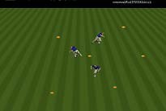  Can the players change speed when the location is called?
‘Open and  Closed  Gates’ | Players attempt to dribble through open gates. The coach and assistant coach stand near or inside a gate. Standing inside a gate closes the gate and the players must move to an open gate. Coaches can move to different gates. | 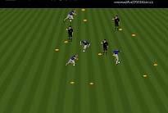  Can the players find the open gates?
Pair Tag | Players are placed in groups of two and one player becomes the chaser who attempts to tag their partner. Every time a tag occurs the roles change. | 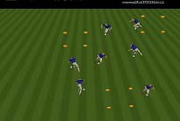  Change of direction/change of speed need to be used.
Base Tag | This tag game has everyone able to tag anyone. The grids represent bases that protect players from being tagged. Only one player is allowed in a base at a time. When a new player enters the base the existing player must exit. | Keep your head up.
Personal Base Tag | Same a previous activity but the players activate a base by stopping the ball. They can only stop the ball for five seconds. Encourage the players to accelerate out of the stop position. | 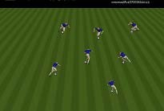  Change of speed.
3v3 | We now end the session with a small sided game on a wide field. Wide fields present more opportunities to dribble as the defense is spread out. | Has your session had an impact on the players?

Cone Switch | Players perform ball touches at a cone. On the command of switch each player dribbles to a new cone. | 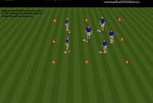  Do the players have their

 |  | knees and waist bent?
Bumper Cars | Players dribble through grid and attempt to hit other player’s balls with a pass. | 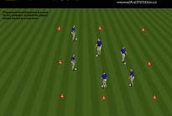  Head up.
Cross the Bridge | Players attempt to dribble through the gate in the middle of the grid and then out of the grid as many times as possible | 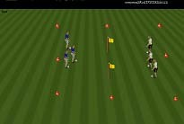  Vision, change of direction
Traffic  Guard | Players start spread out and dribble in the direction the coach calls out. The coach can call for the players to switch directions and dribble through diagonally. As a variation the coach can use visual signs as an alternative to verbal commands. | 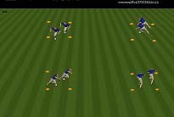  Vision, change of direction
One Vs  All | In a field with gates, players play for themselves attempting to dribble through gates. Have about 1 ball for every two players. | 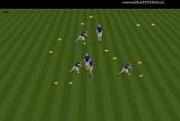  Body between ball and the opposition.
3v3 | We now end the session with a small sided game on a wide field. Wide fields present more opportunities to dribble as the defense is spread out. | Has the session had an impact on the players?

.

Liverpool Dribbling | Players are grouped by three and dribble back and forth. The coach can place restrictions on the number of touches such as no more or less than three touches. The coach can also require patterns such as stop and starts. | 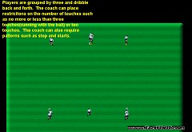  Speed by taking the ball in step.
Body Part Dribbling | Each player dribbles the ball in a 15 yard by 15 yard grid. When the coach calls out a body part the players must stop the ball with a foot and place that body part on the ball. | 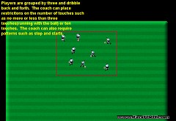  Change of direction
Shielding | Groups of two are formed with one ball. The player with the ball attempts to keep possession of the ball without running away. When the ball is lost, roles change. | 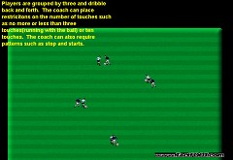  Does the player with the ball keep their body between the ball and the opponent?
1 Vs. 1 with bail out | Groups of two from the activity above combine with another group and play 1v1 in a 10 yard by 15 yard grid. The player with the ball can attempt to dribble by the opponent or may elect to pass the ball back to their team mate who then plays 1v1 against the other resting player. | 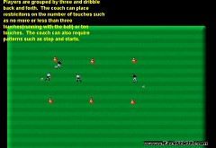  Do players dribble when the have speed and space? Do they pass when one or these is not present?
4v4 Dribble over end line to score | By using an end line as the goal the opposition is spread out and more dribbling opportunities are presented. | 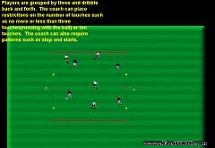  Has the session had an impact on the players?

Shopping | Each square is named after a children’s store such as Toy’s ‘R’ Us. The players dribble around the area and when the coach calls out the store name the players dribble to that store as quickly as they can. | 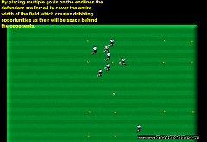  Coaching points include acceleration, dribbling with the head up, and change of direction.
Fish Game | Each player (fish) with a ball swims (dribbles) around the space. When the coach calls out storm, the fish swim to their assigned fish home. The coach can act as a fisherman during storms and attempt to tag (catch) fish. A fish can be rescued by a fish from the same home during a storm. | 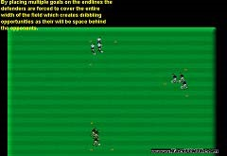  Acceleration, change of direction
Nickel or Dime | Players are split into groups of two. They play 1 Vs. 1 by attempting to touch a cone with the ball. They receive a nickel for touching a side cone and dime for touching the cone the opponent started from. First player to reach twenty five cents wins the game. | 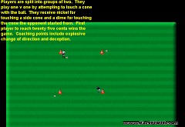  Coaching points include explosive change of direction and deception.
Attack/Defend to corner goals | Players are divided in half. Each player attacks once and defends once per turn. Goals are placed in the corners to encourage unbalancing the defenders. | 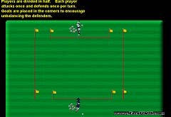  Are the players changing direction or using speed?
4v4 (eight goal game) | By placing multiple goals on the end lines the defenders are forced to cover the entire width of the field which creates dribbling opportunities as their will be space behind the opponents. | 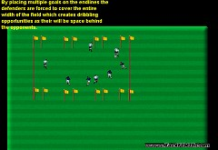  Do players recognize the visual sign to dribble? Space

Passing

Ball  Retrieval | Groups of two are formed and each group needs a ball. Each group brings the ball to the coach. The coach throws the ball and the group of two must return the ball following the conditions set.  Conditions can include # of passes and # of touches. | 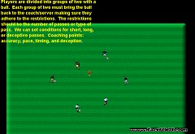  Accuracy and Pace
Gate  Passing | Set up groups of two cones spread out a yard apart to represent gates. Groups of two are formed and groups attempt to pass the ball through as many gates as possible in 30 second intervals. Players attempt to beat their record. | 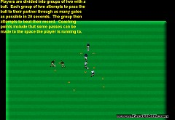  Can players have the ball arrive when the player arrives?
2v2+2 | Three groups of two from the previous activity join to form a group of six and play 2v2 with 2 neutral players. The neutral players always play on the team in possession of the ball. | 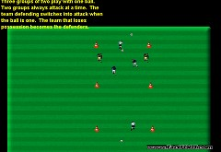  Deception in passing.
2v2  Possession | The neutral players are taken away. | 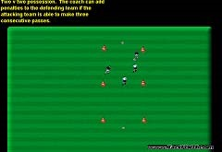  Pass-Move. Pass-Move.
4v4 |  | Has your session had an impact on the players?

Tunnel Passing | Players find a partner and a ball. One player stands with their legs open while the other player attempts to pass the ball through their legs. Roles then flip. This rotation continues for 30 second intervals. The group counts their successes and attempts to beat this record. | 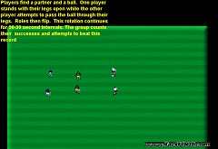  Pace of the pass.
Frost Tag | The group is divided into two and each player in a sub group gets a ball. This group then attempts to pass the ball and hit the players in the other group. Players that are hit must freeze with their legs open. The players can be unfrozen when a player on their team crawls through their legs. | 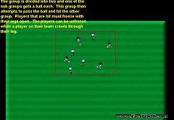  Can player’s time hitting a moving target?
3v1 | The group of three attempts to keep the ball away from the one. When the one wins the ball they attempt to dribble the ball out of the square. | 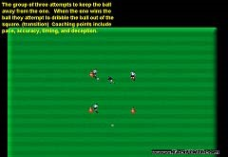  Make the simple pass.
2v1:1v2 | Each player finds a partner. Each group of two now plays a possession game against another group. The defending team has one player sit out until the ball is won. Every time the ball changes teams the team that won the ball adds a player while the team that lost the ball loses a player. | 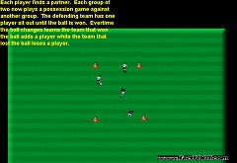  Pass-Move. Pass-Move.
4v4 | A traditional sixe field encourages passing. If you desire to see long passes you can make the field longer. | 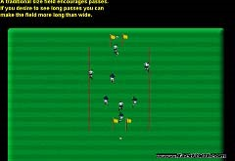  Has the session had an impact on the players?

Shooting

Marbles | Every player has a partner. One of the players in each group shoots the ball across the field. The other player then attempts to hit this ball. Each player continues attempting to hit the other player’s soccer ball. | 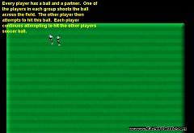  Non kicking foot needs to point to the target.

Rapid  Training  Shooting | Groups of three as in diagram to the right. Player who is not shooting must anticipate where the ball will be played. Shooting activity must be realistic so require the players to shoot a moving ball. | 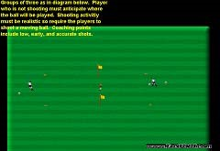  Is the activity realistic in distance and time?
1v1:1v1 | Opposition is added to previous activity to create a 1v1 situation on each side. The player with the ball goes to goal. Players on the non-ball side need to be encouraged to anticipate the bal coming to their side. | 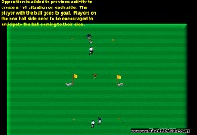  Early chances can be toe pokes.
3v1 to goal | A three Vs. one in between two goals. The three can only shoot after three passes at the goal they are facing. The defender can shoot unrestricted at either goal when gaining possession. | 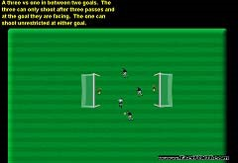  Shooting from close distance is passing into open space.  Finishing
4v4 shooting | By shortening the length of the field the players are closer to the goal and more shooting opportunities are presented. | 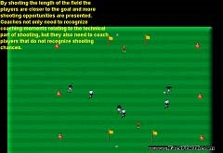  Has the session had an impact on
 |  | the players?

Fence  Shooting | Players in groups of two at a fence. Once player shoots into the fence while the other sets the ball up. The coach can take a position behind the fence so they can sell all of the mechanics of each shot. | Players need to follow through so that they land on their shooting foot.
Rapid  Shooting II | Players in groups of two with each one defending a goal. Make sure we have an ample supply of balls on hand. Each player shoots at their partner’s goal. Make sure the players are shooting a moving ball. | 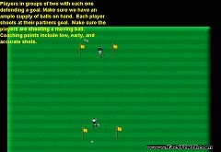  Low-early-accurate
1v1 with goalkeepers | Development on previous activity: the goals are defended with keepers and the players come out of goal to defend against each other. | 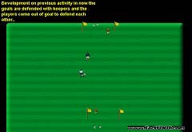  Are shots taken early or is the chance lost?
Attack/Defend | Each turn a player must attack the goal and then defend against the opponents attack. The attacking player starts as soon as the opponent takes their shot. | 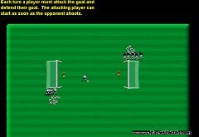  Does the shooter get their head up to look for space in the goal prior to shooting?
4v4 + Keepers | The coach plays the gall back into play as soon as it goes out. | Has the session had an impact on the players?

Receiving

Doctor/Doctor | Each team picks a doctor who is able to heal players from their team once they are struck with a ball, do not receive a ball properly, or dodge a ball that they could have received. Once the doctor is hit their team cannot have players healed. | 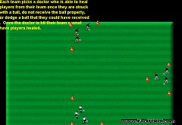  Get in the path of the ball as quickly as possible.

Cone  Receiving | Groups of two are formed as to the right. Once player passes the ball to their partner avoiding the cones. The player receiving the ball must redirect the ball to the other side of the cones before passing the ball back. In the event the players cannot pass with their feet have them serve the ball with their hands. | 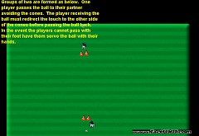  Redirect the ball by positioning the body to face the direction the player wishing the ball to go in.
3v1 | When the focus of the session is on receiving, the coach must require a touch condition on the activity. In this 3 Vs. 1 a two touch minimum can be the condition. | Play the ball away from pressure.
2v1 | As in the previous activity a touch minimum needs  to be used. This activity also puts a premium on the first touch being away from pressure and in the direction of help when possible. | 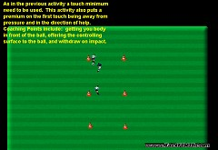  Recognize the space that is available.
4v4 | Again, we use a two touch minimum to require the players to work on their receiving skills. | Has your session had an impact on the players?

Gender Issues

- Girls tend to be more analytical than boys. This means girls will not take generalities at face value. They will want to know why they should do something a particular way more than boys will.
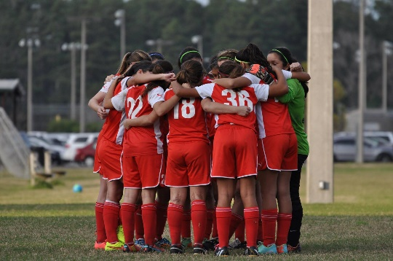
- Team unity is more important to girls than boys.
- Girls may place more emphasis on 'fair play' than boys who are more likely to bend the rules. • Boys are more likely than girls to blame other people (the referee, the weather, the coach) if they lose. Girls have a tendency to blame themselves for a poor performance.
- For girls, winning is not as important as making sure every player gets an equal amount of playing time.
- Males appear to be more 'self' or 'ego' oriented and tend to be more 'win at any cost' in their approach to sport.

`

Observations at AHFSH practices and Games. Suggestions for Coaching Improvement at the U7 and U8 Level

Observation: Many shots from inside the penalty area can go wide .Often this is because the shooter does not take the opportunity to look up

Suggestions
- During a shooting activity show your players that they have the opportunity to look at the goal prior to shooting.
- Instruct the players to look for open space in the goal. If the player is looking for the goalkeeper they are still thinking of the goalkeeper when they shoot and subconsciously may strike the ball to the keeper.
- Demonstrate a shot and have the players narrow their focus to the shooters head. The head needs to be focused on the ball, while the ball is moving come up to look for space and then back to the ball in order to strike the ball correctly.
- Pick a coaching position that does not face the goal. This position shows the players you are more concerned with the procedure than the shot.
- Every time your player takes a glance turn to see the outcome. When they do not take a glance do not turn to see the outcome.
- Ask your goalkeeper to tell each player that does not bring their head up that they failed to glance for space.
- Use goalkeepers during small sided games when working on shooting. Recognize coaching moments that involve the shooter failing to look before shooting when they have the opportunity.

Observation: Many players do not shield the ball when they have no other option. They often turn into trouble or force a ball into bad situations. Players need to learn the visual cues when to shield the ball and wait for help.
Suggestions:
- Go over the principles of shielding. The player with the ball places their body in a side on position between the ball and the opponent. In order for the players to understand side on to the ball, I use the phrase opponent-shoulder-shoulder-ball. The player’s knees are bent to create a better center of gravity. The ball position is moved relative to the opponent’s position.
- Go over the visual signs that indicate shielding is the best option. These include no space behind the opponent and lack of support for a pass.
- Place the players in positions that require shielding. The game of knockout can be used to introduce shielding. In this game, make sure we do not eliminate players. Players who have their ball kicked out of the area can come back in. Demand players shield the ball. Make use
of coaching moments when players turn into opposition.
- Reduce the number of balls. The goal of the activity is now to end the game with a ball. Players who do not have a ball must attempt to dispossess players with a ball. Once a player is dispossessed they must attempt to win a ball. Make sure boundaries are used. As the activity continues reduce the number of soccer balls. You can go to as few as 1 for every two or three players.
- Introduce a direction activity. We suggest the following: Two players in a field line face two players in a field line across the narrow part of a ten by fifteen yard grid. One player dribbles the ball with the object of dribbling the ball past the opponent’s line. One opponent comes out to defend. The player with the ball must decide if they have a quality chance of dribbling past the opponent. If they have speed and space they should attempt to dribble the opponent. When one of these is missing they should place their body between the ball and the opponent and pass the ball back to their teammate. Both players who were actively participating now go back to their starting line and the activity resumes with the alternating players. As a coach you must seize the coaching moments of players who give the ball away with bad decisions on when to dribble.
- End with a small-sided game on a small field. The less space the players have the more likely they will be in situations that require them to recognize shielding opportunities.
- Make sure all players know that a player shielding is a visual sign that they need help and players without the ball should move to supporting angles.

Observation: For practice Sessions, although some maximized time, make sure that the player’s mind’s does not wander.
Suggestions:
- Pick a topic your team needs to improve on. We recommend one topic per week that addresses age appropriate skill development and one topic that addresses a shortcoming from the previous match.
- Plan your practice on paper or in your mind prior to arriving at the field.
- Use a simple to complex progression (warm up, opposition, game).
- Make sure you have plenty of repetition in the warm up.
- The opposition stage needs to be conducted in small groups. You can have more than one group working at a time. This allows for all players to be on task. Use activities, conditions, and/or restrictions that promote the topic the players are expected to improve in during the practice.
- The game portion of the practice also can be modified to create an environment more conducive for the topic.
Narrow your focus and coaching moments to the topic for the practice. In the event you see other areas that need attention, make plans to address these in another session.

Observations: Players lose time and space by taking two or three touches to complete a turn when they receive the ball with their back to goal when they have the opportunity to turn.

Suggestions
- Teach one touch turning with the inside of the foot and the outside of the foot. In both cases the player must line the controlling surface up with the side of the ball closest to the center of the body. That is to say off center of the ball. In this case we are simply redirecting the ball.
- Explain to your players that if their foot meets the center of the ball, the ball will be played in the direction they are facing.
- Make sure your players understand that they turn in the direction (by using the correct foot and surface) they have the most space. Players need communication, vision, or use of their hands to feel for space to know which way to turn.
- Once players are comfortable turning ball with one touch require they turn their body quickly with the ball. Use the phrase gets away speed.
- Require all teammates to use the call: turn when players have the opportunity to turn.
- Add opposition into the activity. At first the opponent should be playing at less than full speed-intensity. Increase speed-intensity.

Observation: Players are uncomfortable receiving air balls.
Suggestions:
- As soon as your games have the ball played in the air, usually around U8’s, introduce the players to the four receiving surfaces. These surfaces include the foot, thigh, chest and head.
- In small groups have the players receive the ball with each surface in repetition. With younger players, you can take a little air out of the ball.
- Make sure the players recognize that there are two methods of receiving an air ball. When a player has space they can cushion the ball. When cushioning the ball, the player gets their receiving surface in line with the ball, relaxes the surface, and withdraws on impact. When a player does not have space, they wedge the ball into open space they can beat the opponent too. When wedging the ball, the player gets their receiving surface in line with the ball, tightens the surface, and pushes the ball lightly in the direction of the space they intend the ball to go to. When wedging an air ball with your foot, the contact must be timed as the ball hits the ground. In this case the foot comes slightly to the top of the ball and for an instance the ball is wedged or trapped between the foot and the ground.
- Place the players in activities that require they receive the ball in the air under pressure.
- End the session with a game that has all restarts initiated with a throw.
- Make sure the players make an early decision on the controlling surface.

Observation: Most games lacked individual creativity. In the games that had creative dribbling, the coach seemed frustrated that the player desired to use their individual talents to benefit the team. As teams get older, we see more organized defenses. Creativity breaks down organization. We need to encourage creativity and give players the green light to experiment in the correct situations.
When to Dribble?
- Whenever there is space behind the opponent. Space behind the opponent is the visual sign that dribbling is a good option. The attacking third of the field pays high dividends to successful dribbling. When the player beats an opponent a scoring opportunity is likely to follow.
- The flanks of the field. We usually have one vs. one match ups on the sides and this gives the player with the ball good odds.

Suggestions
- Explain the importance of dribbling.
- Make the players aware of where and when to dribble. Educate the players of the visual sign.
- Practice creative dribbling and encourage spontaneity in unopposed activities. Encourage the players to use all surfaces of both feet.
- Define touches as quiet, loud, and roll touches. Quiet touches are touches that the ball is pushed by the foot. Loud touches are touches the ball is cut or chopped. Roll touches are touches that the sole of the foot is used to roll the ball.
- Encourage players to use deception such as a step over or body feint.
- Add opposition to put the players in one vs. one situations.

Observations: Coaches are constantly coaching over the top of the game. This often falls into the area of over coaching and giving the players too much information. We see coaches giving constant commands as the players attempt to play and listen to the demands of the coach at the same time. Coaching over the top can be an effective method of putting players in situations where they can make good decisions and develop good habits.

Suggestions
- Monitor your coaching during the period the ball is moving in practice and games.
- Decide how much of this talk tells the player to execute a command and how much puts the player in a situation to make their own decision.
- A command such as pass is different than get your head up. If the player learns to play with their head up they will know when to pass and when not too.
- Instruct other players to tell players where to be instead of doing this yourself. The players will then develop this habit themselves. An example of this is during a throw in ask your central defender to tell the for side defender to get where he should be. You can then determine is the central defender knows the correct distance and angle the player needs to be at to provide the team with the best balance while keeping a restraining line in regards to the off sides line.

Observation: Not many players cut or chop the ball when dribbling.

Suggestions
- Allocate practice time to work on this technique. Demonstrate the technique yourself if able. In the event that you cannot demonstrate the technique properly, have a player that is capable perform the demonstration.
- Perform the demonstration at least three times. The players focus on the striking surface (instep) the first time. The players focus on the position of the knee (high and above the ball in order to come directly down on the edge of the ball) the second time. The last demonstration the players focus on the non-kicking foot (rotates into the direction the ball is cut to)
- Have players practice this technique in repetition and gradually add in opposition.
- Encourage players to watch professional and international games and focus on this technique. Players can also focus on this technique while playing Play Station soccer. It occurs quite often when players are changing direction on the dribble during computer games.

Observation: As coaches we need to make players aware of quick restarts.
Suggestions:
- Make sure your players know that soccer allows for quick restarts. All sports have different rules. In basketball, the referee is required to touch the ball every time the whistle is blown. This is done to make sure all players have the opportunity to be ready. Soccer does not have this rule.
- Make sure your players are aware that if they request ten yards to be given by the referee a second whistle must be blown prior to restarting. Only have them ask for ten yards when they do not have an advantage from a quick restart.
- Add direct and indirect kicks to your games. Call them at opportune times to see how your players react.
- Applaud good decisions and correct bad decisions in regard to the restarts.
- Place spare ball around the field so that players can bring balls played out of bounds back into play quickly.
- Require all players move into advantageous spaces as soon as a call is made.

Observation: The ball is out of play for long stretches of time. There is no urgency to get the ball back into play and teams lose opportunities to take advantage of defensive lapses by prolonging the restart.

Suggestions
- Inform you team that they can take advantage of quick restarts on throws, direct kicks, and indirect kicks.
- During the game part of your practice, position yourself at the edge of the field near the midline. Immediately after the ball goes out of play, play the ball to the team who should have possession of the restart. As players catch on, play the ball to the players who make the best attacking run.
- As you now have conditioned all of the players on the field to stay alert, you must have the players initiate getting the ball back into play. As a condition of the game, you can have the team that touches the ball first after it goes out of play keep possession if they attempt to get it back in with a throw or free kick quickly.
- The last stage should be to have ball placed all around the field and as soon as the ball goes out the team who should have possession gets it back into play quickly by picking up the closest ball. Use the coaching method of freezing the players to show lost opportunities.

Observation: Players do not move after passing the ball.

Suggestions
- Ask yourself how many times your players have heard the phrase “pass and move”.
- Static activities make static players; dynamic activities make dynamic players. Require movement in all phases of the practice.
- Have your team play hand ball. Observe and point out how the players
move without the ball.
- Require the same movement patterns when the game goes back to soccer.

Observation: Many teams leave their defenders at or near the penalty area they are defending. The equivalent to this method in basketball would be to leave two to three defenders back by the basket your team is defending. This leaves your soccer team without as many attacking options and the players lose interest as they are not involved in the game.

Suggestions
- Have players move to midfield when your team is in the attack.
- Keep your players compact to limit the opponents time and space.
- Instruct your players the farther you defend away from your own goal the closer you are to the goal you are attacking when possession is won.

Observation: Numerous players repeatedly play the ball without looking up to see where the options are to pass, dribble or shoot. The game of soccer is very much a visual game. Defenders key on cues. One of the biggest cues defenders use is the position of the attacking players head. When the attacker has their head down, a defender can approach quickly in an effort to dispossess this player.

Suggestions
- Encourage players to keep head up. Use the over the top coaching method to emphasize this during practices. By using this method you are not telling the player which technique to attempt, but instead you are giving them the informing them to get their head up to make the decision themselves.
- Use the stop freeze coaching method for positive examples of players who made good decisions that were predicated from their good vision with the ball at their feet.
- For players U9 and above give a simple penalty to players who kick the ball while under no or limited pressure without looking first.

Observation: Some teams suffered from the heat while others were able to use it to their advantage. The teams who used substitutions early and often stayed fresh.

Suggestions
- Have practices in the heat to acclimate players to these conditions. Be sure to give breaks often and talk to the players about methods in cooling off. Such as placing water over the forehead and neck and the importance of rehydration.
- Instruct players to hydrate themselves prior to matches held in the heat. This should begin 48 hours before the scheduled game time.
- Instruct players to let you know they will need a break prior to having to come out.
- Substitute early and often. Plan ahead and make adjustments in the second half with players who needed breaks and those that did not.

Observation: Most practices do not have a flow from activity to activity. The flow needs to not only take into account the complexity of the progression, but also the transition of space and numbers. A productive practice cannot occur as long is constantly picking up and putting down cones, realigning groups, and formulating teams.

Suggestions
- Demand your players notify you of when they will not be at practice. Explain to the players the importance of your demand.
- Plan your session around the number of players you will have. This plan needs to have numbers that are easily divided and or combines. Examples include groups of 2-4-8-12 or 1-3-6-12.
- Arrange cones so that easy transitions can be made from activity to activity without the coach having to rearrange the field set up. Example a two 2v2 grids separated by 5 yards can be combined for a 4v4 possession activity. The coach will only need to have the middle cones picked up.
- Give out training tops at the beginning of the practice to the players that will need them later in the session. Have these players where the tops immediately.
- Look at the model session below to see a practice that flows.

Observation: Coaches need to tweak the game portion of their practices to allow the topic to occur more often so the players can be tested in a game situation.
Suggestions:
- Use the size of the field as a variable to allow for the topic of the session to occur at frequent rate.
- Use the shape of the field as a variable to allow for the topic of the session to occur at a frequent rate.
- Use the method of scoring as a variable to allow for the topic of the session to occur at a frequent rate.
- Use the method of the ball re-entering the field as a variable to allow for the topic of the session to occur at a frequent rate.
- Use targets as variable to allow for the topic of the session to occur at a frequent rate.

