Locker room Policies
Please discuss this form with you daughter, then sign below and return

Per USA Hockey’s Safe Sport Program please see the below policy the U12 MSGHL team will be following…..
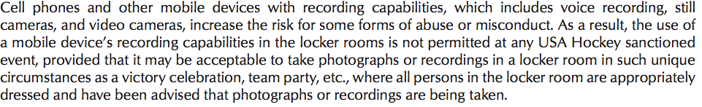
http://www.usahockey.com/page/show/908023-usa-hockey-safesport-program
This policy includes all practices as well. Please discuss this with your daughter and understand if the cell phone is brought to practice it will be collected upon entering the locker-room and returned upon completion of practice.

Once practice is over our team will have 10 MINUTES to take off their gear, get dressed and exit the locker-room. If all players are not out of the locker room within the 10 -minute window, a skating penalty will be enforced for the entire team in the next practice. Ten minutes is ample time for players to leave the locker room. As parents, a significant amount of time is invested to this sport, and this policy will help the players respect the time of their parents. This goes for all the girls so again please discuss this with your child.

____________________________________________ _________________________
Parent Date

____________________________________________ __________________________
Player Date

