NORTHWESTERN ONTARIO BANTAM AAA NORTHSTARS
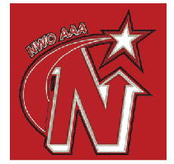
PLAYER REGISTRATION FORM
NAME:________________________________________ AGE:_______________ DOB:__________________

MINOR HOCKEY ASSOCIATION:____________________________________________________________

PARENT/GARDIAN:__________________________________________________________________________

EMAIL:________________________________________________________________________________________

PHONE:______________________________ CELL #:_______________________________________

CITY/TOWN:___________________________________________

TEAM FOR 2014/15:_________________________________________________________________________
LAST SEASON’S TEAM:______________________________________________________________________

HEIGHT:_________ WEIGHT:_________ LEFT or RIGHT POSITION:___________

LAST TEAM’S COACH:__________________________________________________________
Note – make cheques payable to Brent Tookenay
TRYOUT FEE: yes no
cash cheque

