Z

Picture Day Is August 26th & 27th

Please arrive at your scheduled time. Everyone (including coaches) must complete a form, even if you do not wish to purchase.
ALL players and Coaches will be photographed individually for our DIGITAL COMPOSITE Team Photo

Pro-Advantage
Phone: (847)348-0103
email: mmiller@portraitefx.com
www.proadvantage.portraitefx.com

Package B -Player Special!
1- 8x10 FusionEFX TEAM PHOTO, 1-8x10, 2-5x7,
10 Wallets (player) INDIVIDUAL PLAYER ON CD
$43

Package A
DELUXE CD-Pak!
1-8x10 FusionEFX Memory Mate, 1-8x10, 2-5x7,
10 Wallets & 2 Photo
Buttons (player)
PLUS Digital Images on CD of Player & Team Photo
$54

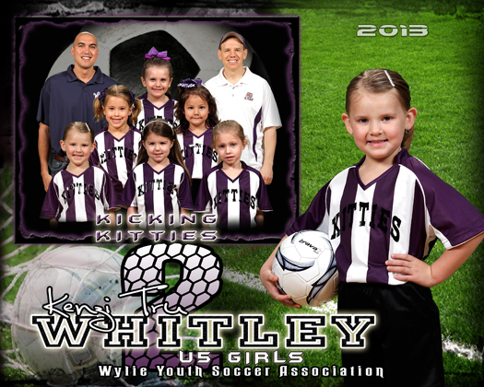
Other Items |  | Price Added to Package | Price Individually
F | 8x10 Player Photo | $11 | $13
G | 2-5x7 Player Photo | $11 | $13
H | 4-3x5 Player Photo | $11 | $13
I | 10-Wallets Player Photo | $11 | $13
J | 1- 5x7, & 7-Wallets | $13 | $16
K | 2-5x7, 10-Wallets | $16 | $20
L | 8x10 Fusion Memory Mate | $12 | $14
M | 8x10 Team Photo | $11 | $13
N | 4- 3x5 Photo Magnets-player | $12 | $15
O | 2- Photo Buttons-player | $12 | $14
P | Sports Towel Memory Mate | $12 | $14
Q | Car Flag TEAM PHOTO | $15 | $18
R | Hi Res Digital File -Player.CD | $25 | $36
S | Hi Res Player &Team Photo CD | $35 | $48

Pkg. C – Value-Pak
1-8x10 FusionEFX TEAM PHOTO, plus 1-8x10,
2-5x7, 10 Wallets
(player)
Only $35

Package D
Most Popular!
1-8x10 FusionEFX Memory Mate, plus 2-5x7, 2-3x5 & 10 Wallets (player)
Only $32

Package E - $26
1-8x10 FusionEFX Memory Mate , plus 1-5x7, 2-3x5, & 5 Wallets (player)

Package F - $21
1-8x10 FusionEFX TEAM PHOTO + 2-3x5s (player)

BEGINNING AUGUST 19th PREPAY ONLINE at
www.proadvantage.portraitefx.com
Select “Order” and then click on GROVE SOCCER. PRINT OUT an extra copy of your receipt to give us on picture day. We ALSO take all payment types at check in on picture day.

This form must be completed & turned in, regardless of payment method.

Order Below. Please PRINT! We are not responsible for missing or inaccurate info on personalized items!
1. Exact payment required on Picture Day. 2. Fill out the form below completely for product accuracy. 3. Each person must have a separate form & payment. Do not combine payments. Return check fee is $30. Pictures will be distributed through the club & coaches in 4-5 weeks.

Player’s
Name: |__|__|__|__|__|__|__|__|__|__|__|__|__|__|__|__|__|__|__|__|__|
Team Name:|__|__|__|__|__|__|__|__|__|__|__|__| __|

Coach:|__|__|__|__|__|__|__|__|__|__|__|__|__|__|

Position: |__|__|__|__|__|__|__|__|__|__|__|__| Uniform # |__|__|

Parent’s Phone: |__|__|__|__|__|__|__|__|__|__|__|__|

Parent’s E-Mail:

|__|__|__|__|__|__|__|__|__|__|__|__|__|__|__|__|__|__|__|__|__|__|__|

Pkg | Qty | PRICE | Total Cost
TOTAL DUE

Division or Age Group

___________________

Make Checks Payable to
PortraitEFX
FOR TRADER CARDS ONLY:
Age: |__|__| Height: |__|Feet |__|inches Weight: |__|__|__|

