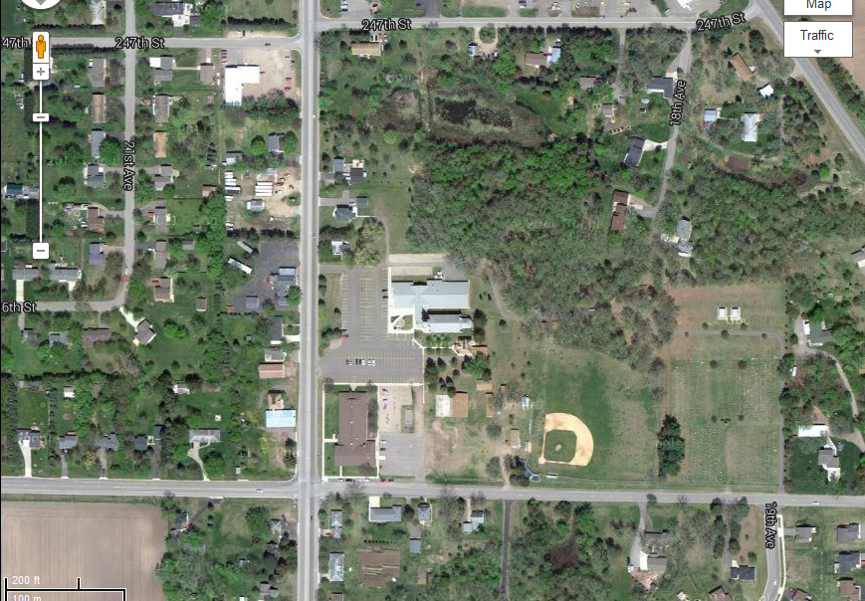
CR7
St. Augusta Field
245th Street
From St. Cloud take CR75 to CR7 and turn left on 245th Street to field (just past St. Mary Help of Christians Church and School)

