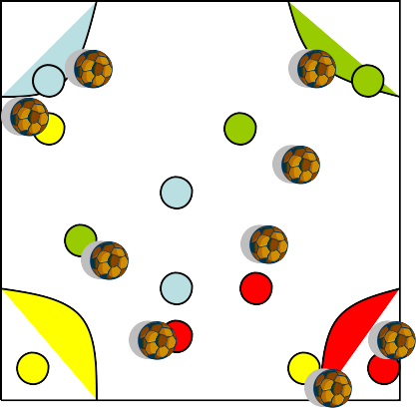Steal the cookies

Area 20 x20 with 4 houses marked in the corners Teams of 2/3
Coach places all of the cookies (Balls) in the middle of the Area. When the game begins the players race out and Take one cookie at a time back to their home
When all cookies are gone out of the middle with one player staying at home players can steal them from other houses

Players in the house can shield the soccer balls but not lie on them or use their hands

Progression 1 individual

- 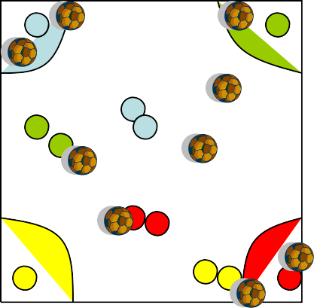Start by allowing them to use their hands to retrieve the cookies
- Players must use their feet
- Players must kick the cookies back to their house
- Each player can only have 1 kick of the ball that they fetch

Progression 2 Team

Each player when going out must be connected with
- Another team mate
- The whole team

Clean your room

Area 40x30 with half way line
As many balls (trash) as possible

Players are restricted to their rooms and when the parents (coaches) leave the house the players must clean their room by getting more trash into the room opposite. After 3 minutes the coach looks to see who has the cleanest room

Progression 1

Have only two players who can clean the room.
Everyone else must get the trash to them

Progression 2
Have a 5 yard mid line that they can’t go in as this is mum and Dad’s room



Coaching point: Try to get the players to recognize space and to put the ball into it
Mum and Dads Room

