Kick out Area 10x10 yards
Players have 1 ball each and try to kick everyone else’s
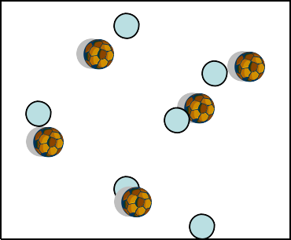out of the area
When a players ball gets kicked out they can come

Progression 1
Hospital
straight back in if they can get to it before it stops rolling Otherwise they go to the hospital and perform 10 ball touches and then come back in

Variations
When the player gets kicked out they go to another area and try to stay in that one

Progression 1
Have defender/s ready to come in and kick out the balls

Progression 2
Make the area smaller

Builders and Breakers

Two teams in a 20x15 yard area
Cones scattered- Half facing up half turned over
One group is the builders who stands the cones up
one is the breakers who flips it upside down Play 1st without and then with ball

Holiday Game

Mexico

S
p a i n

USA

E Area 20 yards square 1 Ball each (passport)
n
g Area 30x40 Players pick out 4 countries
l Each side of the square is a different country
a
n Coach calls out a country and players must get to
d that side as quickly as possible with passport
Add in Passport control who tries to take away their passport

Me and my Shadow

Me and My shadow with a Ball each

Area 20x20 Square
In a restricted area in pairs the front player runs around and the 2nd player tries to stay in their shadow
When the coach says change they switch roles

Area 20x20 Square
In a restricted area in pairs with a ball each the front player runs around and tries to keep the 2nd player out of their shadow
When the coach says change they switch roles Progress to player can try to get the ball in any other players shadow

Coaching Points: Change of direction and speed

Monster Island

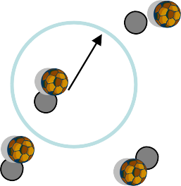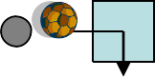Area 30x40 with randomly placed 3 yard houses and an island in the middle

Players have 1 ball each and are challenged by the coach to go into the island, collect fruit and then return to a house

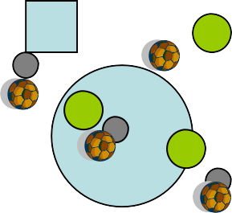Players now try to get across Soccer island with a monster inside. Monsters cant leave the island.
If players soccer balls are caught by monsters they change
M places with a monster

M Progression 1
M Add more monsters

Progression 2
Add monsters outside of the island players can be safe in Houses

Progression3
Take away the safe houses

Golf
1.
1 

2.

3.

D

- In pairs 5 yards apart
Player 1 makes a bridge with their legs Player 2 scores a goal by passing
the ball through their partners legs

Progression

Increase the distance
3 minute games then change partners

- In a 30x20 1 ball between 2
1 player working the other is the goal (as above) The Coach times 1 minute and players try to get The ball through as many different goals as possible

- Now a dog/s are added (Defenders) . The dogs go and get the ball
Dog pound
And bring it to the dog pound
If a player loses the ball to the dogs they must go
To the pound and get their ball back but pay a skill fine

