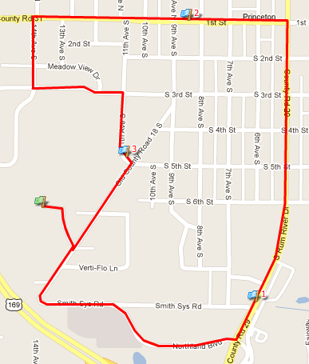

PYHA 5K Fun Run Route
Participants will start and end at the Ice Arena. The route will go along Northland Blvd, turning at Rum River Drive and continue to 1st Street, from there we will turn on 14th Avenue than onto 11th ave and finally back onto old country road 18. There will be volunteers at all cross roads and possibly a police escort.

