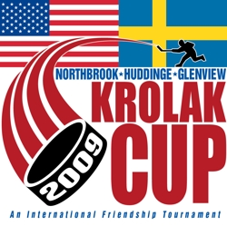

Dear Glenview Stars Mite Players,

Each spring, our Bantam teams have the wonderful opportunity of hosting a tournament called the Krolak Cup that includes teams from Sweden! As part of this tournament, the Swedish players spend the week in a host player’s home learning how USA kids live. Great memories and lifelong friendships are created. Some day you may play in this very tournament. The Glenview Stars cohost this tournament with the Northbrook Bluehawks

This year, we would love to have each of you to participate in the Opening Ceremony. Remember the Winter Classic? When the pro players walked out onto the ice thru a long aisle lined with Mite hockey players! What a welcome! Please come and help form a long aisle to welcome our tournament teams…including our special guest teams from Huddinge, Sweden. The opening ceremony will be held at the Northbrook Hockey rink on Wednesday, April 13th starting 7:00pm. The opening ceremony will last approximately ½ hour followed by a skills competition which you are welcome to stay and watch. Mite players should wear skates, helmets, gloves, Northbrook or Glenview hockey jerseys, and bring a stick. Please plan to arrive at the rink dressed and ready to go at 6:45 sharp. Volunteers will greet you while your parents can watch in the stands.

And, don’t forget to check out your website for all information regarding this tournament. We invite you to come and watch some GREAT hockey!

If you would like to join us for this very special celebration, please contact Stephie Arkus at info@glenviewstars.org. Looking forward to hearing from you!

