

SHAKOPEE SOCCER ASSOCIATION

COACH’S HANDBOOK
RECREATION PROGRAM

Coaches,

Welcome to the Shakopee Soccer Association (SSA). Thank you very much for “stepping up” and volunteering to work in our Recreation Program. The SSA Rec. Program is dependent on volunteer coaches to make the program work so we appreciate your time and efforts with the kids The kids may not tell you directly but they appreciate you organizing and leading their team and without you, they simply don’t get to play. As you work with these kids and build relationships with them, I think you will find the time you spend on the field will be very rewarding and fulfilling.
This manual is designed to help you navigate the season. If you have issues, question, ideas, or suggestions, please feel free to contact the SSA Rec or club leadership at the locations listed on the following pages. Thank you again for being a Rec. Coach.

Have a wonderful season!

Recreational Coaching Director

Table of Contents

SAA Contacts 4
General Information…………………………………………………………………………………………………………………………………………….5
Coaching Information………………………………………………………………………………………………………………………..……6
Practice Day…………………………………………………………………………………………………………………………………………….7
Coaching Tips for Practice Day………………………………..………………………………………………………………………8
Game Day…………………………………………………………………..…………………………………………………………………………..9
Coaching Tips for Game Day………….………………………………………………………………………………………………10
Team Information………..……………………………………………………………………………………………………………………….11
Team Information – Age Specific………………………………….………………………………………………………………………12
Referees………………………………………………………………………………………………………………………………………………..13
Rules………………………………………………………………………………………………………………………………………….………….13
Safety Guidelines…………………………………………………………..……………………………………………………………………..14
Sample Activities\Practice Plans
U5-U7………………………………………………………………………………………………………………………………………15
U8-10………………………………………………………………………………………………………………………………………..20
U11-13………………………………………………………………………………………………………………………………………25
Appendix A – MYSA Player/Adult Protection Guidelines………………………………………………………………..……30

SSA CONTACTS

COACHING DIRECTOR
coachingdirector@shakopeesoccer.com

RECREATIONAL DIRECTOR
recdirector@shakopeesoccer.com

RECREATIONAL COACHING DIRECTOR
rectrainer@shakopeesoccer.com

GENERAL INFORMATION

Uniforms
- Uniforms are handed out to players, by the coach, at first team activity.
- Uniforms should be worn to all games and practices.
- Home team will wear pinnys (mesh vests) over uniform on game days.
- All players are required to wear shin guards.
- Cleats are optional but suggested for ages 8 and up.
- No earrings or jewelry is allowed.

Equipment
All players should bring:
- Size 4 ball, labeled with their name, to all games and practices.
- Water bottle.

Pictures
- Team and individual photos will be taken during the SPRING Rec. session.
- Date, Time and Location will be announced at beginning of season.
- Photos will be distributed through coaches.

Other
- Air Compressor located at the building.
- Lost and Found located at the building.

COACHING INFORMATION

Behavioral Expectations
- HAVE FUN!!!
- Make them want to come back.
- Be positive.
- Keep the kids organized and safe.
- Model good sportsmanship.

Practical Expectations
- Complete background check (annually). See link on SSA website.
- Complete concussion training. See link on SSA website.
- Find replacement coach, from within your team, on days you need to miss.
- Stay with kids at the complex until all are picked up.
- Communicate with your team throughout the season.
- Attend orientation meeting.
- Work with Rec. Coaching Director to identify possible candidates for the SSA Traveling Program.

Game-Day Expectations
- Play everyone as equal time as possible.
- Play everyone in all positions.
- Make sure they are warmed up (especially older kids).
- Focus on improvement and team play rather than “winning.”

PRACTICE DAY
- All practices are held at the 17th Ave Sports Complex.
- Pick up bag of balls, cones and pinnys (mesh vests) at building.

Schedules
- Posted online and in the windows of the building at the complex.

Weather
- SSA follows Minnesota Youth Soccer Association guidelines for weather.
- Cold Weather - Practices are canceled if 35 degrees or below.
- Warm Weather – Practices are canceled if 105 degrees or above.
- The Rec. Director, Rec. Coaching Director or other SSA official, reserve the right to cancel practices onsite.
- Notification – SSA will notify participants first via text and second on the website.
- Text Follow Shakopeesoccer to 40404 to receive weather and field notification texts.
- WE WILL PLAY IF AT ALL POSSIBLE.

Make-Up Practices
- There will be no makeup practices for cancelations due to weather.

Coaching Tips for Practice Day

Make it FUN!!! - Don’t forget why the kids signed up to play. They want to have FUN and, as a coach, you should have fun too. Don’t be a drill sergeant.
Don’t try to “fix” everything - Pick a few issues to address for the whole season and focus on those.
Avoid the three L’s (Laps, Lines, Lectures).
Always try to do activities WITH the ball.
Keep as many active as possible.
Get them going quickly – You only have 1 second per year of age so talk little, play much.
Activities should have implications for the real game – Explain how the activities relate to the real game.
Simple to complex – Start simple, add one command at a time.
Make sure it is Age Appropriate – If the kids don’t understand, perhaps it is too difficult.
Be organized – Come with multiple activities that you can use in the event one isn’t working.
Appropriate feedback – Be positive.
Don’t “over coach” - Let the players make their own decisions.
Make it FUN!!!

GAME DAY
- All games played at the 17th Ave Sports Complex.
- Home team – Pick up pinnys (mesh vests) at building.
- Pick up bag of balls if desired.
Game Structure (60 minutes total)
15 minute warmup
20 minute half
5 minute half-time
20 minute half
Schedules
- Game schedules are posted online and in the windows of the building at the complex.
Weather
- SSA follows Minnesota Youth Soccer Association guidelines for weather.
- Cold Weather - Games are canceled if below 35 degrees.
- Warm Weather – Games are canceled if above 105 degrees.
- Field closures are made by The City of Shakopee.
- The Rec. Director, Rec. Coaching Director or other SSA officials, reserve the right to cancel games onsite due to weather or other unforeseen conditions.
- Notification – SSA will notify participants first via text and second on the website.
- Text Follow Shakopeesoccer to 40404 to receive weather and field notification texts.
- WE WILL PLAY IF AT ALL POSSIBLE.
Make-Up Games
There will be no makeup games for cancelations due to weather.

Coaching Tips for Game Day

Make it FUN!!! - Don’t forget why the kids signed up to play. They want to have FUN and, as a coach, you should have fun too. Don’t be a drill sergeant.
Don’t try to “fix” everything - Pick a few issues to address for the whole season and focus on those.
Appropriate feedback – Be positive.
Don’t “over coach” - Let the players make their own decisions.
Make it FUN!!!

TEAM INFORMATION

Coaches
Teams may have:
- Head coach
- Co-Coaches
- Team Manager

Team Rosters
- Posted online and in the windows at the complex building.

Team formation
Players are placed on team:
- That have a mixture of experienced and inexperienced players.
- With siblings if same age.

Special placement requests are reviewed on a case-by-case basis but not guaranteed.

TEAM INFORMATION – AGE SPECIFIC INFORMATION
5 Year Olds
- Coed 3v3
- No keeper(Goalie)
- Roster Size 5-6
- Coach Referee
6 Year Olds
- Boys and Girls separate 3v3
- No Keeper(Goalie)
- Roster Size 5-6
- Coach Referee
7 year Olds
- Boys and Girls separate 4v4
- No Keeper(Goalie)
- Roster Size 6-8
- Coach Referee
8, 9 and 10 Year Olds
- Boys and Girls separate 6v6
- Keepers(Goalie)
- Roster Size 9-12
- Referees at some games – Coach will referee if no referees are provided
11, 12 and 13 Year Olds
- Boys and Girls separate 7v7
- Keepers(Goalie)
- Offside is in play
- Roster Size 10-12
- Referees at most games - Coach will referee if no referees are provided

Referees
- Referees MAY be provided for ages 8 and up.
- Have completed at least a level 8 certification.
- They are not professionals.
- Are not expected to make all calls – mostly flagrant or deliberate fouls and restarts.
- Games should be played even if Referees do not show up.

Rules
- No scores are kept or recorded. Focus on development and enjoyment.
- Kickoffs are taken at center field.
- No Penalty Shots – Fouls in the penalty box (large box) are taken as indirect free kick (cannot score directly from kick).
- Out of bounds (over the sideline).
  - U5-U7 Kick-in from where ball went out
  - U8 and up – Throw-ins (both feet on round, ball and both hands over head)
- Corner Kick – Taken by defensive team after ball goes over end-line, last touched by offensive team.
- Ball is out of bounds and goal scored when it is wholly over the line (see diagram below).

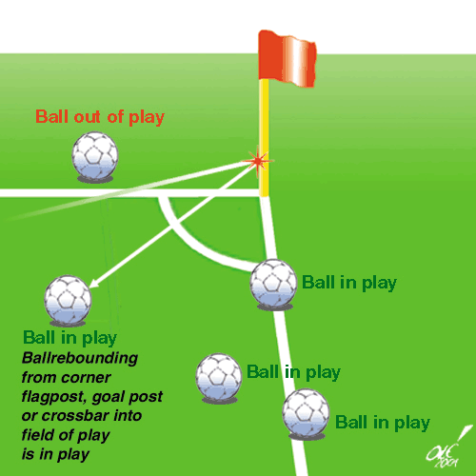

SAFETY GUIDELINES

COACHES SAFETY ROUTINE
Prior to each practice or game coaches and their assistants should develop the habit of a safety check with the goal of promoting a safe environment for both participants and spectators.

Goal Safety
- Goal posts properly secured and anchored.
- Inspect goal post for sharp corners to include general integrity.
- Forbid any horseplay by players or members of the general public on or around any goal post.

Field Safety
- Inspect for foreign objects.
- Make sure sprinkler heads are seated.
- Please ensure spectators observe 2’ Safety Space from Touch Line (The line between the sideline and observers).
- Notify club officials of unsafe field conditions.
- Do not allow participation by your players until noted hazards have been corrected.

Clothing\Uniform Safety
- Make sure socks cover shin guards.
- Make sure shoes are tied.
- Make sure pinnys (mesh vests) are not are not too restrictive or too tight or too loose.
- No jewelry is allowed.

Sample Activities\Practice Plans

U5-U7

U5-U7 Activities - Dribbling
Retrieval | Description | Coaching Points
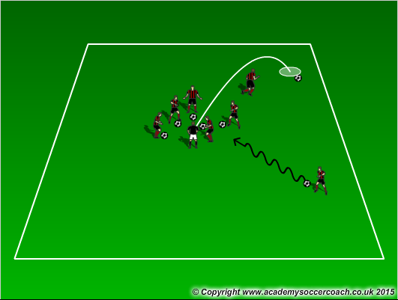 | All players, with a ball.  Hand ball to coach and say name.  Coach throws ball out and player goes and retrieves.  Progressions  Make them use their feet.  Left\right foot only.  Limit # of touches.  Coach moves so kids have to find him. | Use “pinky toe” to dribble.  Keep ball close.  Toes down and slightly inward, ankle locked.
Tag | Description | Coaching Points
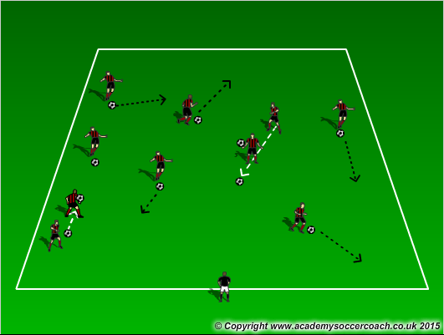 | All Kids involved.  Freeze Tag – If tagged, freeze with ball above head, feet apart. Teammates dribble thru legs to unfreeze.  Progressions  Start without a ball and teammates tag to unfreeze. Then add ball. | Eyes up.  Keep ball close.  Toes down, ankle locked.  Change speed.
Gate Dribbling | Description | Coaching Points
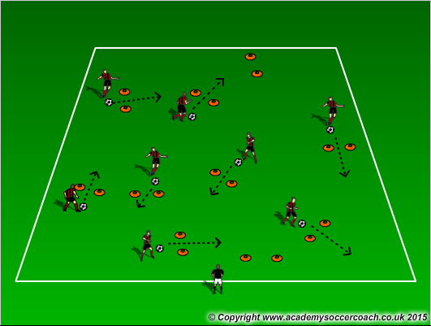 | All players with ball.  See how many gates they can go thru in 1 minute. Can they beat their record by 1?  Progressions  Left\Right foot only.  Accelerate after leaving gate.  Coach or parent stand in gate which means it is closed. | Use “pinky toe” to dribble.  Keep ball close.  Toes down and slightly inward, ankle locked.  Eyes up.  Accelerate.
Game – 3 v3 |  | Coaching Points

U5-U7 Activities – Dribbling\Body Awareness
Free Dribble | Description | Coaching Points
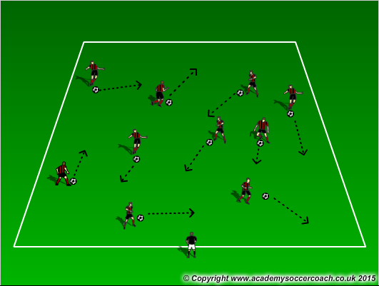 | All Players with a ball dribbling.  No collisions.  Encourage them to be creative.  Progressions  Coach can put pressure on them.  Players can dribble at each other, perform a move and accelerate away. | Use “pinky toe” to dribble.  Keep ball close.  Toes down and slightly inward, ankle locked.
Freeze Tag | Description | Coaching Points
 | 1-2 ”Freeze Monster”.  Tagged players freeze and lift ball above head, feet apart.  Teammates dribble thru legs to unfreeze.  Progressions  Start without a ball. Teammates can unfreeze by tagging. Then add ball.  Left\Right foot only. | Use “pinky toe” to dribble.  Keep ball close.  Toes down and slightly inward, ankle locked  Slow down and use inside of foot when unfreezing teammate.
Get Outta Here | Description | Coaching Points
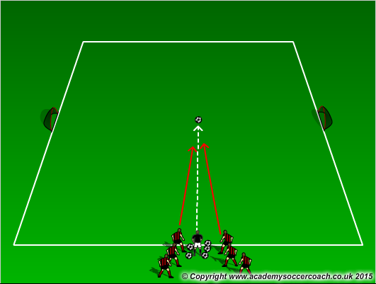 | 2 teams & coach, on sideline, at mid field.  Balls at coach’s feet.  Goal on each end.  Coach kicks ball out and 2-3 players  play soccer to goals.  Yell “Get Outta Here” when out of bounds.  Progressions  Add kids. Left\ right foot only. | Use “pinky toe” to dribble.  Keep ball close.  Toes down and slightly inward, ankle locked.  Eyes Up.
Game – 3 v3 |  | Coaching Points

U5-U7 Activities – Dribbling\Moves
Red Light, Green Light | Description | Coaching Points
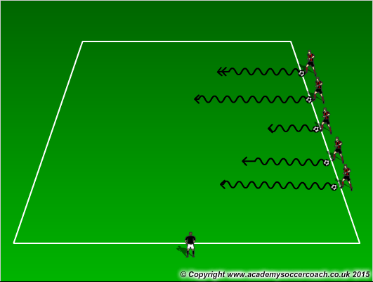 | All kids with ball on one side of field.  Coach commands.  Green Light=go  Red Light=stop  Dribble to far side of field and stop.  Progressions  Add yellow light=slow.  Add different color=give silly activity.  Free “driving” with no collisions. | Keep ball close.  Accelerate.  Use sole to stop ball.  No hands. To stop ball.
Paint the Field | Description | Coaching Points
 | All Players with ball (paintbrush).  Choose favorite color.  Try to “paint” entire field in 90 sec.  Progressions  Left\Right foot only.  Collision =“spilled paint” start over. | Keep ball close.  Change direction and speed.  Eyes up.  Pinky toe dribbles.
Hospital Tag | Description | Coaching Points
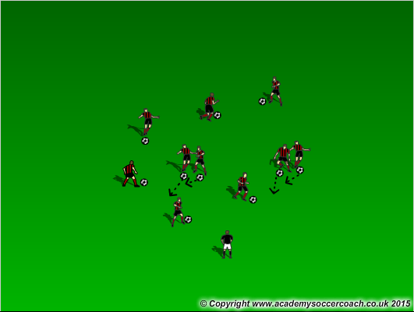 | 1-2 taggers.  If tagged, put bandaid (hand) on injured part. 3 bandaids go to “Hospital” where coach gives 3 toe touches as a “cure”.  Progressions  Add ball, Left\Right foot only.  Add taggers. | Use “pinky toe” to dribble.  Keep ball close.  Toes down and slightly inward, ankle locked.  Eyes up.  Accelerate.
Game – 3 v 3 |  | Coaching Points

U5-U7 Activities – Dribbling\Body Awareness
Sharks and Minnows | Description | Coaching Points
 | All kids (minnows) with ball on one side of field.  1-2 sharks.  Minnows try to dribble across field without getting ball kicked out (eaten) by sharks. “Eaten” players become sharks.  Progressions  Add sharks (parents?).  Make “ocean” smaller. | Eyes up.  Pinky toe dribbling.  Change of speed and direction.  Ball close.
Body Part Dribble | Description | Coaching Points
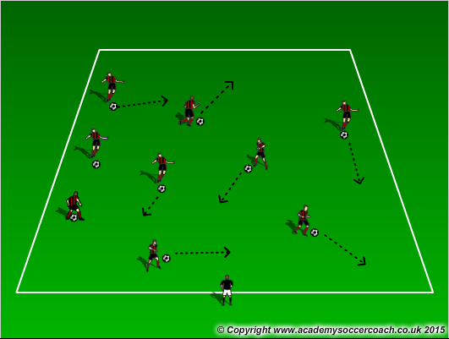 | All kids with ball dribbling.  On Coach command, kids must stop ball with body part.  Progressions  Name 2 body parts.  Stop ball in 2 seconds. | Eyes up.  Pinky toe dribbling.  Change of speed and direction.  Ball close.
Knockout | Description | Coaching Points
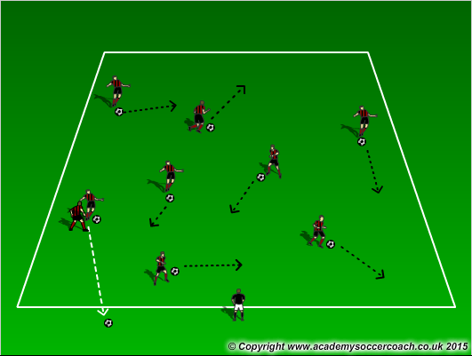 | All kids with ball, dribbling.  Try to knock ball out.  If knocked out, perform simple task (e.g.3 jumping jacks) then re-enter game.  Progressions  Introduce “shielding” (using body) to protect ball. | Eyes up.  Use moves, change of speed to get away.  Use body\bottom to shield ball from opponent.
Game – 3 v3 |  | Coaching Points

Sample Activities\Practice Plans

U8-U10

U8-U10 Activities – Dribbling\Shielding
Shadow Dribbling | Description | Coaching Points
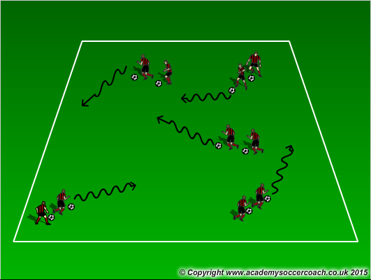 | All players in pairs, 1 player is leader, 1 is “shadow”.  “Shadow” tries to copy leader.  Switch roles.  Progressions  Right\Left foot only.  Make groups of 3. | Leader makes quick  changes of direction and speed.  Pinky toe dribbling.  Eyes up.
Dribble-Shield | Description | Coaching Points
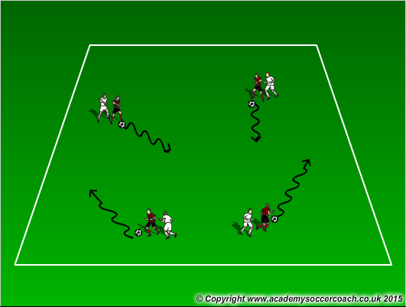 | Pairs, one ball.  Leader dribbles and tries to keep “shadow” from stealing ball. If ball stolen, roles reverse.  60-90 seconds, switch roles if they haven’t.  Progressions  Left\Right foot only. | Use foot away from defender to dribble.  Body sideway on defender.  Knees bent.  Change of speed.  Keep ball close.
Knockout | Description | Coaching Points
 | All kids with ball, dribbling.  Try to knock ball out.  If knocked out, perform simple task (3 jumping jacks) then reenter game.  Progressions  Introduce “shielding” (using body) to protect ball. | Eyes up.  Use moves, change of speed to get away.  Use body\bottom to shield ball from opponent.
Gave 5 v 5 |  | Coaching Points

U8-U10 Activities - Passing
Sequence Passing | Description | Coaching Points
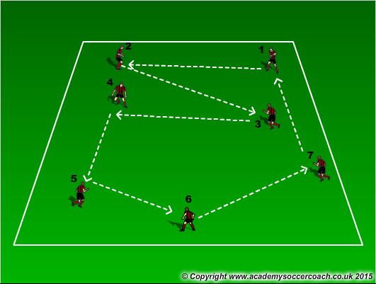 | All Players numbered sequentially,  1 ball. #1 passes to #2, #2 passes to #3 etc. Last # passes to #1.  Everyone moving all the time.  Progressions  Add second ball.  Add time limit to 3 complete circuits. | Inside of foot.  Accuracy of pass.  Belly button pointing to target.  Can players think in advance?
Gates Passing | Description | Coaching Points
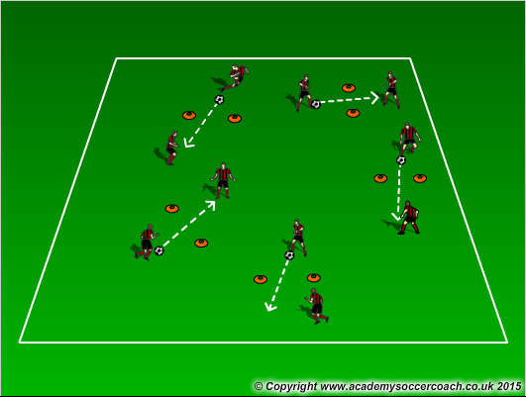 | Players in pairs, 1 ball.  Passing to each other through gates.  Progressions  Time limit, can they beat previous score? Must go to different gates.  Left\Right foot only. | Inside of foot to pass.  Toes up, ankle locked.  Belly button pointing to target.  Pace of pass.
Bullseye | Description | Coaching Points
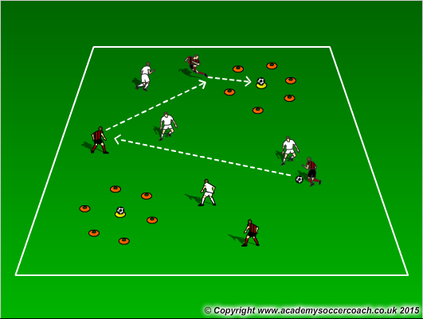 | 2 teams, 1 ball, collection of balls at coach’s feet.  2 balls on cones with small circle of cones around.  Teams score by knocking ball off cone. Players may not enter circle.  Progressions  Limit # of touches each player can have.  Make space smaller. | Passing to teammates.  Toes up, ankle locked.  Can they recognize when area is congested and change the “point of attack” by quickly going elsewhere?
Game 5 v 5 |  | Coaching Points

U8-U10 Activities – Team-Work to goals
Eagles Nest | Description | Coaching Points
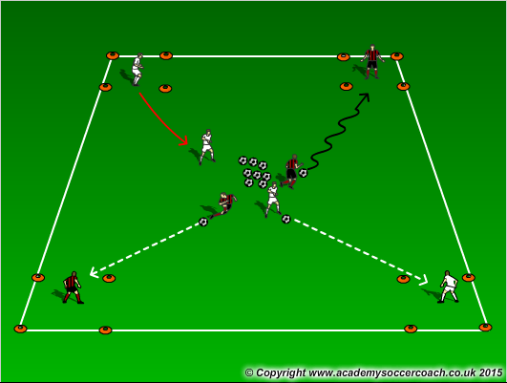 | All Players in 4 teams.  4 rectangles (nests) in corners.  Collection of balls (eggs) in center of field.  Players get eggs and bring to nest, then steal from other nests.  Progressions  Require a pass before scoring.  Limit # of touches when dribbling. | Teamwork.  Let them solve problems.  Can they figure out how to get eggs to nest faster?
2v2 to End Zones | Description | Coaching Points
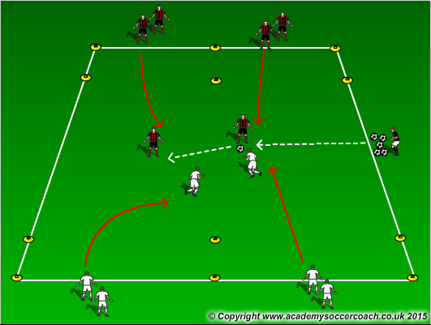 | 2 Teams, opposite sides of field in 2 lines.  Coach serves ball.  Pairs try to score by dribbling into opponents end zone & stopping ball.  Progressions  Require a pass. | Work together on offense and defense.  1 person to ball.  Communication – who is getting ball?  No defending in end zone.
Goals, Goals, Goals | Description | Coaching Points
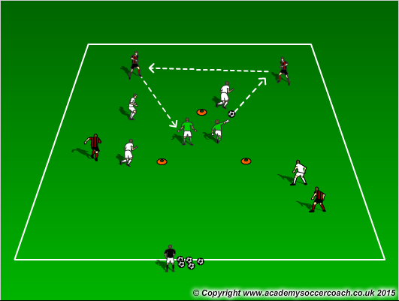 | 2 teams, 2 keepers in 5 yd. triangle.  Teams score by playing ball thru triangle (on the ground) to teammate.  Progressions  Add 3rd keeper.  Add 2nd goal with 1 keeper per goal. | 1 person to ball.  Quick ball movement to unbalance the defense.  Passing using inside of foot.  Make sure hips point where they want the ball to go.
Game – 5 v 5 |  | Coaching Points

U8-U10 Activities – Dribbling\Passing to Goal
Dribble to Goal | Description | Coaching Points
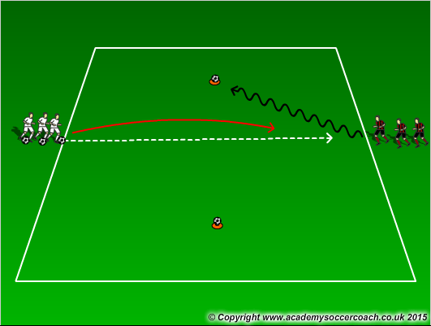 | 2 lines across from each other.  1 line serves to the other then plays defense.  Score by knocking ball off either cone.  Progressions  Time limit so others don’t stand. Make it 2 v 2.  Replace ball on cone with small goal. | Use pinky toe to dribble.  Eyes up.  Use body to “sell” a fake then explode other direction.
2 v 2 to Bumpers | Description | Coaching Points
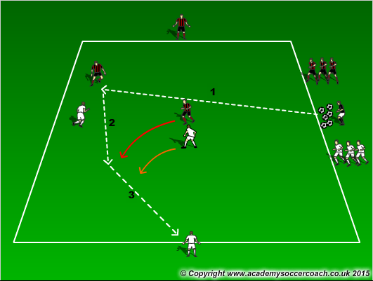 | 2 teams, one on each side of field.  Each team has one bumper at one end of field.  Coach serves ball.  2v2 to your bumper.  Progressions  Make it 3 v 3.  Add 2nd bumper on each side. | 1 person to ball.  Dribble using pinky toe, pass using inside of foot.  Bumper moves to receive pass.
Bullseye | Description | Coaching Points
 | 2 teams, 1 ball, collection of balls at coach’s feet.  2 balls on cones with small circle of cones around.  Teams score by knocking ball off cone. Players may not enter circle.  Progressions  Limit # of touches a player gets.  Make space smaller. | Passing to teammates.  Toes up, ankle locked.  Can they recognize when area is congested and change the “point of attack” by quickly going elsewhere?
Game – 5 v 5 |  | Coaching Points

Sample Activities\Practice Plans

U11-U13

U11-U13 Activities - Passing
Dynamic Passing | Description | Coaching Points
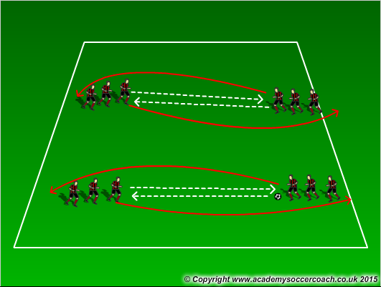 | 2 Lines, 20 yds. apart, 1 ball.  1st player in line 1 passes to 1st player in line 2, then follows pass to end of line 2. 1st player in Line 2 passes back.  Start with unlimited touches to get control, then pass.  Progressions  3 touch, less people in line to get cardio work. | QUALITY of pass.  Inside of foot pass.  Belly button pointing to target.  Soften foot to receive pass.  First touch “out of feet”.  See how many they can do in a row without loosing control.
Short, Short, Long | Description | Coaching Points
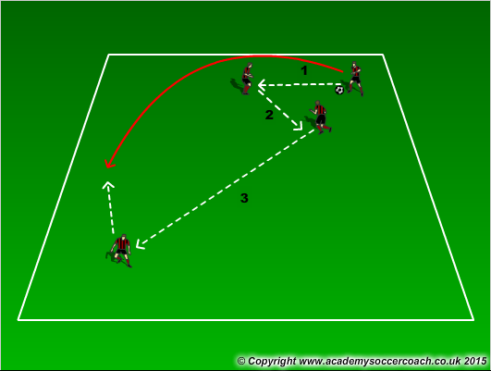 | Groups of 3, 1 ball.  Players pass in area. 1st and 2nd pass are short, third pass is long.  Then restart count.  Progressions  3 touches per person. | Quality pass.  Inside of foot.  Can they see the long pass? Person without ball has to find space and think long.  First touch “out of feet”.
To the Middle & Back | Description | Coaching Points
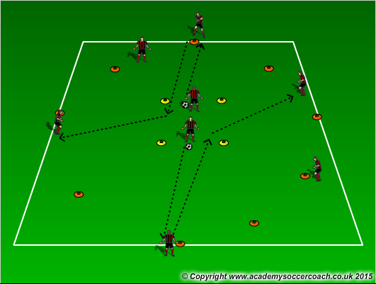 | 2 teams, one outside of circle (no ball), one inside square, each with ball.  Players dribble out of square to an outside player and stop ball. Outside player takes ball and dribbles thru middle square to different outside player.  Progressions  Make pass to outside player. | Pinky toe dribbling.  Eyes up, to problem solve.  No collisions.  Passing with inside of foot, belly button pointing at target.
Game – 5v5 |  | Coaching Points

U11-13 Activities – Dribbling\Footwork
Lids and Saucers | Description | Coaching Points
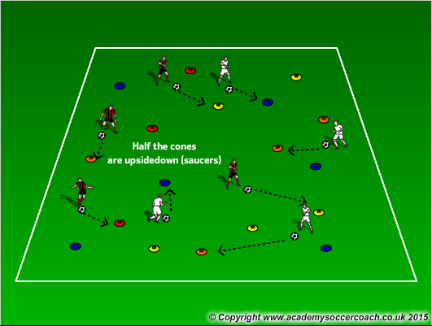 | Even # of disc cones, spread out across area, ½ upside down.  2 teams – one team turns discs upside down, other team turns right side up. 60-90 sec.  Which team has more cones?  Progressions  Add ball.  Use only feet to flip cones. | Eyes up.  Quick movement.  Ball close when dribbling.  Problem solve – Don’t go to same cone.
To the Middle and Back | Description | Coaching Points
 | 2 teams, one outside of circle (no ball), one inside square, each with ball.  Players dribble out of square to an outside player and stop ball. Outside player takes ball and dribbles thru middle to different outside player.  Progressions  Make pass to outside player. | Pinky toe dribbling.  Eyes up, to problem solve.  No collisions.  Passing with inside of foot, bellybutton pointing at target.
Dribble to Goal | Description | Coaching Points
 | 2 line across from each other.  1 line serves to the other then plays defense.  Score by knocking ball off either cone.  Progressions  Time limit so others don’t stand. Make it 2v2.  Replace ball on cone with small goal. | Use pinky toe to dribble.  Eyes up.  Use body to “sell” a fake then explode other direction.
Game – 5v5 |  | Coaching Points

U11-U13 Activities - Passing
Sequence Passing | Description | Coaching Points
 | All Players numbered sequentially,  1 ball. #1 passes to #2, #2 passes to #3 etc. Last # passes to #1.  Everyone moving all the time.  Progressions  Add second ball.  Add time limit to 3 complete circuits. | Inside of foot.  Accuracy of pass.  Hips pointing where they want the ball to go.  Can receiving player get into space to receive, in advance?
Gates Passing | Description | Coaching Points
 | Players in pairs with one ball per pair.  Passing to each other through gates.  Progressions  Time limit, can they beat previous score? Must go to different gates.  Left\Right foot only. | Quality passes.  Inside of foot to pass.  Toes up, ankle locked.  Belly button pointing to target.  Pace of pass.  Stress quality over quantity.
2 v 2 to Bumper | Description | Coaching Points
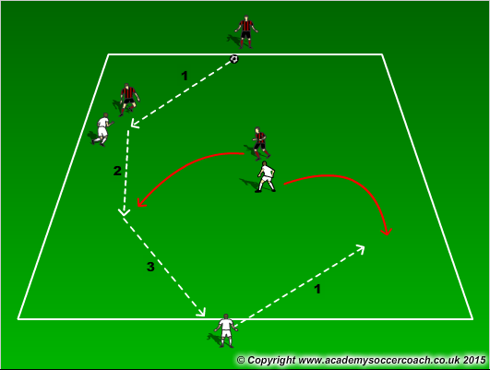 | 2 teams, one on each side of field.  Each team has one bumper at one end of field.  Coach serves ball.  2v2 to your bumper.  Progressions  Make it 3v3.  Add 2nd bumper on each side. | 1 person to ball.  Dribble using pinky toe, pass using inside of foot.  Bumper moves to receive pass.
Game – 5v5 |  | Coaching Points

U11-U13 Activities
Short, Short, Long | Description | Coaching Points
 | Groups of 3, 1 ball.  Players pass in area. 1st and 2nd pass are short, third is long.  Then restart count.  Progressions  3 touches per person. | Quality pass.  Inside of foot.  Can they see the long pass? Person without ball has to find space and think long.  First touch “out of feet”.
2v2 to End Zones | Description | Coaching Points
 | 2 Teams, one on each side of field in 2 lines.  Coach serves ball.  Pairs try to score by dribbling into opponent’s end zone & stopping ball.  Progressions  Require a pass. | Work together on offense and defense.  1 person to ball.  Communication on who is going to get ball.  No defending in end zone.
2v2 with Bumpers to Multiple Goals | Description | Coaching Points
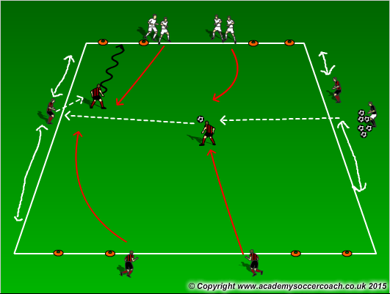 | 2 teams one on each side of field.  “Bumper” player on each side.  Coach & supply of balls on one side.  Coach servers ball in.  2v2 – can score on either goal.  Bumpers may not enter field.  Progressions  3v3. | 1 person to ball.  Communication.  Passing.  Person without ball must move.  Switch bumpers out.
Game – 5v5

Appendix A

MYSA Player/Adult Protection Guidelines

DEFINITIONS
For the purposes of this document, we will define ADULT as those persons in their roles as coach, assistant coach, trainer, team manager, board member, officer, administrator or adult referee who works with, for or around PLAYERS. This would include anyone older than the age group they are interacting with; for example, a 15-year-old assistant coach of a U-11 team would be considered an ADULT for the purposes of these Guidelines.
PLAYER defines all persons who are members of or play on a soccer team. This definition does include those players who participate at the U-19 level, even though they may be of legal age.
In the example of the 15-year-old assistant coach: if s/he is also a rostered participant on a U-16 or higher team, that person is also subject to the guidelines applicable to a PLAYER.
GUIDELINES
These guidelines recognize that the lines of authority and separation between adults and players must be recognized and respected. Generally, players are children and as such, deserve special protection. These guidelines provide that protection while setting levels of acceptable conduct for adults.
I. Physical Contact
ADULTS must be aware that any physical contact with PLAYERS can be misinterpreted. Physical contact should be limited to that necessary and appropriate to teach a skill, treat an injury, or console or congratulate a player. In the instance of teaching a skill, minimal contact should be involved and none which places the ADULT in a position of power and/or intimidation; for example, taking a PLAYER by the shoulders and physically moving them to another field or body position.
Sexual contact of any kind or type is prohibited between ADULTS and PLAYERS, whether or not contact is consensual. [The exemption to this guideline would be in the event of player/coach spouses or domestic partners.]

MYSA Player/Adult Protection Guidelines(Cont.)

II. Social Contact
ADULTS should not socialize or spend time alone with PLAYERS except at games, practices, or team functions. An ADULT in a one-on-one situation with a PLAYER; is generally inappropriate.
ADULTS should avoid instances such as driving alone with a non-family PLAYER. However, in the event that a PLAYER remains on a field waiting for transportation, the ADULT should wait with the PLAYER on the field to guarantee the PLAYER’S; safety and well-being. (ADULTS should stress with their PLAYERS’ parents the responsibility for safe and timely transportation to and from the field.)

III. Health and Well-being
ADULTS share the responsibility for the PLAYERS’ health while at practices, scrimmages and games. ADULTS are also responsible for seeing that the field conditions are safe for the PLAYERS and that the field equipment is in good, safe condition prior to the start of any activity.
Head injuries resulting in disorientation should result in a PLAYER remaining out of the game.
ADULTS transporting players must model safe driving techniques and enforce seat belt use with PLAYERS and other vehicle occupants.
ADULTS need to be aware of signs of neglect and abuse (physical, emotional or sexual) of the PLAYERS. Observations should be reported to the local law enforcement agency

MYSA Player/Adult Protection Guidelines(Cont.)

IV. Language
Offensive and insulting language by ADULTS or PLAYERS is unacceptable. ADULTS should model good communication skills.
Language that is denigrating in nature, content or tone or refers to one’s gender, race, national origin, disability, sexual orientation or religion is unacceptable.
Inappropriate language targeting officials, opponents or spectators may be grounds for PLAYER penalties or ADULTS’ removal from the game and/or the premises.
V. Violations
Violations of these guidelines by ADULTS or PLAYERS will subject them to disciplinary actions, including but not limited to, warnings, sanctions, suspensions or release by the Member Club and/or MYSA.
Appropriate legal authorities may be called upon based on the nature of the violation.
Anyone witnessing a violation of these Guidelines should report the violation to the MYSA State Risk Manager or MYSA Executive Director.

